Number 03  Club address:  Email address:  Website:  Meeting location:  Meeting time:  Facebook: | 16 July 2018  PO Box 116, Nunawading 3131  foresthillrotary1975@gmail.com  www.foresthillrotary.com  Bucatini Restaurant, 454 Whitehorse Road, Mitcham, 3132 (Melways 48H9)  Monday 6.15 for 6.30 pm  Rotary Club Forest Hill

CLUB PROGRAM

Date | Event | Chair | Thanks & Meeting Report
16 July | CHANGEOVER NIGHT | Bob Williams | Stuart Williams
23 July | Report on the RI Convention in Toronto Stuart Williams | Ray Smith | Bob Laslett
30 July | Trachoma  Alex Ioannidis | Chris Tuck | Glenys Grant
6 Aug | “The Three Brothers”  Stephen Manatelli | Barbara Searle | Sue Ballard
CELEBRATIONS

DUTY ROSTER
 | JULY | AUGUST
Recorder | Chris Tuck | Bill Marsh
Greeter | John McPhee | Ron Brooks
Emergency | John Donaghey | Bob Laslett
Cashier | Glenys Grant | Stuart Williams

ATTENDANCE
APOLOGY – IF A MEMBER IS NOT GOING TO COME TO THE MEETING or you intend
bringing a guest please contact Ray Smith by 10.00 am MONDAY on 0412 807 585 or rcssmith@optusnet.com.au
SPECIAL DIETARY NEEDS to Ray by 10am at the LATEST.
Any CANCELLATION AFTER 10.00 AM should be made direct with the management of
Bucatini Restaurant on 9873 0268

Pres Mike’s Musings
None this week “Mike is enjoying his holiday and his contribution to the newsletter will recommence after his installation
However, he had something to say to Ray and Barbara Williams on his 90th birthday and her talk “Person behind the badge” last week.

Ray Smith
I once heard a description of coolness that seemed perfect to me that it’s now the only one I use. Coolness, it said, is understated competence. It’s the ability to do something well without making a big deal of it. Using that metric, Ray is probably the coolest person I know, or indeed have ever known. He’s a wealth of information, but still willing and interested to learn new things. He has mastered a wide range of skills, and will help you master them, if you ask him.
Barbara Williams
I have said several times now that it is hard for me to characterise Barbara as a ‘new Rotarian’. That is not to take away the happiness that I hope she and I know the rest of us feel in her new status, it’s just that she does and has done so much for this club and, through the club, for the community that I tend to think of her membership as recognition of something we all knew was true for a long time.

Whether you call her a new Rotarian or you think her status as a club member has been hiding in plain sight for years, Forest Hill is a stronger and happier club with Barbara Williams.

Coming up:
Saturday 14 July Blackburn Craft Market
Monday 16 July Changeover
Friday 17 August RC Nunawading Christmas in August
Wednesday 22 August Primary Schools Speech Contest

President’s Reflection
No reflection from Pres Mike so let us all reflect on the wise person who proposed Ray for membership of our club, and Rotary International. Who else is out there that you have not asked? That person could be the next “Ray Smith”. They are losing the opportunity and so is Rotary International.
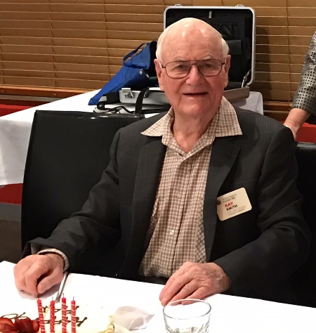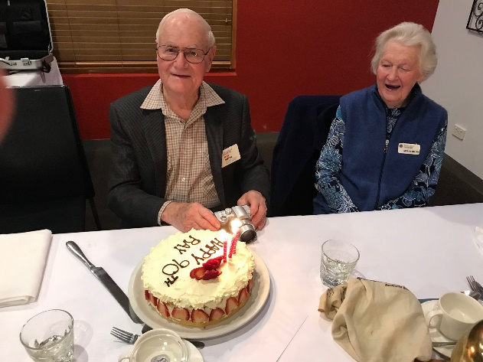

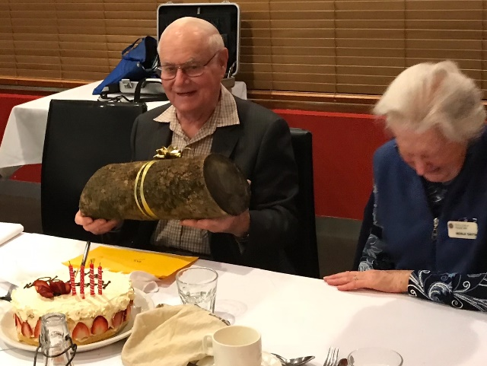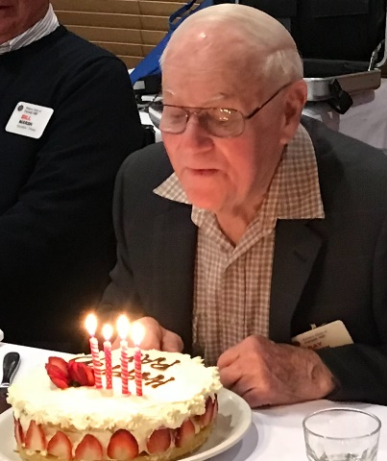
Thanks Glenys for the photos.

Club Meeting Report 9th July Rotarian behind the Badge
Great to see so many of our members there plus Glenys Coates, Judy M and Judy L, Merle, Barbara and Bob’s daughter, Amy and mates Anna and Hans.
Sergeant Bob proposed our two toasts then showed a Powerpoint presentation of club photos from over the years with many of our 90 year young member Ray.
Chair Stuart ran the night with our Youth chair Glenys, advising that the organising for the Primary school speaking contest was running to schedule and thanked Sue for her work in providing transport for our RYLA attendee and they both agree that the experience should greatly assist this young man.
John Mc asked that if any of our usual Blackburn market workers can’t be there on Saturday to please let him know.
Bill reported that we had several brave the cold conditions to attend dinner and movie Friday night.
Even though Pres Mike was an apology, in his usual efficient way he had organised a cake with Bucatini for Ray’s celebration which was our dessert after a beautiful main of chicken. Barbara W had done her usual beautifully artistic card which she had everyone sign and that was presented to Ray as we sang “Happy Birthday”. Bill then presented him with a log of wood, gift wrapped in a gold ribbon so maybe he can work some of his magic on it to produce another of his wood turning masterpieces.
Stuart led us all in telling some “Rayisms” with some gems fondly remembered from us all. Again our forward thinking Mike had sent a piece on his thoughts on Ray which Stuart read. I’m sure this will feature in his Pres report (see Mike’s Musings).
Sergeant Bob recalled that 90 years ago the first sale of sliced bread occurred in Missouri, USA, the date of Ray’s birth so is Ray the second best thing since sliced bread? The session raised $35-35.
Raffle raised $67 with first prize drawn by Merle and won by Glenys Coates who took the white wine, while Amy drew the second prize won by a thankful and thirsty Ron (he chose the red wine), with Chris Tuck taking the third prize, chocolates.
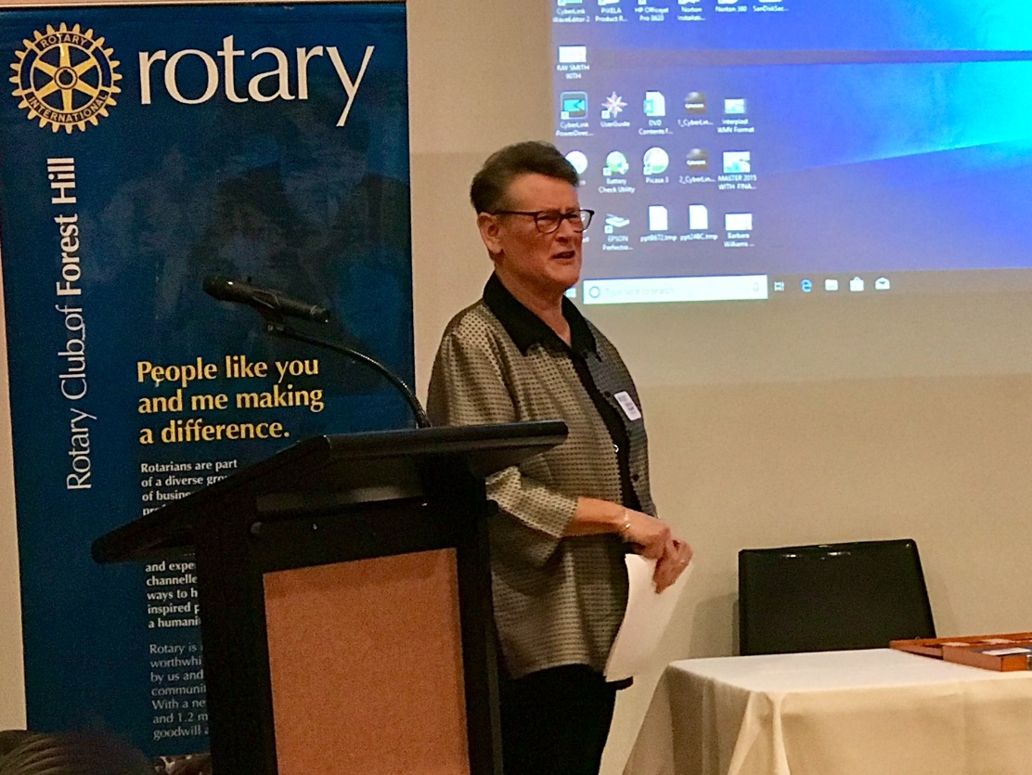
Our “Person behind the badge” was Barbara Williams who took us back through pictures and prose to her grandfather on her mother’s side who was an artist, with his pen and ink drawing published in early Webster dictionary editions. Her father from Boulder in WA travelled to the USA to study Osteopathy as the course wasn’t offered then in Australia and met and married Barbara’s mother who had grown up with a neighbour, Theodore Geisel in Springfield Mass. They kept in touch when she migrated to Australia and on her 80th he sent her a note with “the Cat in the Hat” penned as he later wrote children’s books under the name of Dr Seuss. We saw photos of Barbara with her four siblings and her first driving lesson at age 11 on their farm. Many great experiences at the family lakeside holiday home at Wonboyn Lake. She became a teller at the then Bank of New South Wales where she met a fellow worker Bob, and they later married having two children, Amy and Simon and many experiences with their country banking life, caravanning and keeping up with their family and friends.
Daughter Amy trained and worked as an osteopath until she met and married Tim and had the first of their four boys. Tim’s work took them all to Sweden for several years so Barbara and Bob visited them there enjoying the experience. Another OS trip saw them travel to USA/Alaska/Canada with several coach trips recently around the North of Australia.
Barbara’s later work was as the admin officer at the Aged Care Facility at Vermont South until she retired and this role included driving the council bus for the “oldies” plus going out to return any who had wandered off from the Hostel.
She always supported Bob with his Volunteer work from the 1970’s, first in Apex, then Rotary and various other organisations, so joining Rotary was a formalisation of the many and varied volunteer roles she has done over the past 40 years. Her main interests are her much loved family, Amy and Tim with their four boys, Joshua, Lucas, Toby and Zachary and Simon and Debbie with their two, Ryan and Indigo, card making, crossword puzzles, walking, cycling and they have another Northern Territory coach trip coming up next month.
A wonderful presentation both visually and verbally,well received by all.
Stuart then read another email from Pres Mike about his high regard for Barbara and her great value to our club (see Mike’s Musings).
Bob W

DUTIES OF MEETING CHAIRMAN and VOTE OF THANKS/MEETING WRITEUP

Without wishing to offend anyone (have I ever? would I ever?) during the last little time I have noticed that these duties have been carried out in different ways by different members, or not carried out as the case may be. Some years ago, the Board noticed a lack of consistency with our meetings and some that went way over time so came up with some procedures. They were put in the Newsletter at the time ………… but it is some time ago and perhaps worth reiterating. So, without it being an exhaustive list I note the following. Please read the list and act appropriately so we look and act like a professional organisation.

Chair
- Prior to the night contact the speaker and find out how the speaker wants to be introduced. You can get the contact details from the person organising the programme.
- Note who is giving the vote of thanks from the Flyer. Check that person is present and that they have the pen for the Vote of Thanks (Get it from Ray). If that person is absent it is your responsibility to ensure someone else knows they have the job and the pen.
- Make yourself known to the Speaker and tell them where they are sitting (check with the President, or whoever is standing in for the President)
- Ask the guest speaker if they would like a drink. Get it from the bar and get a receipt. Give it to the Treasurer who will immediately refund you.
- Check that the microphone is working. If not, do something about it. Either go and see Bucatini staff and tell them (batteries may need replacing) or if you are too busy with the speaker ask someone else.
- You need to tell the speaker how long they have. You control the timing, you control the meeting, that is why you get a running sheet. Tell the speaker when they have 2 mins or 5 mins to go ….. whatever YOU arranged with the speaker. Arrange whatever signal you like with the speaker but pre arrange it.
- When time is up, STAND UP and walk to the front. The speaker will get the message.
- It is up to the chairman, not the speaker to ask for questions and field those questions from the floor as you know the audience and when to stop taking questions. Try and have a question just in case there are no others. It is not a good look if there are no questions and yours may elicit others.
- It is not up to you to say thankyou to the speaker, we have a person nominated.
- Stay at the front while the vote of thanks is given then call on the President, or whoever has taken the President’s place, to close the meeting.

Vote of Thanks/ Meeting writeup
- Come prepared to take notes. Take notes on the entire meeting not just what the guest speaker said.
- Make sure you check on what wood has been used to make the pen before you get up to speak.
- Keep the vote of thanks short. You are not there to give a precis of what the speaker said. You are there to thank the speaker on behalf of the audience.
- Write up a report of the entire meeting and ensure that your report gets to the newsletter editor before 5pm on Wednesday. Spell check the report.
Ron Brooks

FOREST HILL COLLEGE BREAKFAST
The small group that do this club project had last Tuesday off ‘cos of school holidays. Next week it is the usual team of Robbie and Barbara W

ROTARY MONTHLY THEMES
July Rotary Awareness

ARTICLES
Next week please forward your prize-winning articles once more to rlaslett@optusnet.com.au by 5pm Wednesday. Ron is grateful to have Bob L back on deck.

I thank members for the way members expressed their best wishes to me for my 90th birthday and special thanks to those who went to much trouble to present the evening.
Ray Smith

