|  |  |  |
| --- | --- | --- |
|  | Weekly Newsletter  foresthillrotary@hotmail.com |  |
| Number 11: 15th Sept 2014  Club address: PO Box 116, Nunawading 3131  **Email address: foresthillrotary@hotmail.com**  **Website:** [**www.foresthillrotary.com**](http://www.foresthillrotary.com)  Meeting location: Bucatini Restaurant, 454 Whitehorse Road, Mitcham, 3132  Meeting time: Monday 6.15 for 6.30 pm  **Facebook: ForestHill Rotary** | | |

|  |  |  |  |  |  |  |  |  |  |  |  |  |  |  |  |  |  |  |  |  |  |  |  |  |  |  |  |  |  |  |  |
| --- | --- | --- | --- | --- | --- | --- | --- | --- | --- | --- | --- | --- | --- | --- | --- | --- | --- | --- | --- | --- | --- | --- | --- | --- | --- | --- | --- | --- | --- | --- | --- |
| |  |  |  |  |  | | --- | --- | --- | --- | --- | | **CLUB PROGRAM** | | | | | | **Date**  **15th Sept** | **Event**  **DG Tony Monley Visit & Club Birthday** | **Chair**  **Pres Bill Marsh** | **Thanks/meeting report**  **PE Bob Williams** |  | | **22nd Sept**  **29th Sept**  **6th Oct** | **ACNC, Murray Baird**  **FOOTY FEVER night !!!**  **Michael Sukkar,MP Deakin**  **combined with Mitcham RC** | **Jenny Coburn**  **Bob & Stu Williams**  **Bill Marsh** | **Ray Smith**  **Stu & Bob Williams**  **Bob Laslett** |  |  THIS WEEK'S CELEBRATIONS Sept 13th Warwick Stott Club anniversary (39years)  Sept 13th Forest Hill Birthday DUTY ROSTER  |  |  |  | | --- | --- | --- | |  | **Sept** | **October** | | Cashier | John McPhee | Jenny Coburn | | Recorder | Stuart Williams | Warwick Stott | | Greeter | Doug Berwick | Glenys Grant | | Emergency | Bob Williams | Ray Smith |  ATTENDANCE  |  | | --- | | **APOLOGY** – **IF A MEMBER IS NOT GOING TO COME TO THE MEETING or you intend bringing a guest please contact Ray Smith by** **10.00 am MONDAY** on9878 4891 or[rcssmith@optusnet.com.au](mailto:rcssmith@optusnet.com.au%20)  Any CANCELLATION AFTER 10.00 AM should be made direct with the management of Bucatini Restaurant on 9873 0268 | |

Chris Tuck will be absent from 23rd Aug to 25th Sept

**BILL’S** **BLURB**

Well we have finally had a relatively quiet Rotary week!

On Monday we had an excellent speaker in Marianne McEwan from Forest Hill College. Marianne is involved with the welfare and wellbeing team for the college. Her outline of her role was very interesting, and perhaps eye opening, for those of us who have been out of school for a while. Because of time constraints, Marianne was due at a series of parent/teacher interviews, she spoke while our meal was being served and consumed. A daunting task that she handled extremely well and we are very grateful for her forbearance. Marianne has been invited back at another time when she can relax a little more and enjoy the meeting and friendship a little more.

Committees met on Monday and we now have a better picture of the projects to be undertaken by the various groups and a clearer view to present during the DG's visit next week.

Next week we not only welcome the DG for his official annual visit we also celebrate the 39th year of the club's operation. It will be an enjoyable night and an affirmation of the outstanding contribution our club has made to the lives of so many others in our community - locally and internationally.

This coming weekend will see the club involved in a number of activities that will stretch our resources. On Saturday we have our Blackburn Station Craft Market, on Sunday we have the Whitehorse Farmers' Market and also on Sunday we are involved at the Schwerkolt Cottage Historical Day. All fun activities and all outdoors - so let's hope for sunny days.

The first issue of 'Community Connections@Forest Hill' is at the printers and should be in 9,500 homes around the area shortly.

Thanks to Stan who donated a lovely bottle of port for the prize in this week's raffle which was duly won by John D.

**Little Known Fact**: The National Health Service (of Britain) is the world's 4th largest employer after the US Defence Department, the Chinese Red Army and Wal-Mart.

**Enjoy your week in Rotary and keep working to "Light Up Rotary"**

Pres Bill

**LAST WEEK’S MEETING**

Guest Speaker.. Marianne Mc Ewan Counselling & Wellbeing Leader for Forest Hill College. We were entertained by a very well presented and informative outline on the role of a wellbeing officer in today’s education system. In today’s more demanding society expectations of youth, to achieve educators need new technology to replace the strap. This is where the Wellbeing officer, Chaplain and support staff, come into play by providing counselling and pastoral care support.

Some of the problems which they encounter are:-

25% of students over 16 face at some stage some form of mental health problem

Rise in self harm and eating disorders

Facebook and physical harassment

Technology advances

To work on these difficulties they counsel and lead using ;-

Restorative [practices to resolve conflict

Liaison with agencies, to keep up with what’s going on in the youth communities

Building strength and control in group discussion with teams of boys and girls, so that they can appreciate the other persons position and learn to temper their own actions to achieve belief in self whilst learning to control any assertive responses.

Communication skill development and risk assessment including safe parties.

Positive education to overcome illness to wellbeing attitude to their education

Spirituality Learning of the worth of one self, irrespectively of one’s religious belief or non belief and the important role that the Chaplaincy plays to present a balanced view of each person’s spirituality, irrespective of the chaplain’s personal beliefs

In conclusion Marianne outlined their role in developing a breakfast facility twice a week at a nominal cost to students, and the student’s charity achievement in a recent basketball marathon.

Notes by John McPhee

Sergeant Stu opened the meeting and asked us to think about Welfare- personal welfare. Was it what to reply to a Tiger supporter when he asked me “How should I react to the loss?” Is it our response to hearing about the teacher who was awarded $1.2 million for a breakdown after being traumatised by “feral” students. What is fair support for young people out of work? Why would we have someone responsible for welfare in a middle class area like Forest Hill? Is Rotary a welfare organisation? We talk about “*humanity in motion*” and “*doing good in the world*” Good for the welfare of the world. Our society has to be more than just a strong economy. A caring, mature society surely puts in place sensible welfare policies.

(you are certainly using your meeting openings to make us think Stu, great stuff-editor)

The Sergeant raised $34.80 ! How does he do it?

# GRAHAM SHARMAN

Graham is now in Donvale Rehab, Doncaster Rd and would love you to call in or give him a ring on his mobile which is by his side 0412-555-435. He may be there for some time but is recovering well.

# DON HULLAND,

Honorary member Don is not too well. His arthritis is a real problem. He is at present in Kellock Lodge in respite and hoping to be able to stay there full time. The address is 15 Bon St, Alexandria 3714 and his telephone is 0409 530 435. Why don’t you give him a call or write to him.

**ANNUAL FOOTY FEVER FROLICS**

The two Williams’ boys are at it again on 29th Sept in their annual Quiz night. It’s a partner’s night of course. In preparation can I suggest you click on the following link

[www.youtube.com/watch?v=N-NznmUykqQ](http://www.youtube.com/watch?v=N-NznmUykqQ)

**DINNER AUCTION FOR SOUTH SUDAN SCHOOL**

RC of Manningham is running a dinner auction at 7 for 7-30pm on Saturday 11th October at Monte Carlo receptions, 5 Mitchell Street, Doncaster East. Cost is $70 per person for a buffet dinner with drinks at bar prices.

All proceeds to go towards the cost of building a school in Rumbek, South Sudan.

Barbara and I will be attending and it would be great to have some more from Forest Hill.

We need numbers by 30 September so please let me know if you wish to come along.

Bob Williams

**MONDAY 22nd SEPT is HAT DAY at FOREST HILL ROTARY**



Every year HAT DAY reminds us to keep supporting Australian Rotary Health. So come along to our meeting at Bucatini and **WEAR A HAT**. $2 donation if you wear a hat, $5 if you don’t.

**“LARRY the LORIKEET” BOOK**

Take action NOW. If you want to buy a copy … or two, ….. or three, then give your order into Pres Bill ([**bjmarsh@bigpond.net.au**](mailto:bjmarsh@bigpond.net.au)) as we are planning a second print run if the demand is large enough.

# WEBSITE

Do not forget to check out our website, [www.foresthillrotary.com](http://www.foresthillrotary.com) and send Ron Brooks any information and suggestions.

**HAND BRAKE TURN**

Gary Baltissen was talking to Phil, one of the instructors at Dandenong, and he was very enthusiastic about how Rochelle Grimes, our awardee last year, was progressing. He said she was a whole new lady who was exceeding all expectations, passing all her exams and has a weekend mechanical job.

# REASONS FOR JOINING ROTARY

Jenny Coburn gave me a list of reasons, I am putting in a different one every week - **think about them when you talk to prospective members**

**Sharing Professional Skills:** You have a desire to share your professional skills to help make a difference in the world. Rotary provides you with this opportunity through Vocational Service. You can create projects that fit around your skills.

**WEEKLY RAFFLE.**

We are now running a weekly raffle, winner’s choice of a bottle of white wine, red wine, or a box of chocolates. Tickets $2 each or 3 for $5. Proceeds will go to our General account to help fund our new member drive. It raised $55 last week. John D won the raffle and opted to take the bottle of Penfolds PORT which had been donated by Stan. Fantastic

**STAMPS**

Please cut out all the stamps you get on your snail mail leaving an approximate 1cm margin and give to Jenny Coburn. They are worth nothing to you but Rotary sells them. Over $89,000 since starting in 1991/92 and $7,091 in 2013/14.

**WHITEHORSE FARMERS’ MARKET**

**Egg and Bacon Stall and Information Table**

Sunday 12th October

Our club is manning both the egg and bacon stall and the information table and we need 17, repeat ***17*** assistants on the day. Please see Warwick Stott (Mob 0412444393, email [wstott@netspace.net.au](mailto:wstott@netspace.net.au)) to offer your help for a 2 hour shift of cooking, conversing and enjoying a beaut Rotary project. We need you, being either Rotarians, partners, friends of Rotary, offspring, and possibly friends of individual Rotarians, because it is a huge number for our small club

**BALLARAT CONFERENCE 2015**

A booking has been made for 6 double rooms at Ballarat Lodge  for District Conference.( Fri 13 - Sunday 15 March 2015.  Rooms booked for Fri night and Saturday night at the venue of the Saturday night function.

Families  Grant/ Williams, Bob/ Williams, Stuart/ Brooks/Laslett/Marsh.     Jenny and Roger will stay in own accommodation.

Cost  $149 per night.  FULL Buffet breakfast if required $20.  I believe no money needs to be paid until we arrive. (I believe the Saturday Night function will be held at this venue)

Stuart Williams

On to Conference organiser

Club officers & Committees 2014-15

**President** Bill Marsh

**Vice President** John Donaghey

**Secretary** Ron Brooks

**Treasurer** Warwick Stott

**President Elect** Bob Williams

**Sergeant** Stuart Williams

**Foundation & International** Chris Tuck

Members: John Donaghey, Stan Harper,

**Youth Service** Glenys Grant

Members: Ray Smith, Bob Williams, Graham Sharman

**Community & Vocation** Bob Laslett

Members: Stuart Williams, Gary Baltissen, Ron Brooks

**Membership & Publicity** Doug Berwick

Members: John McPhee, Warwick Stott, Jenny Coburn

**Fellowship** John McPhee

**Primary Schools Speech Night** John McPhee

**Programme** Ray Smith & Gary Baltissen

**Bulletin Editor** Ron Brooks

**Web page & Facebook** Ron Brooks

**On to Conference** Stuart Williams

**Historian** Stan Harper

**Almoner** Graham Sharman

**Public Officer** Bill Marsh

Note that Bob Williams has volunteered to swop over from Foundation/International to Youth Services to support Glenys and Ray as Graham will be spending very little time in Melbourne.

Newsletter articles to the editor at [ronbrooks1@optusnet.com.au](mailto:ronbrooks1@optusnet.com.au) by **5 pm Wed**. If you do not wish to receive this publcation please contact the editor.

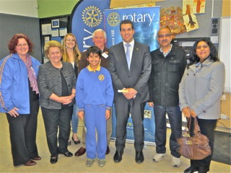

“Our” Hope Katolo water tanks Primary School Speech Contest winner

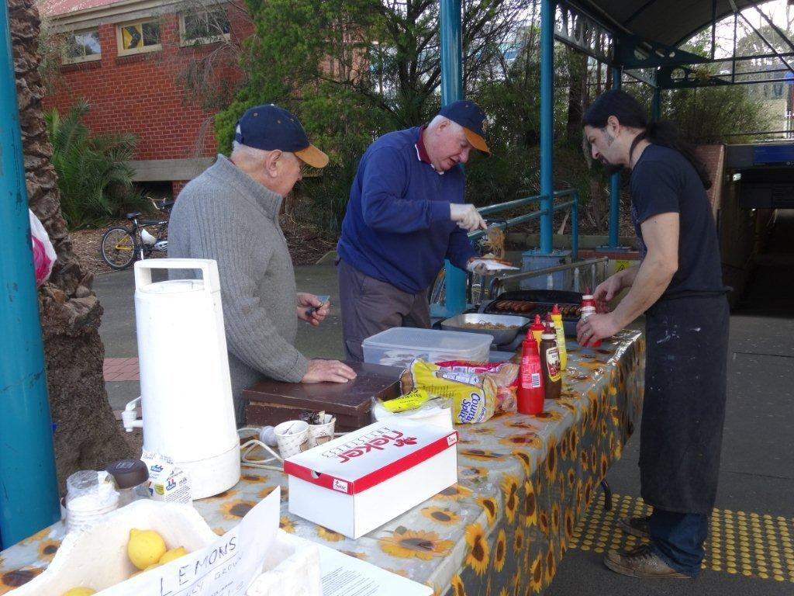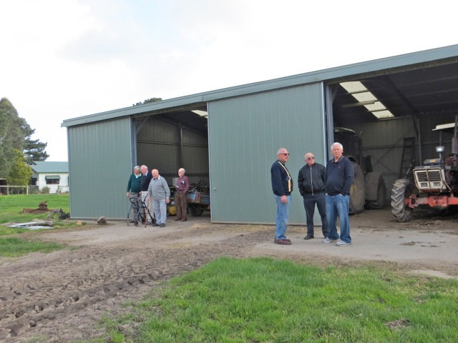

Blackburn Market Saturday morning “Experts” studying the Davis tractors