|  |  |  |
| --- | --- | --- |
|  | Weekly Newsletter  foresthillrotary@hotmail.com |  |
| Number 12: 22nd Sept 2014  Club address: PO Box 116, Nunawading 3131  **Email address: foresthillrotary@hotmail.com**  **Website:** [**www.foresthillrotary.com**](http://www.foresthillrotary.com)  Meeting location: Bucatini Restaurant, 454 Whitehorse Road, Mitcham, 3132  Meeting time: Monday 6.15 for 6.30 pm  **Facebook: ForestHill Rotary** | | |

|  |  |  |  |  |  |  |  |  |  |  |  |  |  |  |  |  |  |  |  |  |  |  |  |  |  |  |  |  |  |  |  |
| --- | --- | --- | --- | --- | --- | --- | --- | --- | --- | --- | --- | --- | --- | --- | --- | --- | --- | --- | --- | --- | --- | --- | --- | --- | --- | --- | --- | --- | --- | --- | --- |
| |  |  |  |  |  | | --- | --- | --- | --- | --- | | **CLUB PROGRAM** | | | | | | **Date**  **22nd Sept** | **Event**  **ACNC, Murray Baird** | **Chair**  **Jenny Coburn** | **Thanks/meeting report**  **Ray Smith** |  | | **29th Sept**  **6th Oct** | **FOOTY FEVER night !!!**  **Michael Sukkar,MP Deakin**  **combined with Mitcham RC** | **Bob & Stu Williams**  **Bill Marsh** | **Stu & Bob Williams**  **Bob Laslett** |  |  THIS WEEK'S CELEBRATIONS is HAT DAY $2 donation if you have a hat on,  $5 if you are hatless  SUPPORT AUSTRALIAN ROTARY HEALTHDUTY ROSTER  |  |  |  | | --- | --- | --- | |  | **Sept** | **October** | | Cashier | John McPhee | Jenny Coburn | | Recorder | Stuart Williams | Warwick Stott | | Greeter | Doug Berwick | Glenys Grant | | Emergency | Bob Williams | Ray Smith |  ATTENDANCE  |  | | --- | | **APOLOGY** – **IF A MEMBER IS NOT GOING TO COME TO THE MEETING or you intend bringing a guest please contact Ray Smith by** **10.00 am MONDAY** on9878 4891 or[rcssmith@optusnet.com.au](mailto:rcssmith@optusnet.com.au%20)  Any CANCELLATION AFTER 10.00 AM should be made direct with the management of Bucatini Restaurant on 9873 0268 | |

Chris Tuck will be absent from 23rd Aug to 25th Sept

Gary Baltissen will be overseas from 30th Sept to 3rd Nov

**BILL’S** **BLURB**

Well, well!! Here we are in our fortieth year and what a great send off we gave 39. It was marvellous to see so many partners and Honorary Rotarians enjoying the evening and each other's company. Thank you to all who came along to help us celebrate and to all those who worked behind the scenes to make it a successful and fun evening.

Monday was also a 'formal' occasion in that we hosted the DG's official visit to the club. The night got off to a great start. I arrived to find Warwick and Ron cooling their heels outside the front door. We (I) had forgotten to tell Ivan that we were meeting at 4.30pm and so Bucatini's was closed as tight as a drum. Fortunately Ivan was inside and Ron could reach him by phone. A DG's visit held in the backseat of my wagon would have been interesting if a little crowded. This incident showed, again, why Bucatini's is such a great venue for us as Ivan didn't miss a beat and the meeting proceeded without a hitch. Thanks, Ivan.

Our meeting with DG Tony Monley and AG Paul Mee was very positive as it gave us the opportunity to showcase all of the great work that our club does for the community - both locally and internationally. Tony and Paul were impressed with what we had achieved in the past and with our plans for the coming year. Tony was at the Primary Schools Speech Competition and Paul at the launch of 'Larry' and they knew of our success with NYSF, RIPEN, RYLA and MUNA so talking to them was very easy. They were very interested in our involvement with Hope Katolo and Hand Brake Turn and were amazed at the support we receive from the Davis and Harper families. An enjoyable and affirming meeting and my thanks to Warwick, Ron and Bob Williams for attending and their support. Tony gave an interesting and informative report on the club, District and Rotary International towards the close of the evening and Kathy gave us an update on her project 'The Koori Academy of Excellence'. Bob W thanked Kathy and the club gave her a $200 donation towards the project. This added to the $100 we presented when Kathy came to our Changeover meeting. Kathy has already raised over $7,000 towards her project. A fantastic effort in just 3 months.

Anyone for a sausage? Probably not after the weekend when we cooked and sold at least a million sausages, well 45 kg, at the Blackburn Market and the Historical Society Open Day at Schwerkolt Cottage. The assembly line at Schwerkolt was a sight to behold and the guys on the BBQ are to be commended as we were selling sausages faster than they could cook them - despite having around 30 on the BBQ at all times. A small aside for those who know our Ray, and who doesn't! Smithy actually broke into a sweat at the peak time. Pity we didn't get a photo but everyone was too busy.

On Thursday I will be attending a Cluster meeting where the finishing touches will be put in place for our Rotary Day to be held at the October Whitehorse Farmers' Market. Hopefully we get everyone there on the day as not only will we be involved in the Rotary Day, we are also running the egg & bacon stall. The Rotary Day will be a great opportunity to bring Rotary to the forefront in our community.

Some Diary Dates:

22 Sept. Guest speaker Murray Baird & an update from Membership on our Membership & Information Evening.

29 Sept. Football Night - under the tender care of the Williams boys.

6 Oct. Joint meeting with Mitcham RC with guest speaker Michael Sukkar.

13 Oct. Membership Information Evening

17 Oct. Visit to Box Hill Hospital - 9.00 am (Limited to 15 so get in early)

19 Nov. Cluster presentation 'Rotarians Against Child Slavery' organised by the Rotary Club of Box Hill Central.

8 Dec Address by RI President Elect - venue to be confirmed.

**Little Known Fact**: India has almost 155,000 post offices: more than any country in the world and almost twice as many as China.

**Enjoy your week in Rotary and keep working to "Light Up Rotary"**

Pres Bill

**LAST WEEK’S MEETING**

As we are in the middle of the football finals I have taken the liberty of mentally shifting our last meeting from Bucatini’s to the MCG and related other grounds.

Our coach Tony Monley and Kathy along with assistant coach Paul Mee and Adele were there to guide and support us for Monday night’s game.

Umpire Stuart came out to the cheers from the crowd and bounced the ball to get proceedings underway.

Captain Bill took control of the ball and told us of the very busy weekend with the Saturday fixture seeing us playing away at the Blackburn Station ground where we attracted a reasonable crowd and made $614. On Sunday selected members of the team represented us at the Whitehorse Farmers’ market match where we again played well with our usual share of the match proceeds being $7/800. Under the direction of our specialist coach John McPhee we played our annual game at the home ground of the Whitehorse Historical Society on Sunday under a clear sky with the wind not being a factor. Our property man, Ray Smith had all our footy gear ready for the bounce of the ball at 11am with a big crowd in attendance.

We used all our reserves coming on and off the bench and were able to withstand the enormous pressure and demands of the crowd to get us over the line once again. Our takings this time were $824 making a grand total of over $2,000 for the weekend’s games which will no doubt be put towards projects nominated by our deputy leaders Chris Tuck, Glenys Grant and Bob Laslett.

Captain Bill spoke of our fantastic rover, Jenny being the driving force behind organising the distribution of our promotional newsletter to 9,500 households and we hope to increase our club membership from this initiative.

Rover Jenny is also seeking members to support another event on the 18th October called Guess Who’s Coming to Dinner so all footy supporters should get behind this.

Deputy Leader Glenys then marked the ball and updated the club on our recent publication called Larry the Lorikeet which was created by some of our younger supporters.

The match resumed after half time with umpire Stuart re-starting proceedings with his address and seeking money from the vast crowd His promise of the more money thrown in would make him stop talking was immediately taken up by the spectators with $56 made and he was silenced.

Coach Tony then took control of the match and it was easy to see why he commanded such a high transfer fee to attract him into the head coaching role at the Rotary International District club

He and assistant coach Paul had interviewed captain Bill and his team earlier and were impressed by the game plan of the Forest Hill team with their many great moves and plays they intend to carry out during the season.

Tony’s District team has been reduced from 49 to 47 players and they need to attack to win.

He spoke of the need for challenge within the clubs with retention of good game styles whilst seeking new ones. Clubs need to be competitive as there are many competing interests plus to keep in mind the community expectations of us playing within the rules.

This year there is particular focus on keeping the ground lights on to ensure the future of the Rotary club as playing in the dark doesn’t attract attention.

He spoke of plays for publicity such as the Rotary event which Forest Hill is running next month, more members and to complete the job on Polio Eradication for our less fortunate spectators.

The Rotary Footy Club Strategic Plan is a key feature of our future with material needed for different market segments and his desire is to gain two new players this year to return the team to 49.

There will be a future leader’s seminar the day prior to conference and we need to attract more corporate sponsorship with the District now offering donors tax deductibility.

District is expanding our Youth Protection Policy as one of many initiatives being developed.

Coach Tony told us of his personal take on the Rotary club game as giving him balance to his life (and introducing him to Kathy) and he also enjoyed this same feeling when he played for the Apex League. Personal development and team friendships with other players sharing similar values are other attributes of membership of the great Rotary International club who aim to be premiers this year.

The coach behind the coach, Kathy updated us on the project she is championing, the Koori Academy of Excellence and the Forest Hill club was able to give her another small contribution towards assisting future players.

The club raffle raised $116 and after the game we continued enjoying our 39th birthday with a cake.

Captain Bill in his after match address thanked everyone for their attendance.

Notes by Bob W

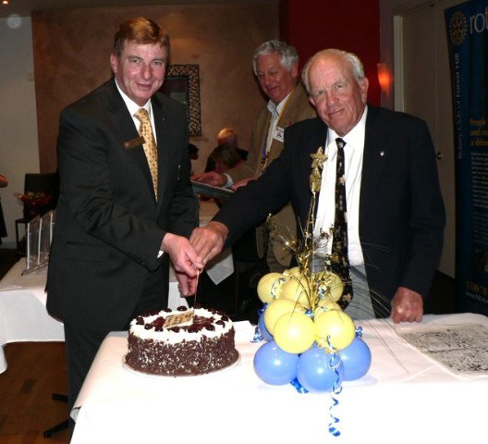

Charter member Warwick and DG Tony cutting the club birthday cake with Pres Bill

Sergeant Stu opened the meeting saying let’s think about Rotary coming to Forest Hill. The Rotary Club of Nunawading’s vision resulted in an enthusiastic group forming our club. He asked us *“Is our community a better place having a Rotary Club”. “Has Rotary impacted positively on our area*”. We could do the maths. We could count the dollars donated, we could feel good about our impact on the health of many……….but just think for a moment………What has Rotary meant to you? All Rotarians and their families have been part of something very special. The fabric of our community is substantially richer due to the friendships/ camaraderie and intelligent awareness of Forest Hill Rotarians. We and our community are better thanks to Rotary.

Merle Smith won the first prize in the raffle which was a choice of red or white wine, or a box of chocolates. Enjoy the chocolates Merle. Runners up got 4 flowers in pots and three balloon table centre pieces (courtesy of Jenny & Roger, a big thankyou). Thanks Ray for organising the raffle tickets.

We had a full house with DG Tony & Kathy, AG Paul & Adele Mee, Norm & Mary Durham, Heather Bremner and Heather Neilson along with 8 partners. It really makes these nights so much more enjoyable when we see and get to chat to some of the “old” faces [got to be careful how I phrase that].

During the week we have had birthday wishes via Facebook from John Bindon, and past exchange students Antti (Finland), Carmina (Mexico), and Marianna (Argentina).

**HISTORICAL SOCIETY OPEN DAY at SCHWERKOLDT COTTAGE SUN 14th SEPT**

The great efforts at the Sausage Sizzle we ran for the annual Historical Society open day at Schwerkoldt Cottage and Museum complex raised $942 of which we gave $100 to the Historical Society.

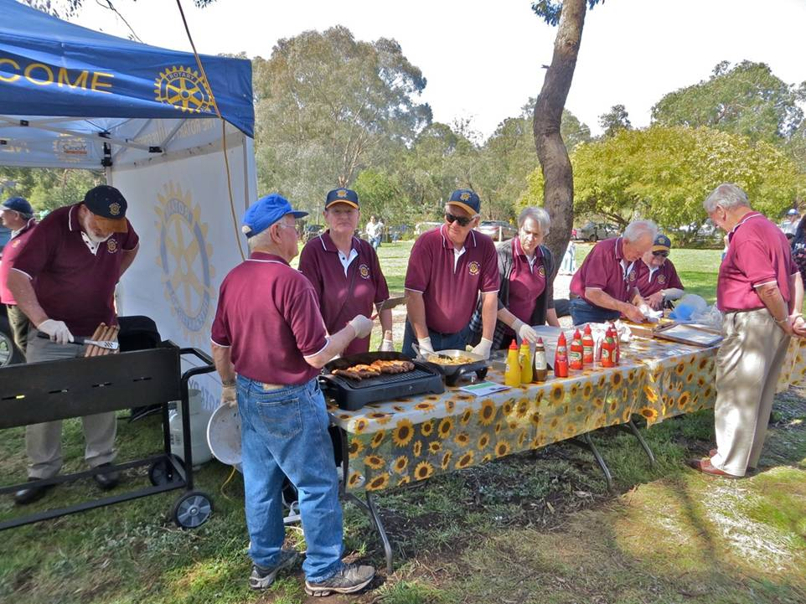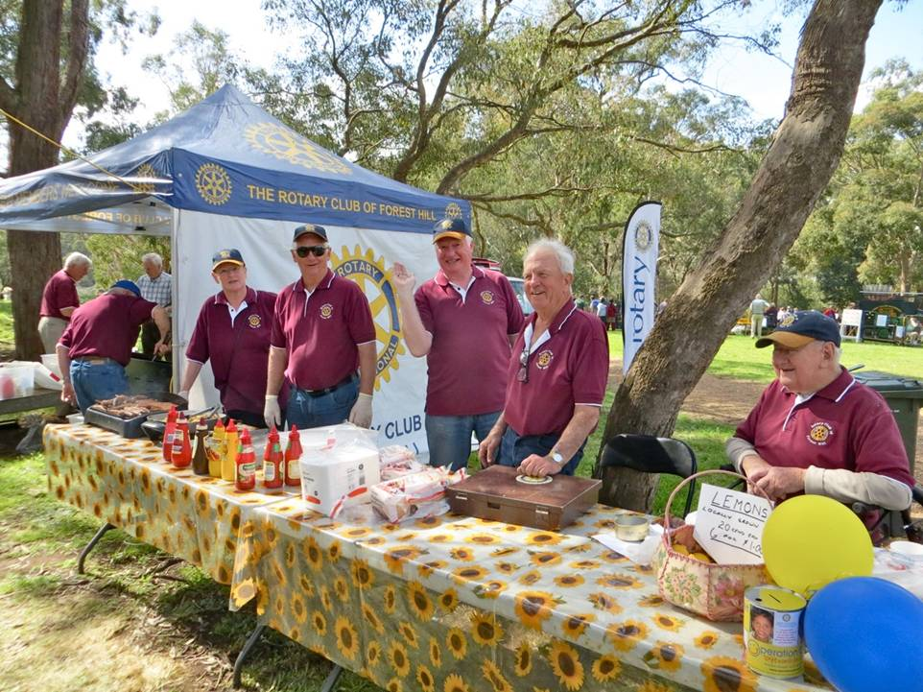

# CLUB MEMBERS

Stan has told me that we have inducted 186 members in our 39 years, 5 of them have been inducted twice. They are Ian Huxley, Max Parish, John Stanton, Jenny Coburn and Warwick Stott.

# GRAHAM SHARMAN

Graham is now in Donvale Rehab, Doncaster Rd and would love you to call in or give him a ring on his mobile which is by his side 0412-555-435. He may be there for some time but is recovering well.

# DON HULLAND,

Honorary member Don is not too well. His arthritis is a real problem. He is at present in Kellock Lodge in respite and hoping to be able to stay there full time. The address is 15 Bon St, Alexandria 3714 and his telephone is 0409 530 435. Why don’t you give him a call or write to him.

**ANNUAL FOOTY FEVER FROLICS**

The two Williams’ boys are at it again on next week 29th Sept in their annual Quiz night. It’s a partner’s night of course. In preparation can I suggest you click on the following link

[www.youtube.com/watch?v=N-NznmUykqQ](http://www.youtube.com/watch?v=N-NznmUykqQ)

**DINNER AUCTION FOR SOUTH SUDAN SCHOOL**

RC of Manningham is running a dinner auction at 7 for 7-30pm on Saturday 11th October at Monte Carlo receptions, 5 Mitchell Street, Doncaster East. Cost is $70 per person for a buffet dinner with drinks at bar prices.

All proceeds to go towards the cost of building a school in Rumbek, South Sudan.

Barbara and I will be attending and it would be great to have some more from Forest Hill.

We need numbers by 30 September so please let me know if you wish to come along.

Bob Williams

**“LARRY the LORIKEET” BOOK**

Take action NOW. If you want to buy a copy … or two, ….. or three, then give your order into Pres Bill ([**bjmarsh@bigpond.net.au**](mailto:bjmarsh@bigpond.net.au)) as we are planning a second print run if the demand is large enough.

# WEBSITE

Do not forget to check out our website, [www.foresthillrotary.com](http://www.foresthillrotary.com) and send Ron Brooks any information and suggestions.

**POLIO WEBINAR**

We’ve talked about Webinars before. Here is another one you should follow on your computer. Talk to me about it if you are a beginner on webinars To learn more about our fight to End Polio Now, [attend the World Polio Day webinar](http://echo4.bluehornet.com/ct/46098126:27781578704:m:1:1539467922:A29139E564C3D751FEE4B4C4726C143B:r) on 24 September. We learned last week from the DG that through Rotary’s efforts 1 of the three strains of polio has vanished from the earth, one has nor been seen in over 12 months and the third is only causing cases in three countries with hopefully Nigeria being declared free very soon , just leaving Pakistan and Afghanistan that the Taleban stops us from completing the task. However, there were only 403 cases reported in 2013.

Also,

On 24 October, Rotarians clubs and districts around the world will come together to fight polio. Register today for our [End Polio Now: Make History Today Livestream](http://echo4.bluehornet.com/ct/46098122:27781578704:m:1:1539467922:A29139E564C3D751FEE4B4C4726C143B:r) event to receive a global update on the current status of polio eradication, hear inspiring stories, and musical performances. The event will begin at 18:30pm CDT and will be streamed live at [endpolionow.org.](http://echo4.bluehornet.com/ct/46098123:27781578704:m:1:1539467922:A29139E564C3D751FEE4B4C4726C143B:r)

**MEMBERSHIP WEBINAR**

Join us on 8 October 2014 at **10 a.m. Central Standard Time** for the next installment of the **Membership Matters!** webinar series - Perception vs. Reality: Club Evaluation and Visioning.

This webinar will feature Steve Wilcox from the International Vision Facilitation Council; Steve has over 12 years of experience helping Rotary clubs develop and implement their club vision strategy as well as training other leaders in the facilitation process. Steve will share his insights into the process of club visioning and provide you with the steps to perform this transformational process in your own club. Joe Brownlee, RI’s chief strategy officer, will join us to discuss the resources and support available from Rotary. Attendance is limited to 1,000 participants so make sure to register today.

Register at: [https://attendee.gotowebinar.com/register/3368431197324866050](http://echo4.bluehornet.com/ct/46091119:27778557647:m:1:1539467922:DD51372589336BD9C4D899283508EA00:r)

Please note these times are in US Central Standard Time (Evanston).  To see what time this will be in your area, please use the [time zone converter](http://echo4.bluehornet.com/ct/46091120:27778557647:m:1:1539467922:DD51372589336BD9C4D899283508EA00:r).

You can find this and other Rotary webinars on the webinar page at:  
[https://www.rotary.org/myrotary/en/learning-reference/webinars/upcoming](http://echo4.bluehornet.com/ct/46091121:27778557647:m:1:1539467922:DD51372589336BD9C4D899283508EA00:r)

These webinars are a great way to learn more from the comfort of your own armchair

**SCAMMERS ARE A CLICK AWAY**

*“It only takes ONE CLICK for an attacker to establish a foothold in their target’s computer*”. CLICKJACKING is all about a scammer picking on something that most people will be tempted to click on. Social networks like Facebook or getting an email from your “bank” or from a friend with a message click here. Always best to retype the link into your browser as you never know what is hidden under the link words.

# REASONS FOR JOINING ROTARY

Jenny Coburn gave me a list of reasons, I am putting in a different one every week - **think about them when you talk to prospective members**

**Fun:** Each meeting is fun, our club projects are fun and social activities are fun.

**STAMPS**

Please cut out all the stamps you get on your snail mail leaving an approximate 1cm margin and give to Jenny Coburn. They are worth nothing to you but Rotary sells them. Over $89,000 since starting in 1991/92 and $7,091 in 2013/14.

LDB Accountants in Blackburn have been collecting stamps for some time for another charity but they did not want them any more and via the web found that our club wanted used stamps. I collected a large box of stamps from them on Tuesday 16th Sept and after chatting to Lee, their Practice Manager, she has contacted the other major business in their building and offered to take their stamps as well. She has given me a lead to two other businesses.

**WHITEHORSE FARMERS’ MARKET**

**Egg and Bacon Stall and Information Table**

Sunday 12th October

Our club is manning both the egg and bacon stall and the information table and we need 17, repeat ***17*** assistants on the day. Please see Warwick Stott (Mob 0412444393, email [wstott@netspace.net.au](mailto:wstott@netspace.net.au)) to offer your help for a 2 hour shift of cooking, conversing and enjoying a beaut Rotary project. We need you, being either Rotarians, partners, friends of Rotary, offspring, or possibly friends of individual Rotarians, because it is a huge number for our small club

**BALLARAT DISTRICT CONFERENCE FRI 13th –SUN 15th 2015**

Families  Grant/ Williams, Bob/ Williams, Stuart/ Brooks/Laslett/Marsh.     Jenny and Roger will stay in own accommodation. Cost  $149 per night. Buffet breakfast $20

Stuart Williams On to Conference organiser

Club officers & Committees 2014-15

**President** Bill Marsh

**Vice President** John Donaghey

**Secretary** Ron Brooks

**Treasurer** Warwick Stott

**President Elect** Bob Williams

**Sergeant** Stuart Williams

**Foundation & International** Chris Tuck

Members: John Donaghey, Stan Harper,

**Youth Service** Glenys Grant

Members: Ray Smith, Bob Williams, Graham Sharman

**Community & Vocation** Bob Laslett

Members: Stuart Williams, Gary Baltissen, Ron Brooks

**Membership & Publicity** Doug Berwick

Members: John McPhee, Warwick Stott, Jenny Coburn

**Fellowship** John McPhee

**Primary Schools Speech Night** John McPhee

**Programme** Ray Smith & Gary Baltissen

**Bulletin Editor** Ron Brooks

**Web page & Facebook** Ron Brooks

**On to Conference** Stuart Williams

**Historian** Stan Harper

**Almoner** Graham Sharman

**Public Officer** Bill Marsh

Note that Bob Williams has volunteered to swop over from Foundation/International to Youth Services to support Glenys and Ray as Graham will be spending very little time in Melbourne.

Newsletter articles to the editor at [ronbrooks1@optusnet.com.au](mailto:ronbrooks1@optusnet.com.au) by **5 pm Wed**. If you do not wish to receive this publcation please contact the editor.