Number 1  Club address:  Email address:  Website:  Meeting location:  Meeting time:  Facebook: | 3 July 2017  PO Box 116, Nunawading 3131  foresthillrotary1975@gmail.com  www.foresthillrotary.com  Bucatini Restaurant, 454 Whitehorse Road, Mitcham, 3132 (Melways 48H9)  Monday 6.15 for 6.30 pm  Rotary Club Forest Hill

CLUB PROGRAM

Date | Event | Chair | Thanks & Meeting Report
3 July | CLUB CHANGEOVER | Ron Brooks | Mike Finke
10 July | Active Living for a Healthy Heart  Christine Rees | Bob Laslett | Barbara Searle
17 July | Story Telling and Poetry reading  Annie Wisham
24 July | Depression- How to reclaim your life  Wim Ooms | Glenys Grant | John McPhee
31 July | Bucatini with partners

CELEBRATIONS
Congratulations to John McPhee for leading the club this past year.
All the best to Bill Marsh and his team for the year ahead.
Best wishes to Graham and Joan Sharman (wedding anniversary July 5), Mike and Kira Finke (wedding anniversary July 9) and Ray Smith (birthday July 7).

DUTY ROSTER

 | JULY
Recorder | Ron Brooks
Greeter | Bob Williams
Emergency | Glenys Grant
Cashier | Graham Sharman

ATTENDANCE
APOLOGY – IF A MEMBER IS NOT GOING TO COME TO THE MEETING or you intend
bringing a guest please contact Ray Smith by 10.00 am MONDAY on 0412 807 585 or rcssmith@optusnet.com.au
.SPECIAL DIETARY NEEDS to Ray by 10am at the LATEST
Any CANCELLATION AFTER 10.00 AM should be made direct with the management of
Bucatini Restaurant on 9873 0268

DON HULLAND
Don is in Kellock Lodge, 15 Bon Street, Alexandra 3714, and his mobile number is 0409
530 435. Please give him a call or phone the office 5770-2100 and ask for Don.

Mystery Presentation
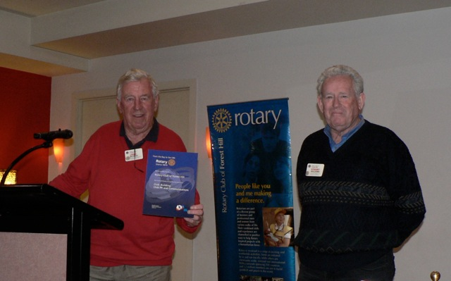

Who can tell us what is happening here?

Meeting report June 26
Sergeant Stuart opened the meeting with a brief reflection and President John continued and welcomed Sue Ballard, and reminded us that Changeover Night was next Monday. Mike announced that potential Ebay sales were on the go with a Fowlers Vacola bottling kit being currently available.
As the guest speaker had not arrived, Stuart, having recently returned from the Atlanta International Convention, told us a little about his travel experiences in Colorado, where he experienced 6” of snow which is very late in the season.
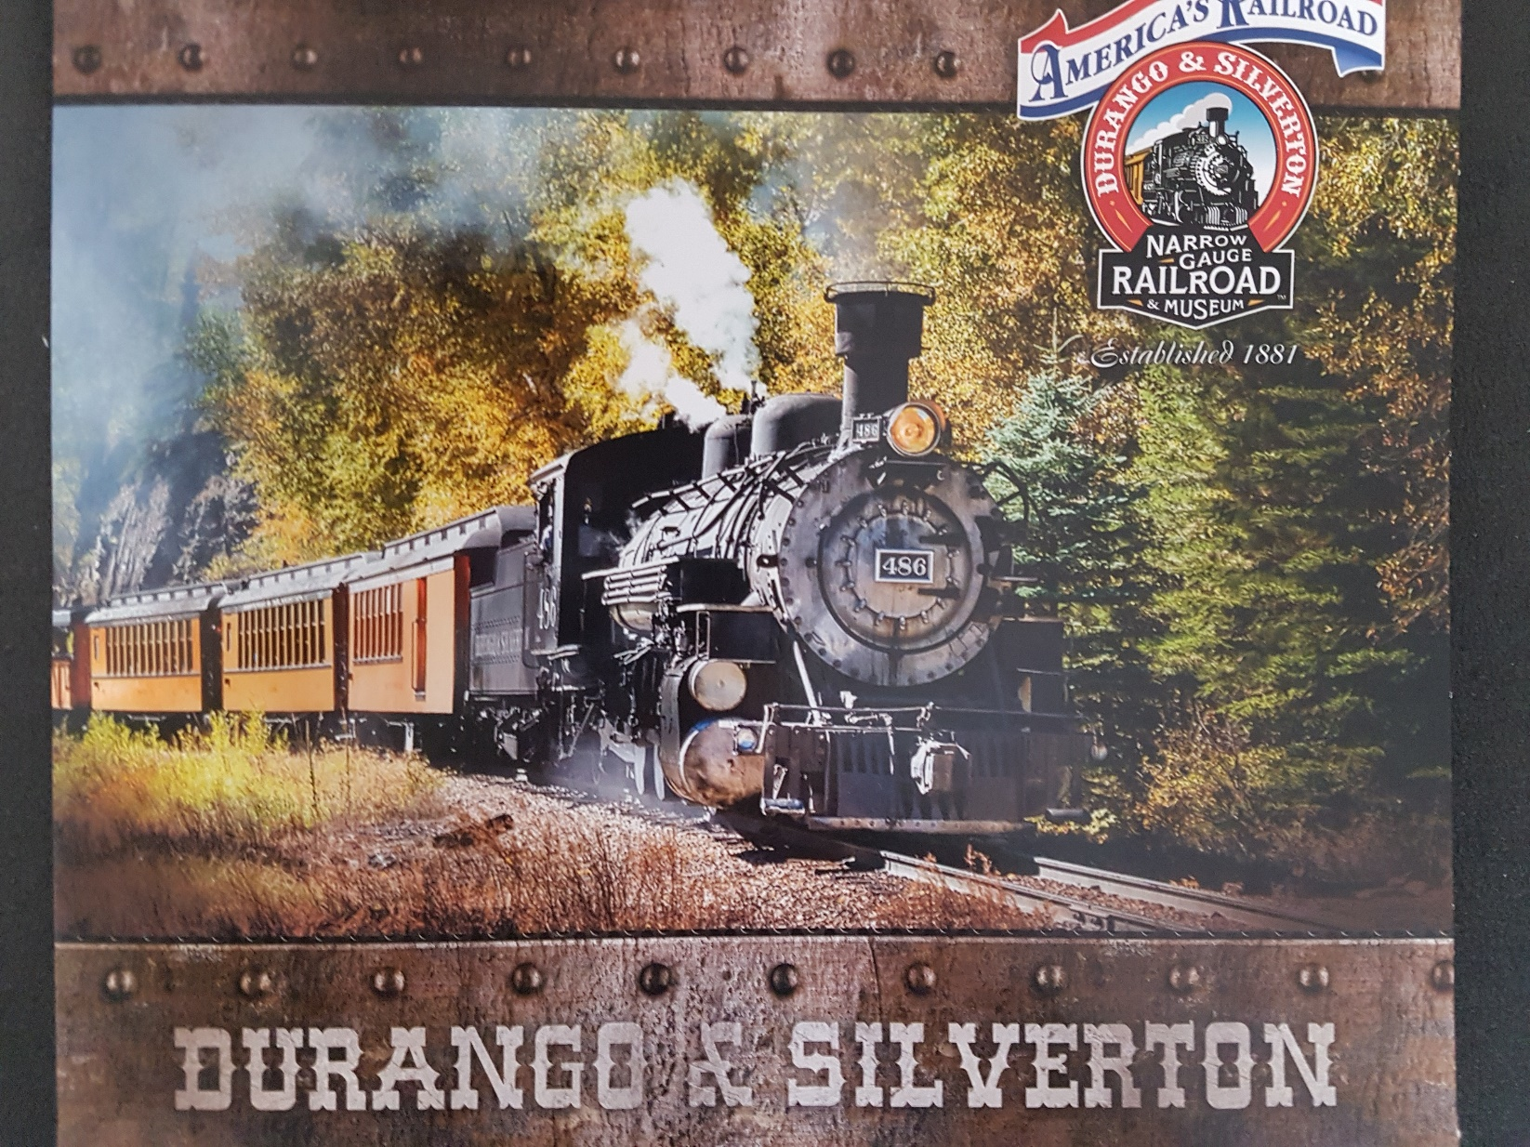

(With apologies for spelling) he went on the Durango-Silverton Railway which is 7 hours from Denver and was built in 11 months, the latter being a ski resort. USA has 42 mountains over 14000 feet (compared with our highest at 7238 (or thereabouts). He saw the Great Sand Dunes which are in a rain shadow in the Rockies. He went up Pykes Peak which is 14000’ with its road going right to the top –- all vehicles coming down are stopped about half way to check the temperature of the brakes which at that stage must not be higher than 300 degrees. He also went to Vale one of the flashiest snow villages.
North of Denver is flat iron country where Boulder is a University town. The winds can be very severe in Denver, whilst on the plains they are on the edge of the tornado belt. (So it appears that the rain in Spain falls mainly on the plain).
He also went to an Animal Rescue Service where there is an elevated walkway, underneath which are lions, tigers, bears and others, many of which have come from people who have acquired these as pets when small but when they grew the owners realised they were not able to be kept in private homes, surprisingly!
He also went to the Denver Botanical Gardens where both garden-type plants and exotic ones were grown, and he went to a display of historical places of cowboys and Indian films.
Martine won the raffle (which brought in $50) whilst the sergeant raised $29.75.

Warwick

Additional info from Stuart
One Colorado landmark I did not get to mention is -Red Rocks Amphitheatre, an iconic concert venue that is 10 miles west of Denver. It is the world's only naturally occurring acoustically perfect amphitheatre. It can seat 9,500 people. Some of the great acts that have played Red Rocks. Moody Blues, Stevie Nicks, Santana, Jimi Hendrix, The Beatles (1964), Jethro Tull, Bruce Springsteen, U2, James Taylor, Judy Collins, The Eagles, The Carpenters, Sonny and Cher. The day we were there Celtic Woman were doing sound checks for their evening concert.

Amazing sights: Durango to Silverton narrow gauge railway (a few scenes from "Butch Cassidy and the Sundance Kid" were filmed using the train. Historic Strater Hotel-Durango.
Pikes Peak, Mt Evans, Colorado Springs, Vail, Aspen, Boulder, Estes Park, Denver Art Gallery, Denver Botanical Gardens. The Great Sand Dunes National Park. San Luis Valley. The Rio Grande, Mesa Verde -- with over 600 cliff dwellers (and a smaller version near Colorado Springs)
Denver Airport -United Airlines hub through there. Their "sails roof" was designed by an Australian.
I visited two Rotary Clubs. Rotary Club of Smoky Hill, and Rotary Club of Littleton.
Marijuana has been legalised in Colorado--along Broadway there were many, many shops offering it.

Sergeant Reflection 26 June 2017
Travelling around the Kimberley earlier this month I noticed a blind aboriginal woman in Katherine that reminded me of incoming Rotary International President Ian Riseley’s desire to have a trachoma free Australia by 2020. Whilst visiting several Indigenous cultural areas I chatted to locals about Rotary’s plan to help which was well received.
Trachoma is an infectious eye disease that can be prevented by good hygiene practices. Australia is the only developed country in the world with trachoma which is shameful.
There has been a coordinated effort since 2009 to eradicate the incidence of this disease with antibiotics and surgery and it has dropped from affecting 21% of our indigenous population in 2009 to 5% in 2015. But, as we have experienced in our eradicating polio from the world campaign, there is still a lot of work to be done to have a zero result.
To stop trachoma transmission and to keep trachoma from bouncing back again, we must ensure that all children in affected areas are able to keep their faces clean and have safe and functional washing facilities.
I spoke to District Governor Elect Russell Gurney at the District Governor’s changeover dinner Saturday night and his company is donating soap to our indigenous communities.
Some of the projects clubs can support include:
Funding a communal washing machine or facilities
Subsidising hygiene kits of towels, soaps and toothbrushes and
Sponsoring the operations of remote swimming pools to keep kids clean and active
I’m sure our District will be urging all 9810 clubs to assist in some way or another and I know our club will get behind the push to finally eradicate this awful disease from our indigenous neighbours.
Bob

Report from Mitcham Community House
Facilitated Playgroup - Tuesdays
We have a diverse group of grandparents and parents participating in our Facilitated Playgroup on Tuesdays. The Playgroup has been so well attended we are now running a second group on Wednesdays. These groups are facilitated by an Early Childhood Educator and a great way to meet other local families. They are friendly, social and welcoming. The fun filled session can include singing, story time, movement/drama and a simple art/craft activity (time permitting). Following the structured session, the Grandparents and Parents are free to socialise in a safe environment.
Thank you to Forest Hill and Mitcham Rotary Clubs for giving us a grant.

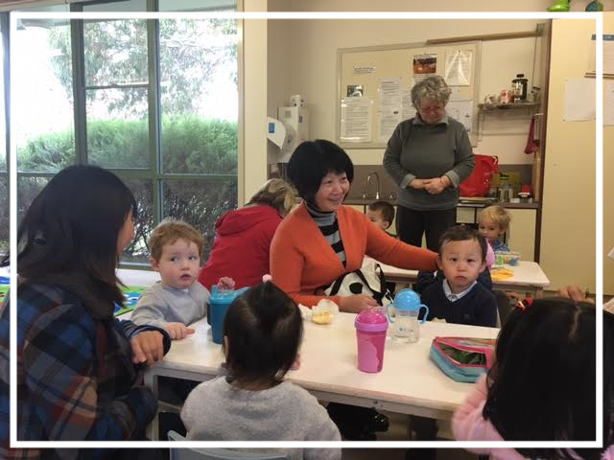
The above photos show the Facilitated Playgroup in action.

The contribution from Forest Hill Rotary Club has been acknowledged on our Facebook page, website and as a news bulletin to all our participants.

Please pass on the photos to John McPhee and the other Forest Hill Rotary Club members.

Kind regards

Anne Kean
Fundraising
e-bay
This is a permanent link to RCFH's e-bay page: Please use it

http://r.ebay.com/MJM4fV

Complete Fowler’s Vacola kit now available.

RCFH Roles in 2017-18
President Bill Marsh Board Member
President Elect/Vice President Mike Finke Board Member
Immediate Past President John McPhee Board Member
Secretary Bob Laslett Board Member
Treasurer Warwick Stott Board Member
Youth Service Glenys Grant Board Member
Foundation & International Stuart Williams Board Member
Community & Vocational Martine Macleod-Craig Board Member
Program Ron Brooks Board Member
Membership Warwick Stott Fundraising Mike Finke
Sergeant Stuart Williams Newsletter Editor Bob Laslett
Web Page Ron Brooks Whitehorse Farmers’ Market Warwick Stott
Facebook Mike Finke, Stuart Williams/Ron Brooks
Blackburn Market John McPhee Attendance/Meals/Bucatini Ray Smith
Club Protection Officer Martine Macleod -Craig
DIARY DATES
July 8 Blackburn Market
July 9 Whitehorse Farmer’s Market
ROTARY MONTHLY THEMES
July Rotary Awareness
August Membership Extension
ARTICLES
Newsletter articles to rlaslett76@gmail.com.au by 5 pm Wednesday please.

