|  |  |  |
| --- | --- | --- |
| |  |  | | --- | --- | |  | 2019-20 Theme logo - Rotary Connects the World |   **FOREST HILL HAPPENINGS**  No 1 President: Stuart Williams 3 July 2019 |

**CHANGEOVER – A NEW BEGINNING**

This week our club gathered to welcome in our new President (Well actually slightly recycled as this is Stuart’s third time as President!)

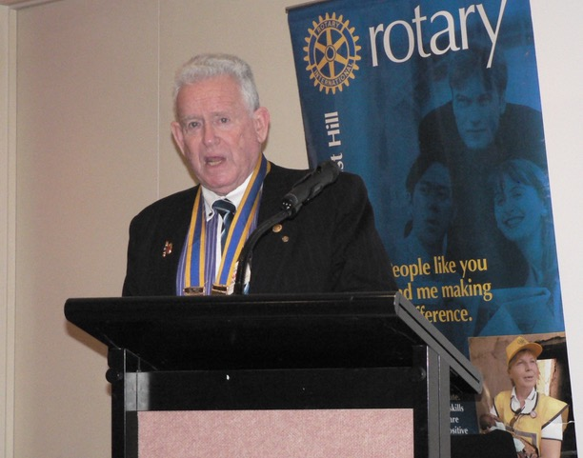

It was a night of celebration – first to celebrate the terrific year we had just had being led by Mike Finke and then to celebrate the great year that Stuart has planned for the club.

Some words of wisdom from the President:-

Thanks to PP Mike.

Our New York import has been a breath of fresh air to our Rotary Club. Some of us are not happy that he managed to pick 7 winners in the Footy Tipping this week…. HOW!!!!

Mike has single- handedly dragged our club into a new technological future. Thanks Mike—tap payments for BBQed sausages, social media selling for fund-raising, much more awareness of social media.

A man of many skills and interests, we have thoroughly enjoyed your culinary talents and appreciated you and Kira opening up your home for relaxed meetings at the start of the year.

You provided many thoughtful reflections as we started our meetings. We have appreciated your quiet leadership style. You have battled on through health issues and we appreciate you being here tonight so soon after hip surgery.

You have left me with a stronger club and one more inclined to face a different future.

Well done Mike.

We have a wonderful Rotary Club. Diverse souls who have been drawn together because WE want to give back to the community and society that has supported and encouraged us. Rotary connects the world.

Thank you all for the opportunity to once again lead this club.

We are a small club, a boutique Rotary club – but a friendly, effective club. Think about this. If you think you are too small to make a difference, try sleeping in a room with a mosquito.

Over the years we have realized our limitations. We might not be able to do great things, but we can do small things with love and professionalism. We have been generous supporters of End Polio Now – an enormous world-wide effort that will benefit mankind. On a smaller scale, in the youth area, we have made significant, positive impact on the lives of many young people.

My goals for the year are modest:

* Consolidate and grow our club.
* Have fun while making a difference.
* Make a positive, visible contribution to our local community - maybe with a street library, and certainly with Mike’s photo competition.
* Tackle an international project and have our newest member, Ian, guide us with his vocational expertise.
* Make a further positive contribution to the wonderful Hope Katolo Nursery School in Kenya.
* Continue as a champion of young people in their quest to make the world a better place.
* Explore ways of doing Rotary a little differently.

The reality is, this club is made up of people who are involved in many, many other organisations. We don’t need a huge social program because most of us spend many hours together each month “ doing” Rotary. Commitment doesn’t have to interfere with a busy life. I want to encourage individuals to champion an idea and then promote and develop that idea. In that way our Rotary lives will be more engaging and more fun. Life is an opportunity – benefit from it.

Let me end by quoting my favourite Rotary quote… the one by Past RI President, Australian, Clem Renouf.

“Rotary takes ordinary people and gives them extra-ordinary opportunities to do more with their lives than they ever dreamed possible. “

May it continue to do so.

I apologize for not publicly thanking all those people who helped make Monday night so successful.

Firstly to Bob and Barbara Williams.  Barb helped with plant selection, wrapping gifts, was there early to set up, made a presentation,  made a card for Dot Rogers and was a great  positive support.  My mate Bob must have put hours into seeking out embarrassing things to put into the video.  The video was fabulous and I thank him for all the work involved, at home and on the night.

Ray Smith, so thorough and so good.  Thanks Ray for managing numbers, communicating numbers and for setting up, producing the photo album and USB chronicling Mike’s year.  We truly appreciate your energy and continued enthusiasm.

Bill Marsh.  Bill worked hard behind the scenes with the Annual Report, organizing the meeting, stepping up when Bob  and Judy fell ill and chairing the meeting.  There is not much chance to relax and enjoy as chair.

Mike Finke.  Not many out-going presidents would have had a hip replaced 3 weeks before Changeover.  Mike stayed in touch, kept an eye on things, inquired as to what was organized, and was organized on the night to do his bit.  Thanks Mike.

Ron Brooks was happy to be involved and thanks for reading Carmina's letter and conductingthe **Hard Quiz**. (I think you have missed your chance to win a Logie though.)

I am sure to have missed others.  Sue was involved, thanks Sue. Buaban did lots of work and many others did little things as requested.  A small club has to just get on with stuff and we usually do that.

Thanks to Heather Neilson for coming out and supporting us, thanks to the partners who also came along on such a big night.  A special mention to Pam and Peter Davis.  The Davis family support for, and interest in, our Rotary Club is very much appreciated.  Actually, I think our club is also their Rotary club.

A great finish to the year and a wonderful start to a new Rotary year.

Stuart Williams

**OPENING REFLECTION**

First let me say it’s wonderful to see so many excellent people here. It’s not the first ceremony for our new DG, but it’s the first of the Rotary year, so I’m going to count that as something special. We’ve also got our AG here, and plenty of partners. And most of us put some kind of effort into dressing up. And I’m standing more or less vertically. So a good night all around, so far.

Tonight’s ceremony is called a changeover. Which is a weird word to use, really, because it seems to imply no continuity at all, and that’s just not true. You change a light globe when it blows out. And I’d like to think I went out a little bit better than that.

Tonight is a night for a lot of words that start with the prefix ‘re’. It’s a night to refresh our club and our commitment to Rotary. I see some of you are enjoying some refreshments right now. It’s a chance to renew our goals under new leadership. It’s an opportunity to rethink some of what we’ve been doing and for our incoming president to propose some new ideas and projects. And as far as the committees and executive board goes, it’s a time to rebalance them with a judicious combination of replacement and recycling. In a club of this size there’s always going to be at least a bit of recycling, but sometimes a bit of replacement is just the ticket. And I’m speaking from personal, and extremely recent, experience here.

The year has been challenging. I didn’t feel like I had enough information or experience to feel confident in some of my decisions, but I felt supported, even when I made the wrong choices, because I knew I was surrounded by people who did know what they were doing. At this point I think I’ve managed to get more right than not. And there’s still another, what seven or eight weeks of the season? So plenty of time to improve my ranking. I’m referring to the footy tipping, of course. And most of that goes for the Rotary year as well, except of course, that there aren’t any more weeks left. This is it. It’s time to pass the baton.

**ANNUAL REPORT**

I think it’s a record of achievement by our club and by our members. The Blackburn market is back to full strength and is probably better than it has ever been. Our relationships with the schools and training institutions have never been stronger. We’re extending our reach further into the Whitehorse community, linking up with networks like women of Whitehorse and we’re making better, stronger connections with the cluster clubs, with Rotary Action Groups and district project management committees. That is all thanks to the great work of our members both working directly for our club and extending their Rotary commitments outside the club.

And that’s not to take anything away from the success we have in maintaining our existing commitments. This club, at eighteen members, punches above its weight in volunteering. We are dependable. Sausage sizzles, breakfast club, tin rattling: if we say we’re fully rostered, it can be taken as a guarantee. RCFH’s word is its bond, and in a world full of things you cannot rely on that’s a genuinely rare thing. This annual report is a good news story about the quality of this club and its members. It’s your story, and you should be proud of it.

Mike Finke

**MEETING REPORT**

Thirty eight people gathered at Bucatini to celebrate the Rotary Changeover.  Bill Marsh chaired the meeting on a cool night.  President Mike offered a reflection that concentrated on the R word, rather than changeover.  Renew- Refresh- Recycle.  Thoughtful and very appropriate.  Mike then proposed a toast to Australia.

Bill welcomed, DG  Shia Smart, Assistant Governors - Geoff Logie-Smith, Joan Young (so pleased to have her-  Her husband's health has dramatically improved ) and Christina Chia. Melanie Haley- founder of Hope Katolo Nursery School, Kenya, Stuart's children - Dana Roles and Lachlan Williams.  Stuart's Thai friend - Buaban Mungmart, Visiting Rotarian- Stuart Mc Donald (Healesville), Honorary Member Heather Neilson, Partners of club Rotarians, visitor Jafrin, and of course club members.

The raffle, with 8 prizes was promoted.

Our own Assistant Governor PP Bob Williams proposed a thoughtful toast to Rotary.  DG Shia Smart, in her first DG role, responded to the Rotary toast.

President Mike recognized his 2018-19 Board and then spoke to the annual report.  Copies of the Annual report were handed out.

Sue Ballard made a presentation of a lavender plant to Kira Finke.

We enjoyed a delicious Bucatini meal.

Bob Williams then entertained those assembled with a video he had compiled of Stuart's past, in Apex and Rotary.  So well done and a good chance to have a laugh.  Ron Brooks then conducted the --Incoming President interview.  He grilled Stuart and Buaban and then asked 20 questions to Stuart.  Buaban was asked what she believed Stuart would have said.  She got more than half correct.  President Mike then conducted an induction ceremony and handed over the Presidential chain.

President Stuart's first action was to thank Mike for his leadership and present him with a Past President's certificate and a photographic record of his year from Ray Smith.

Another highlight of the night was a congratulatory Power Point presentation.  This consisted of photos of those who had sent messages.  The messages from past GSE participants and Youth Exchange students were moving and powerful.  The exercise demonstrated how Rotary Connects the World.  Our club could be proud of the positive impact we have had on so many young people.

The exchange student during Stuart's first term as President- 1994-95, Carmina sent a wonderful, detailed letter and Ron Brooks read it out.  It brought tears of laughter and tears of love and respect.

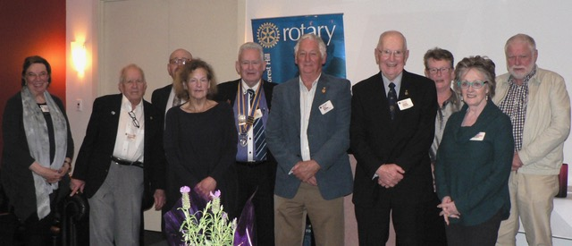

The “Rogues’ Gallery” for 2019-20

The club Board for 2019-20 were called out the front to be recognized.  Barbara Williams made a small presentation to Anne (on behalf of all the Bucatini team) to thank them for the excellent service we receive each week.

Stuart then presented his goals and ideas for the New Year.

The raffle was drawn and 8 prizes handed out.  The raffle raised approx $115...(the usual suspects Glenys and Sue went away with some of the loot.)

Bill announced that we have a film night this Friday night.

The meeting closed with Stuart thanking all those that attended and thanking those who had assisted with planning, preparation and set up.  We closed almost on time.

**COMING UP**

|  |  |  |  |
| --- | --- | --- | --- |
| **Date** | **Event** | **Chair** | **Thanks & Report** |
| 5 July  8 July  15 July  20 July  22 July  29 July  5 Aug**.** | Film Night – Waverley Cinema, Pinewood  Club Meeting  The Truth About Asylum Seekers and Refugees – David Spitteler  Bunnings Bake Sale  District Community Chair – Trish Smyth  Apprenticeship Awards – Indi Hangan  Club Forum | John Bindon  Sue Ballard  Stuart Williams  Stuart Williams | Bob Laslett  Bob Williams  Chris Tuck  Ray Smith |

**CONGRATULATIONS & BEST WISHES**

Congratulations to Ray Smith for his birthday on 7th July and to Mike & Kira for their wedding anniversary on the 9th July.

**DUTY ROSTER**

|  |  |  |
| --- | --- | --- |
| Recorder  Greeter  Emergency  Cashier | **JULY**  Glenys Grant  John Bindon  Bob Williams  Barbara Williams | **AUGUST**  Sue Ballard  Ron Brooks  Mike Finke  Ian Teese |

**ATTENDANCE**

If you are not coming to the meeting or if you wish to bring a guest please contact Ray Smith by 10.00am Monday on 0412 807 585 or [rcssmith@optusnet.com.au](mailto:rcssmith@optusnet.com.au)

Please ensure Ray is aware of any special dietary needs.

If you need to cancel after 10.00am please contact Bucatini Restaurant directly on 9873 0268.

**PHOTO COMPETITION**

The 2019 Whitehorse Photo Contest is already well underway. If you haven’t put in your entry yet it’s not too late – entries close on the 15th July.

Check all of the details on our Facebook page. <https://www.facebook.com/events/2023814937705559/>

Terms and Conditions and the entry form can be found at <https://tinyurl.com/y5yzcdtr>

* Open to Grade 5 & 6 students living in or attending schools in the City of Whitehorse.
* Top prize in the popular vote and expert judged categories is $100.
* Photos must be taken within the City of Whitehorse.
* Finalists in the expert judged category will be on display at the Nunawading Library for the month of August.

More information can be had by emailing [info@whitehorsephotocontest.xyz](mailto:info@whitehorsephotocontest.xyz)

Thanks to our sponsors, Bendigo Bank (Blackburn South) and Officeworks (Vermont South).

**BREAKFAST CLUB**

Breakfasts at Forest Hill College will be back on when the new term starts in a couple of weeks. We are indebted to the members, partners and friends who have kept it going and Bob Laslett would love to have some more volunteers to add to his list and thus share the load.

**ROTARY MONTHLY THEME**

Let’s celebrate “Bring a friend to Rotary” month.

**ARTICLES**

Articles, notices and photos for inclusion in **FOREST HILL HAPPENINGS** to [bjmarsh@bigpond.net.au](mailto:bjmarsh@bigpond.net.au) no later than 10.00am on Wednesday each week.

**WEBSITE**

Keep up-to-date by checking our website at [www.foresthillrotary.com](http://www.foresthillrotary.com)

**FUNERALSERVICE**

A funeral service will be held for past member John Rogers on:

Monday 8 July 2019, at 1pm

Heritage Funerals

733 Boronia Road, wantirna

 (no flowers by request, envelopes for donations to Blue Ribbon appeal, at service)

**CONTACT DETAILS**

Address: PO Box 116, Nunawading, 3131

Email: [foresthillrotary1975@gmail.com](mailto:foresthillrotary1975@gmail.com)

Website: [www.foresthillrotary.com](http://www.foresthillrotary.com)

Facebook: ForestHIll Rotary

Meetings: 6.30pm, Bucatini Restaurant, 454 Whitehorse Road, Mitcham, 3132 (Melways 48H9)