|  |  |  |  |
| --- | --- | --- | --- |
| 2CDFD0D0 | | Weekly Newsletter  [foresthillrotary1975@gmail.com](mailto:foresthillrotary1975@gmail.com)  **President Bob Williams** |  |
| Number 27 18th January 2016  Club address: PO Box 116, Nunawading 3131  **Email address:** [**foresthillrotary1975@gmail.com**](mailto:foresthillrotary1975@gmail.com)  **Website:** [**www.foresthillrotary.com**](http://www.foresthillrotary.com)  Meeting location: Bucatini Restaurant, 454 Whitehorse Road, Mitcham, 3132  Meeting time: Monday 6.15 for 6.30 pm  **Facebook: ForestHill Rotary** | | | |
| |  |  |  |  |  | | --- | --- | --- | --- | --- | | **CLUB PROGRAM** | | | | | | **Date** | **Event** | **Chair** | **Thanks/meeting report** |  | |  |  |  |  |  | | **18th Jan**  **25th January**  **1st February**  **8th February** | **Value of gymnasiums**  ***Mike Lycenko***  **No meeting**  **TBA**  **Peter Aldin** | **Ray Smith**  **Mike Finke** | **John McPhee**  **Bill Marsh** |  |   CELEBRATIONS Nil   DUTY ROSTER  |  |  |  | | --- | --- | --- | |  | **January** | **February** | | Cashier | Bill Marsh | Chris Tuck | | Recorder | Stuart Williams | Ron Brooks | | Greeter | Ron Brooks | Stuart Williams | | Emergency | Glenys Grant | Mike Finke |  ATTENDANCE  |  | | --- | | **APOLOGY** – **IF A MEMBER IS NOT GOING TO COME TO THE MEETING or you intend bringing a guest please contact Ray Smith by** **10.00 am MONDAY** on9878 4891 or[rcssmith@optusnet.com.au](mailto:rcssmith@optusnet.com.au%20)  SPECIAL DIETARY NEEDS to Ray by 10am at the LATEST  Any CANCELLATION AFTER 10.00 AM should be made direct with the management of Bucatini Restaurant on 9873 0268 | | | | |
| **BOB’S BANTER**  We had a great time at Kathy and John Donaghey’s Ocean Grove home last Sunday and hope it wasn’t too much work for Kathy (oh yes and for John).  Everyone brought various food groups as arranged with Kathy and the chat and good times flowed all day. We went for a walk to the beach which is very close to their home and Kathy said that at this time of the year they tend to walk everywhere as getting a car park at the shops etc is impossible with so many holiday makers.  Warwick arrived looking like he had been in a boxing bout with Jeff Fenech (and lost badly) with his injuries to his face and legs and has learned that falling onto concrete is not a good idea.  Barbara totted up 21 of us, Kathy and John D, Judy and Bob, Judy and Bill, Marg and John Mc, Chris and Warwick, Kira and Mike, Stuart, Barbara and Bob, Glenys and Roger and mates Pam, Judy A, Anna and Hans.  Stuart invited Joan to come with him but she didn’t feel up to it at this difficult time for her and her family. You were in our thoughts Joan.  Various photos taken and I’ve put a few from Stuart in this edition including one below of us singing Happy Birthday to Kathy. (Your 49th birthday Kathy?)  A huge **THANK YOU** to Kathy and John for their wonderful hospitality (again) and I hope we didn’t devalue your terrific home too much!  Glenys and Rob have been busy with the sale of Rob’s mum’s home in Tassie and all the work packing up etc but Glenys had time to advise of some good news about “Larry the Lorikeet” that appears later in this edition.  As Ron has entrusted me again with this edition while he and Robbie trot off OS I will publish some news of their trip again later in the newsletter.  Box Hill club has a fund raising night at Peridot with details later on.  Don’t forget to let Stuart know if you can come to the Jazz Club day on the 9th March.  OG3  **Happy Birthday Kathy!**  **Remember “Be a Gift to the World”. President Bob** | | | |

**DIARY DATES**

Thursday 4th February Peridot play

Wed 2nd Mar International Women’s Day (Box Hill Central)

Wed 9th Mar Women in Rotary Forum

Friday 18th to Sunday 20th March District Conference at Shepparton

Sat/Sun 30thApr/1stMay MUNA weekend

28th May/1st June RI Convention SEOUL, KOREA

Sun 19th June Multi District function to farewell Ian Riseley (RI Pres ‘17-’18)

**LAST WEEK’S MEETING**

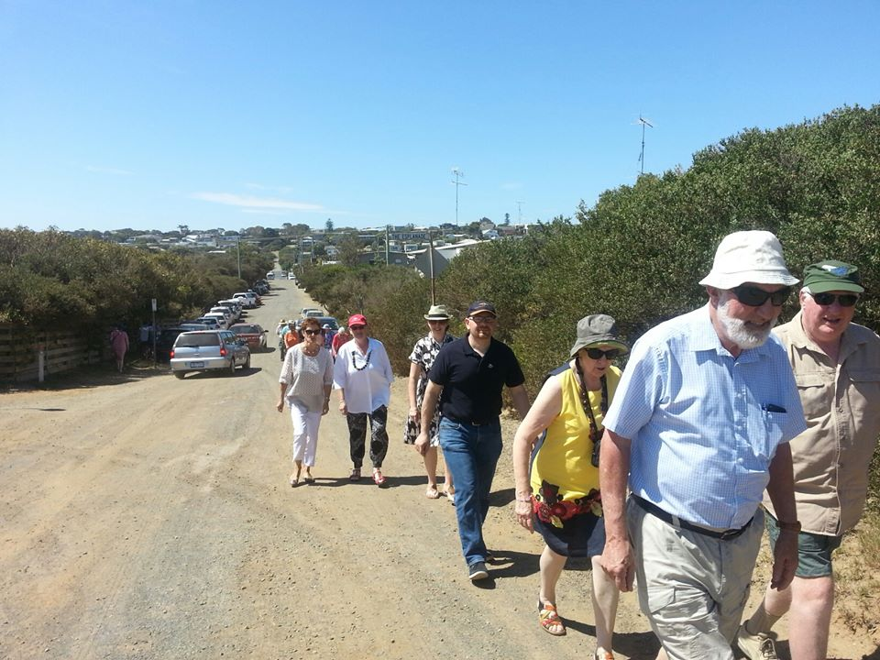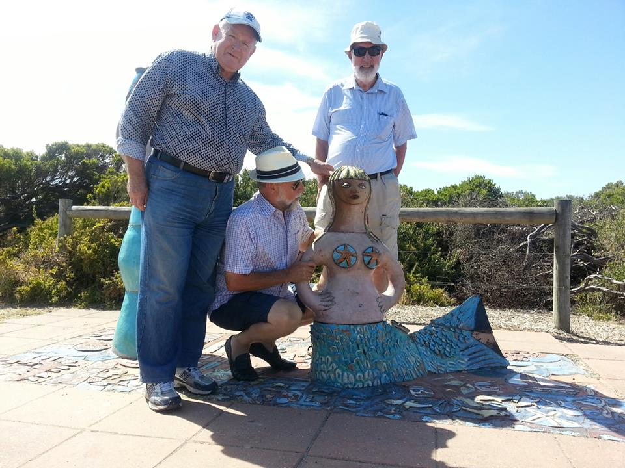

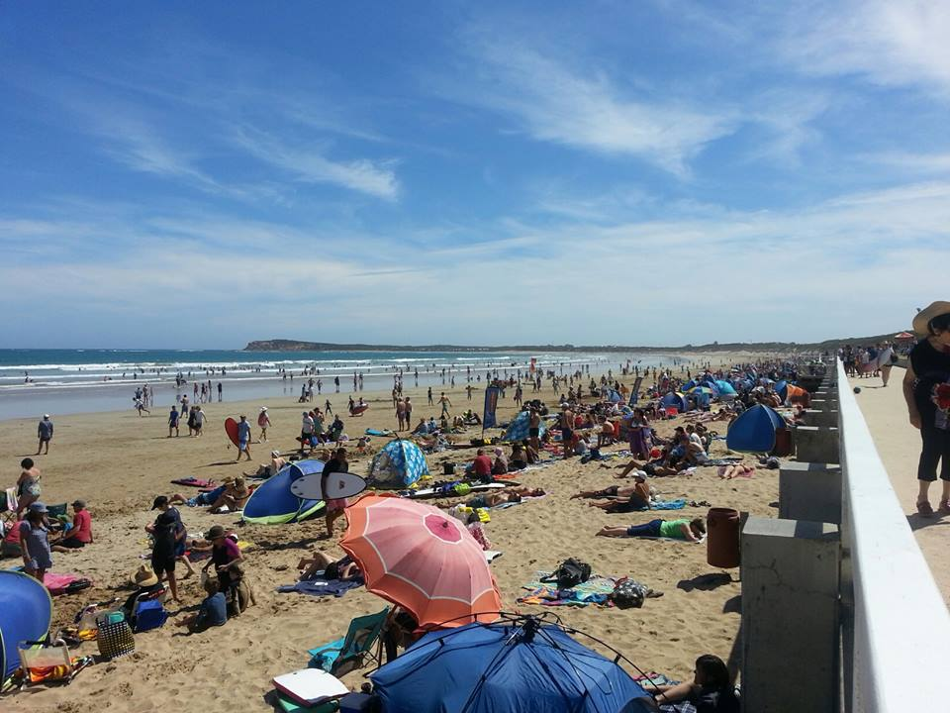

So many at the beach on Sunday.

**SERGEANT’S REFLECTION**

Stuart received his “just desserts” on Sunday

**“LARRY THE LORIKEET” UPDATE**

Hi Glenys.

Thanks for all your efforts with the Education Program throughout the year. I am sure you will be pleased to know that a couple of copies of Larry the Lorikeet are being brailled for use with blind and low vision kids at Vision Australia. Some of these children will be visiting us during the year and it will be good that they will be able to use these books as an introduction to the Sanctuary.

A recent donation of $46 made by a visiting school for the Education Program has also been passed on to the Vision Australia ‘Felix’ Library.

They will assemble a box of tactile objects related to the story that can be used to ‘bring it to life’ for kids who can’t see the illustrations. The kits are borrowed by families all over Victoria and the urban habitat message of ‘Larry the Lorikeet’ and Blackburn Lake Sanctuary will be spread far and wide. I hope all agree that this was an appropriate use of the funds and something the students who collected the donations would be proud of. Could you please let Rotary Forest Hill know that this initiative is a gift that just keeps giving!

All the best for the festive season.

Lucy : )

For the benefit of our newer readers, “Larry the Lorikeet” is a pre/primary school age book we produced and had printed, written and illustrated by local High school students about a lorikeet at Blackburn Lake with the book donated to all the local pre and primary schools and libraries in our area.

**BOWELSCAN**

Our club helps in the free distribution and collection of Bowelscan kits through local pharmacies. This programme has been going for 13 years. Customers can buy a kit for $10 and then return it to the pharmacy where we pick them up and send them off for testing. Results are conveyed back to the customer directly from the test company. This year 2,843 kits were sold and 80% were used [this is considered an excellent result by the organisation]. **We are saving lives**, with 12 persons were detected with having cancer and 41 persons having polyps (likely future cancer) removed, during the 10 years 2006 to 2015 (27 men and 26 women). There were 31 positives this year [not every positive results from a cancer or polyp. Yet another programme that Rotary does which neither raises money nor costs money but does a great deal of good in the community. This programme is widely advertised, taking place in May each year. Customers always start asking to buy a kit before the kits get to the pharmacies.

*by Ron Brooks*

**HOPE KATOLO NURSERY SCHOOL IN KENYA - UPDATE**

Chris has received an email from Melanie and Leanne regarding them seeking funds for a water tank for their vegie garden at the nursery school which we will consider.

**FELLOWSHIP NEWS.**

**

We thought we would make this our Peridot evening so if you want to go please let Bob W know ASAP. Bob will pass around a folder for names at our 18th Jan meeting so please put your name down then and if not attending the meeting but want to go to Peridot on the 4th Feb please let Bob know by the 18th January. We’ll sort out a movie night maybe for the following Friday night.

Kathy and John.

**FOREST HILL WEBSITE**

**Our website is a window through which the world looks at us**.

Have a look at the website.

* Do you like what you see?
* Do you want other things on our site?
* Tell me what you want to see there.
* Give me some ideas,
* Send me a story to put on,
* Email me some photos,
* Give me some feedback,
* Tell me what is missing.

[**www.foresthillrotary.com**](http://www.foresthillrotary.com)

*by Ron Brooks*

**TELL US ABOUT YOUR LATEST HOLIDAY?**

Only 3 days left. Everything has been very cheap, friendly, and different. Highly recommend the place. One day of rain and it was still warm. Seen lots of different animals close up. Cape Town has been superb. Amazing ostrich steaks which seem indistinguishable from fillet steak, just larger.   
Went down to Cape of Good Hope yesterday, Saturday, loads of cyclists out on the coast road which is more spectacular than the great ocean road.

**Ron and Robbie**

**So let’s hear from you. Tell us where you are going and tell us how the holiday went when you come back…… then give Ron your foreign coins when you return !! EASY.**

**DAYS FOR GIRLS**

Days for Girls is a grass roots charity that has a network of Teams and Chapters around the world that makes and raise funds to provide sanitary hygiene kits. (You may remember the talk on providing toilets for school children at the annual conference in which one added benefit was that if teenage girls have a toilet to go to they don’t miss one week a month). Over 100,000 kits have been given out in over 75 countries. These kits are washable and reusable lasting up to three years.

How can you help?

* you can sew
* you can do non sewing tasks,
* you can donate fabric,
* you can contact [margaretdccunningham@gmail.com](mailto:margaretdccunningham@gmail.com)
* you can visit [www.daysforgirls.org](http://www.daysforgirls.org)

Connie Millott has been in touch with Robbie to say she wants to help. If there are any of you others interested in helping please contact Robbie.

*By Ron Brooks*

**DISTRICT REQUEST**

A message from District |Governor |David Tolstrup,

RE: Social Media Workshop --- We need your Feed Back please

Greetings everyone and Happy New Year,

We need your help and advice please.

At the November President’s Meeting / AGM, I announced that our District would be hosting a Social Media workshop during the first half of 2016.

We have had a number of enquiries about this since then, and I seek your input into our planning as follows:

1. Does your Club see value in a member (or members) attending such a workshop?
2. If yes, then at what level would you like this workshop conducted:
   1. Social Media 101 – that is, basic Facebook and Twitter.
   2. Social Media “Master Class” – that is, taking what you may have to the next level. Tips, tricks and traps +++
   3. Or both, sequentially, or anything in between. Please advise …..
3. How do you see the workshop being conducted? Previously these have been instructive with interactivity and questions as time permits.
4. Do you have any specific areas or questions that you would like covered? Please advise these too …..
5. Timing. This will be confirmed once we receive your feedback, but at this stage, the second Friday in April, and potentially the second Friday in May, look like good options. How would this suit?

Based on your feedback, we do our best to structure a workshop (or workshop), or maybe an alternative support model, with the resources available to us.

Can I ask that your Club responds back by email to our District’s Social Media Advocate and Coordinator, Russell Gurney, **by the end of January** so we can formulate a plan and come back to you with timing. Russell’s email is [rjgurney9810@gmail.com](mailto:rjgurney9810@gmail.com).

**Please let me know your response as I will coordinate for the club. Pres/Ed Bob**

**Stuart’s recent Thailand trip**

**The village went to a wedding**

I was fortunate on my last Thailand trip, in December 2015, to attend an Isan culture, Buddhist wedding. I was in Khon Kaen, a Nth East Thailand city , approx. 200,000 people. It is in an area that many years ago was part of Cambodia. A rice and sugar cane growing area. I flew the delightful “Smile Airways” , a subsidiary of Thai International.

My friend, a rural hairdresser, in the Mahasarakhan province, was going to the wedding of one of the local men. Her brother, and his family graciously invited me. I had my hair cut to look smart and joined in the pre wedding activities. The “Buck’s night” was replaced by a meal for all friends in the village, some drinks and some preparation of the groom by the monk. The groom sat in front of the monk for many hours, he was joined by his “page boys” and eventually all were connected by a woollen thread to the monk. We placed some baht (money) in a bowl. I was intrigued to see men eating and drinking only 50 cm away from a water buffalo that was in its pen, undercover, beside the home. It is prestigious to own a buffalo, they are expensive to upkeep but they can plough some fields that the small Kubota tractor can not do.

The wedding was at 9am, right across the opposite side of Khon Kaen, a trip of approximately 80 km. We started to fill the Toyota Commuter 14 seat bus at 7am. The mother of the groom was very late, then she forgot bowls. We drove around the village, more people got inside. We also saw off a big old bus, multi-coloured as is the Thai way. There were probably 35 people on the old bus. We headed off into KK and picked up 5 people at a “gated community”. This was a well off area, luxury cars and very nice homes. Our 14 seat bus now had about 20 squeezed on board. Some Thai people are not huge but it was squeezy. One woman had to sit on my knee (drat). She was a singer and soon the karaoke was in full swing. A coloured Video screen, images, words and the bus all joining in Thai love songs. No one asked me to sing a Kenny Rogers song.

We drove for an hour and arrived in another sugar cane growing area (it was harvesting time all around KK). We got out, assembled, and walked down the concrete road to the bride’s home. A couple of small palm trees were presented to the groom. As we got near the home we burst into song. In the long driveway were canvas canopies. My friend said, “You go in there and get some photos, I’ll be over here”. She went and joined 50 people already hoeing into the food and drink. Twenty people were in “the lounge room” where the wedding was about to be performed. The monk was there with a big microphone, the bride squatting cross-legged on the floor, soon joined by the groom. A few family watched on. I took some photos and went out to join those eating and drinking. We had our own table and gradually it was groaning under the weight of many dishes and bottles of soft drink and beer. I was given a lesson in how to eat Isan style. Using fingers, make a small ball of sticky rice, then add to it, some vegetable or meat. I did not ask what I was eating. A large open air kitchen was churning out minced beef, cooked vegetables etc. I kept right away from the “spicy” dishes. Some of them, very spicy. The locals love “spicy”. We experienced the wedding, because there was a massive bank of speakers (like a David Bowie concert) in the driveway. The residents of villages 5 km away I am sure enjoyed the flat tones of the monk.

After an hour or so, eating completed, we moved into the house to great the husband and his new wife. They were still sitting on the floor and one by one we moved toward the bride, were given a wool tie and tied that onto her right wrist. In our tie were 100 baht notes. They were popped into a bowl in front of her. The new husband’s first task was to hold his wife’s left hand. They squatted there for over an hour. We were all given a large gift after tying on the wool. Mine was a pillow and a large piece of material, and 2 small candles. The women got a towel instead of material. We headed toward our bus, but alas, were unable to leave because many of the guests wanted to keep celebrating. My first experience of, “Time Thai.” Just like Pacific island time.

A motor-bike “Mr Whippy” made a killing when he turned up, music playing and sold us ice-creams. I bought 10 ice-creams, in bread buns, with 5 scoops of ice-cream each, and topping for less than $4. At about 12.30 we headed off. The groom’s mum insisted we go to a Cobra snake show on the way. All out, but no-one actually went to watch the crazy guys taunt and play with the spectacular and fast moving cobras. We still do not know why she insisted on going there. The long trip home was more subdued than the trip there. It was a delightful and very different experience.

I was privileged to be involved in such an event. The bride and groom did not head off on a honeymoon but to a few days of religious classes conducted by monks to educate them about marriage.

Stuart Williams.

**STAMPS**

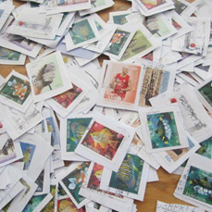Even if you only get a few stamps a week, collect them and give them to me. It’s a no cost project. Just cut around the stamp by about 1 cm and pop it in a spare used envelope and bring them along to me on club night. I collected some from Joan Harper during the week. Thanks Joan.

To date, this Rotary project has collected stamps that have been sold for **$93,212.**

This year the money raised from the stamps will go to **ROMAC**.

**Rotary Oceania Medical Aid for Children**.

*Ron Brooks*

**ROTARY MONTHLY THEMES**

January Vocational Service

February Peace and Conflict Prevention/Resolution

March Water and Sanitation

April Maternal and Child Health

May Youth Services

June Rotary Fellowships

**CLUB OFFICERS & COMMITTEES**

|  |  |
| --- | --- |
|  | **2015-16** |
| **PPresident** | BBob Williams |
| **VVice President** | SStuart Williams |
| **SSecretary** | RRon Brooks |
| **TTreasurer** | WWarwick Stott |
| **PPresident Elect** | JJohn McPhee |
| **SSergeant** | SStuart Williams |
| **FFoundation/International** | CChris Tuck |
| Members | JJohn Donaghey, |
| **YYouth Service** | GGlenys Grant |
| Members | RRay Smith, Bill Marsh, Graham Sharman |
| **CCommunity & Vocation** | BBob Laslett |
| Members | SStuart Williams, Gary Baltissen, Ron Brooks |
| **MMembership & Publicity** | JJohn McPhee |
| Members | WWarwick Stott, Bob Williams, |
| **FFellowship** | JJohn Donaghey |
| **PPrimary Schools Speech Night** | BBob Williams |
| **PProgramme** | RRay Smith, Gary Baltissen |
| **BBulletin Editor** | RRon Brooks |
| **WWeb page & Facebook** | RRon Brooks |
| **OOn to Conference** | SStuart Williams |
| **HHistorian** |  |
| **AAlmoner** | GGraham Sharman |
| **PPublic Officer** | BBill Marsh |

Newsletter articles to the editor at [ronbrooks1942@gmail.com](mailto:ronbrooks1942@gmail.com) by 5 pm Wed Please email me or ring if you want to be removed from the circulation list.