### 

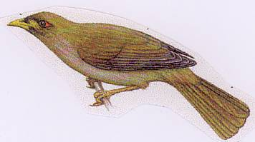

|  |  |  |
| --- | --- | --- |
|  | 2014-2015  Weekly Bulletin  Rotary Club of Forest Hill |  |
| Number 8: 25th Aug 2014  Club address: PO Box 116, Nunawading 3131  **Website:** [**www.foresthillrotary.com**](http://www.foresthillrotary.com)  Meeting location: Bucatini Restaurant, 454 Whitehorse Road, Mitcham, 3132  Meeting time: Monday 6.15 for 6.30 pm  **Facebook: ForestHill Rotary** | | |

|  |  |  |  |  |  |  |  |  |  |  |  |  |  |  |  |  |  |  |  |  |  |  |  |  |  |  |  |  |  |  |  |
| --- | --- | --- | --- | --- | --- | --- | --- | --- | --- | --- | --- | --- | --- | --- | --- | --- | --- | --- | --- | --- | --- | --- | --- | --- | --- | --- | --- | --- | --- | --- | --- |
| |  |  |  |  |  | | --- | --- | --- | --- | --- | | **CLUB PROGRAM** | | | | | | **Date**  **25th Aug** | **Event**  **Primary Schools speech contest** | **Chair** | **Thanks/meeting report** |  | | **1st Sept**  **8th Sept**  **15th Sept** | **Tai Chi - Maree Chadwick**  **Welfare at Forest Hill College - Marianne McEwan**  **DG Visit and Club Birthday – DG Tony Monley** | **Ray Smith**  **Ron Brooks**  **Pres Bill Marsh** | **Warwick Stott**  **John McPhee**  **PE Bob Williams** |  |  THIS WEEK'S CELEBRATIONS Aug 24th John&Kathy Donaghey Wedding anniversary DUTY ROSTER  |  |  |  | | --- | --- | --- | |  | **August** | **Sept** | | Cashier | Ron Brooks | John McPhee | | Recorder | Chris Tuck | Stuart Williams | | Greeter | Stuart Williams | Doug Berwick | | Emergency | Ray Smith | Bob Williams |  ATTENDANCE  |  | | --- | | **APOLOGY** – **IF A MEMBER IS NOT GOING TO COME TO THE MEETING or you intend bringing a guest**  **Please contact Ray Smith by** **10.00 am MONDAY** on9878 4891 or[rcssmith@optusnet.com.au](mailto:rcssmith@optusnet.com.au%20)  Any cancellation after 10.00 am should be made direct with the management of Bucatini Restaurant on 9873 0268 | |

Chris Tuck will be absent from 23rd Aug to 25th Sept

Doug Berwick will be absent from 21st Aug to 12th Sept

**BILL’S** **BLURB**

Wow! What a great week and next week promises to be even better! I said this last week and how true it was - we have had a fantastic week in Rotary. However, next week will be another big one for us.

' Larry the Lorikeet' was well and truly launched on Monday night. The Whitehorse library was full to overflowing with almost 90 Rotarians, partners, guests and, of course, the authors, illustrator and their families and friends. This has been a great collaborative project involving the Rotary Club of Forest Hill, two secondary schools, Whitehorse Council, Blackburn Lake Sanctuary and a local author/illustrator. Congratulations to Glenys and her Youth Service team on a tremendous project. We ran out of copies of the book and are currently negotiating for a re-print of 50 copies. A very positive spin-off from this project has been the strengthening of the relationship between our club and the two schools, in particular with Forest Hill College. They are already looking at other programs in which their students can be involved. It was nice to welcome Neil Angus, the local state member of parliament.

Following the book launch we made our way back to Bucatini's for our regular meeting where almost 30 members, partners, Honorary Rotarians and guests enjoyed a wonderful evening of fellowship and listened intently to three guest speakers from Best Chance Child and Family Care. It was a pleasure to have Paul Mee, Assistant Governor, with us at both the launch and the meeting. A surprise, but very welcome, guest was Victor Sullivan who was attending his first Rotary meeting to see what Rotary was all about. We hope that Victor may join us again at Parkmore PS on Monday night for a further introduction. We will be joined on the night by Michael Sukkar, the local federal member of parliament.

Thanks to Ron for organising an enjoyable night out at the Peridot Theatre on Friday. 16 of us braved the cold and enjoyed a very different production to the usual Peridot show.

Welcome back to John McPhee who will relieve Glenys of the organisation of the Primary School Speech Night. I know that Glenys has almost everything in place and the hand over will be straight forward. We should have an entertaining night on Monday at the Parkmore Primary School when we will be amazed, yet again, at the talent in our local schools.

Tomorrow night 5 members will be attending the District Foundation Seminar at the Dorset Gardens Hotel. While on the 29th August around 8 members and partners will venture into the wilds of Gippsland to visit the Davis family farm and vintage tractor/car collection.

Bob Laslett will be attending the District Vocational Seminar on Sunday from 9.00 am to noon and I know he would love to have some other members there for company and to learn what is going on around the District. If you are available to attend please contact Bob.

We had a visit from a potential new member Dr Victor Chirop Sullivan. He first qualified as an architect, then later qualified in medicine and specialised in neuropsychiatry. We look forward to welcoming him back soon.

**Little Known Fact**: Under the provisions of the 1912 Scottish Protection of Animals Act, the Loch Ness monster is a protected species.

**Enjoy your week in Rotary and keep working to "Light Up Rotary"**

Pres Bill

# LAST WEEK’S MEETING

With a real buzz, the meeting had many visitors including John Bindon, Assistant Governor Paul Mee, Guest Speakers Kevin Feeney, Chris Thompson and Geraldine Ryan, Visitor Victor Sullivan, Partners and friends of the club with Heather Bremner and Heather Neilson and Merle Smith, Judy Marsh, Barb Williams, Judy Laslett and Kathy Donaghey, chaired by Glenys Grant

President Bill reported:

* Thanked Glenys for her untiring work on Larry the Lorikeet project and for everyone’s contribution to the night – great effort.
* The Cluster Group has 4 clubs who will join in Hand Brake Turn and waiting on the other 2 for potential support.
* Club has made its donation to Polio Eradication Program of $1,000.
* Community Connections – our new Community Newsletter - has been completed and it had its first distribution this evening at the Larry Launch in the bags. It is hoped to have this sponsored to go to over 9,500 homes in the Vermont, Vermont South and Forest Hill areas.
* Bill has spoken with Forest Hill College and they are keen to come on board as a member – Great News!

**Announcements:**

**Bob Laslett – Community** advised there is a Community Needs Analysis Seminar on this Sunday. If interested in going, please contact Bob.

**Warwick Stott – Treasurer / Membership** reminded re outstanding fees and encouraged to consider online option - $270.

Also encouraged everyone to complete your Membership Sheet he has provided three times. Please, please!

Warwick also shared that Reg M has been unwell and in Bellbird.

Trying to get Michael Lawlor, Indigenous Health Scholar to speak to the club.

**John McPhee – Primary Schools Speech Contest**

It is welcome back John and into it! John has prepared listing of roles for next Monday evening at Parkmore Primary. He will email to all members. We have names of all students and progressing well.

**Jenny Coburn – Guess Who’s Coming to Dinner and Rotaract**

On 18th October, Jenny is coordinating a Guess Who’s Coming to Dinner for the District to raise funds for Polio. Cost is $40 per person with $20 going to the Polio campaign, $20 goes to the host of the event to cover meal costs, etc. Would be great to have Forest Hill join in the dinner.

**Whitehorse Rotaract**

Jenny reported she went to Whitehorse Rotaract on Wednesday and updated them on what the club is doing and invited them to join us for our events.

**Ray Smith - Leongatha Visit**: Friday, 29th August

Leaving 8.30 – 9am, Farm Tour, lunch at the Davis’ property and return later in afternoon. Anyone who would like to go, please contact Ray. At this time – Glenys, Ron, Stan, Bill, Ray and Norm are going.

**Program:**

Lots of great meetings to come along to – with the 1st September we will have Maree Chadwick on Tai Chi – please invite partners to join us. The following week is our Governors Visit – partners also invited.

**Doug Berwick** - **Marketing**

Thanked Jenny for her contribution in bringing gift bags together for the Larry Launch.

**Sergeant Stu** was certainly on the ball with an amazing $56.90 plus CAN$2 collected! Animals and fun with names for Sharks (Greg Norman), Dogs, Cats, Fish, Lions, Mice, Mosquitos and so many more. Well done Stu.

**And our Guest Speakers: Best Chance**

Kevin Feeney, Chris Thompson and Geraldine Ryan www.bestchance.org.au

Our own Glenys is a Director on the Board of Best Chance, so it was very much our privilege to hear of the amazing services provided by this organisation based in the City of Monash.

Kevin Feeney is the CEO and opened the presentation with an overview which shared that the origins were back to 1895 when the Burwood Boys Home began. The aim is to ensure that children have the best possible start in life with the main focus on the 0 to 5 years age group. It covers the geographic area from Boroondara to Yarra Ranges and Manningham to Dandenong [similar to Rotary District 9810]. The organisation has over 500 staff and a $20m budget.

They have 2 Long Day Care Centres (7.30 am to 6pm) and 61 Kindergartens across that region; Parent & Child Support Services, Emergency Relief, Specialised School for children at risk of being expelled in Primary School where the aim is to change behaviours and work with the child and their family. They are also a Registered Training Organisation offering programs in Children’s Services, Aged Care and Education Support.

Chris Thompson spoke of the range and location of services – including the Parent & Child Support which includes counselling, can be in home. They have an extensive group of volunteers who assist with their programs across the board. Maternal & Child Health and a GP are also available. Their Long Day Care Services are based at Glen Waverley and Noble Park. Interestingly they have in their Emergency Services area, a group known as Sew n Sew who assist with sewing all sorts of items needed – including curtains, blankets and so much more for those in need. The 61 kindergartens have 259 staff and have between 3000 and 4000 children daily. There are also volunteers as there are also children with special needs. Noble Park is a particular service which has a broad range and an integrated service. This is the most disadvantaged area in Australia, so a significant need.

Geraldine Ryan shared the personal story of Clare and her family; as her husband lost his job when she was pregnant, the challenges of the health of her new born and how Best Chance was able and ready to help out Clare and her family with their needs – both supporting emotionally, medically and with how to access financial support.

An excellent presentation which generated lots of questions.

.

Notes by Jenny

**Thank you Jenny for a wonderful report on our meeting. Remember, it is the responsibility of the Thanker to do a write up of the meeting so others who were not there can stay in the loop. (Editor). Report by Wed 5pm.**

# DON HULLAND

Don is not too well. His arthritis is a real problem. He is at present in Kellock Lodge in respite and hoping to be able to stay there full time. The address is 15 Bon St, Alexandria 3714 and his telephone is 0409 530 435. Why don’t you give him a call or write to him.

# WEBSITE

This needs updating as there is nothing about any projects done in the last few years. It makes it look like we have done nothing. Having old stuff is worse than having no stuff. What about Hope Katolo, Hand Brake Turn, Larry, Youth Achievement Awards, Apprentice Awards, I need photos and some short written stories. As from next week, I will be deleting all stuff over three years old.

Do not forget to check out our website, [www.foresthillrotary.com](http://www.foresthillrotary.com) and send Ron Brooks any information and suggestions.

**WEBINARS ABOUT MEMBERSHIP AND CLUB MEETINGS**

Please register for Flexible and Innovative Clubs on Aug 26, 2014 6:00 PM EST at:

**https://attendee.gotowebinar.com/register/3040662381890031617**

Please register for Flexible and Innovative Clubs on Aug 27, 2014 8:00 AM EST at:

**https://attendee.gotowebinar.com/register/716508106027376897**

These two webinars will discuss how Clubs can and need to be Flexible and Innovative. PDG Jessie Harman and PDG Noel Trevaskis will lead this Webinar and will be sharing how some Clubs have gone about being flexible and innovative in their approach to membership, club meetings, diversity etc.

For those not familiar with webinars, depending on which time you want to listen to the discussion, put the appropriate bolded line in your web browser and hit enter. It will take you to a site where you register by putting down your name and email address and you get emailed instructions, with a link that you click on 5 or 10 mins before the webinar starts and the computer does the rest. Generally you can write in questions before and/or during the discussion. It is very simple.

# REASONS FOR JOINING ROTARY

Jenny Coburn gave me a list of reasons, I am putting in a different one every week - **think about them when you talk to prospective members**

**Solving The Need:** When you have identified a need in a community or country overseas, you can bring this to your club and seek the support and help of your club / members.

**WEEKLY RAFFLE.**

The Board has decided to run a weekly raffle, choice of a bottle of wine or a box of chocolates. Tickets 3 for $5. Proceeds will go to our General account to help keep costs down.

**PERIDOT THEATRE VISIT**

There were 16 of us who went to see “House Guest” written by Francis Durbridge (who wrote the Paul Temple series for the BBC). As usual the $22 ticket bought you sherry before the play, complementary cake and biscuits at the interval, and complementary wine, soft drink and sandwiches after the performance when you could mingle with the actors. The play took place in the living room of Robert and Stella in Weybridge between 5pm Wednesday night and 8am Thursday morning. In that time Robert “Sergeant” Clayton did a return trip to London, plus “Major” Crozier, “Inspector” Burford, Philip Henderson (Robert’s double), and was it Vivien Norwood were all killed…….. I think? People were dying left right and centre. It was like an episode of Midsomer Murders. I don’t think it was Peridot’s best performance as quick action like this needed snappier dialogue interplay. I think they do comedy better. But it was a good evening of fellowship. Stan and Joan sat on the front row as usual while the rest of us languished in the back stalls. Patricia Jones joined us once again, she is a regular cinema goer with us as well, great to see her making sure Glenys knew what the plot was about. Perhaps Dorothy in her cameo role came out best without either dying or shooting any body. Somewhere in the mix was a kidnapping offstage of Robert and Stella’s son and an attempt to smuggle drugs(?) out of England in exchange for 24 diamonds being smuggled back in. The sandwiches were excellent – ask Glenys. AND Ask John McPhee about our next Peridot theatre visit, the club goes to all their plays.

**South Sudan Dinner Auction -Saturday 11th October 2014**

The Melbourne Rumbek Primary School Committee, of whom I’m a member, and the RC of Manningham are running a dinner auction at Monte Carlo Receptions, 5 Mitchell Street Doncaster East at 7 pm for 7-30pm on Saturday 11th October 2014. Full buffet dinner at a cost of $70 per person plus drinks at bar prices.

You may remember that Samuel Manhom spoke at our club a couple of years ago now of his experiences as a refugee from South Sudan escaping from the Civil War there and of his desire to build a school in his home town of Rumbek in South Sudan. My link is that when I was at Good Shepherd I employed Samuel as the accounts person as his first “desk” job in Australia and he impressed me as a wonderful young man with a vision and when he spoke of forming a committee to explore the possibility of building a school there I readily “joined up.”

The project is under the umbrella of R.A.W.C.S. and so has tax deductibility etc. There is still some unrest in South Sudan but mainly in the capital of Juba which is several hours away from Rumbek. Whatever the result of our fund raising for the project we wouldn’t commence building until total peace is possible. If this proves to not be possible then all money raised will go towards an existing school near the town to build extra classrooms and employ extra teachers etc. Sam ‘s strong desire is that the school will have equal numbers of girls and boys as there is at present little education opportunities for girls in South Sudan. There is a Rotary Club in Juba and they are willing to assist where possible. Our committee has equal representation from the local South Sudanese community here and so have good links to schools and contractors there.

Samuel has been to Rumbek and has acquired land to build the school from the local chief and has organised costing from local contractors there. He also met with Government and Education Ministry officials and has their support for the project as they recognise the great need but of course there are no local funds for such a project. The local Education Ministry has promised to provide trained teachers. The local South Sudanese community here are so thankful for our input and have made South Sudanese singers and dancers available for the entertainment on the night. The idea (still being formed) is to have tables of 10 with perhaps 2 of the table being local South Sudanese.

We meet monthly at North Melbourne Football Club and they have promised us some auction prizes for our auction plus there will be a silent auction as well as raffles. To find out more about the project go to <http://southsudanschool.org/> It would be great to have at least one table from Forest Hill, or as many as we can.

Please let me know by the 10th September if you can come and I will book you in with Barbara and me.

Notes by Bob Williams

**STAMPS**

Please cut out all the stamps you get on your snail mail leaving an approximate 1cm margin and give to Ron Brooks. They are worth nothing to you but Rotary sells them

Over $89,000 since starting in 1991/92 and $7,091 in 2013/14.

**Harvey World Travel Offer**

Harvey World Travel, Forest Hill Chase, offers to the Club $30 for any booking up to $10,000 and anything over $10,000 1% plus 10% insurance.

Thanks to Glory Britto for making this offer available to the Club.

**BALLARAT CONFERENCE 2015**

A booking has been made for 6 double rooms at Ballarat Lodge  for District Conference.( Fri 13 - Sunday 15 March 2015.  Rooms booked for Fri night and Saturday night at the venue of the Saturday night function.

Families  Grant/ Williams, Bob/ Williams, Stuart/ Brooks/Laslett/Marsh.     Jenny and Roger will stay in own accommodation.

Cost  $149 per night.  FULL Buffet breakfast if required $20.  I believe no money needs to be paid until we arrive. (I believe the Saturday Night function will be held at this venue)

Stuart Williams

On to Conference organiser

Club officers & Committees 2014-15

**President** Bill Marsh

**Vice President** John Donaghey

**Secretary** Ron Brooks

**Treasurer** Warwick Stott

**President Elect** Bob Williams

**Sergeant** Stuart Williams

**Foundation & International** Chris Tuck

Members: John Donaghey, Stan Harper,

**Youth Service** Glenys Grant

Members: Ray Smith, Bob Williams, Graham Sharman

**Community & Vocation** Bob Laslett

Members: Stuart Williams, Gary Baltissen, Ron Brooks

**Membership & Publicity** Doug Berwick

Members: John McPhee, Warwick Stott, Jenny Coburn

**Fellowship** John McPhee

**Primary Schools Speech Night** John McPhee

**Programme** Ray Smith & Gary Baltissen

**Bulletin Editor** Ron Brooks

**Web page & Facebook** Ron Brooks

**On to Conference** Stuart Williams

**Historian** Stan Harper

**Almoner** Graham Sharman

**Public Officer** Bill Marsh

Bulletin articles to the Editor at [ronbrooks1@optusnet.com.au](mailto:ronbrooks1@optusnet.com.au) by **5 pm Wed**. If you do not wish to receive this pubcation please contact the editor.

**PHOTOGRAPHS FROM LARRY THE LORIKEET BOOK LAUNCH**

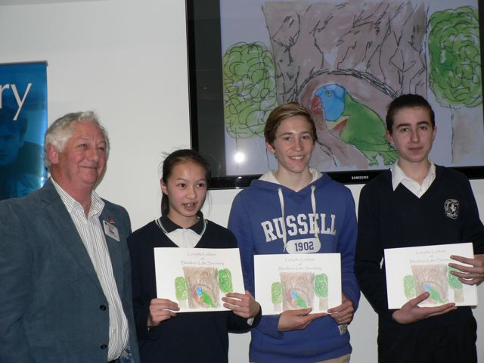

**Pres Bill with artist and script writers**

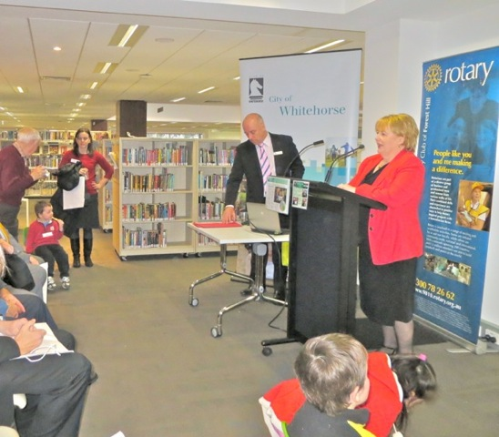

**Our Mayor launching the book**

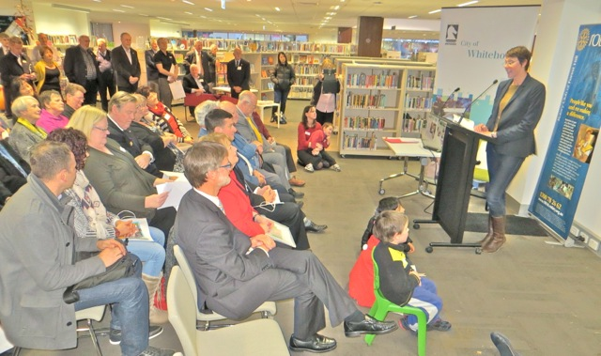

**A rapt audience listening to the book read**

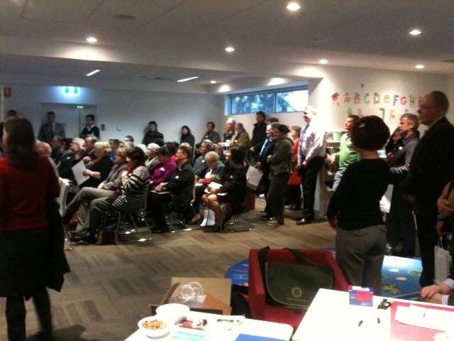

**Audience overflowing the seats provided**