|  |  |  |
| --- | --- | --- |
|  | Weekly Newsletter  foresthillrotary@hotmail.com |  |
| Number 9: 1st Sept 2014  Club address: PO Box 116, Nunawading 3131  **Website:** [**www.foresthillrotary.com**](http://www.foresthillrotary.com)  Meeting location: Bucatini Restaurant, 454 Whitehorse Road, Mitcham, 3132  Meeting time: Monday 6.15 for 6.30 pm  **Facebook: ForestHill Rotary** | | |

|  |  |  |  |  |  |  |  |  |  |  |  |  |  |  |  |  |  |  |  |  |  |  |  |  |  |  |  |  |  |  |  |
| --- | --- | --- | --- | --- | --- | --- | --- | --- | --- | --- | --- | --- | --- | --- | --- | --- | --- | --- | --- | --- | --- | --- | --- | --- | --- | --- | --- | --- | --- | --- | --- |
| |  |  |  |  |  | | --- | --- | --- | --- | --- | | **CLUB PROGRAM** | | | | | | **Date**  **1st Sept** | **Event**  **Tai Chi - Maree Chadwick** | **Chair**  **Ray Smith** | **Thanks/meeting report**  **Warwick Stott** |  | | **8th Sept**  **15th Sept**  **22nd Sept** | **Welfare at Forest Hill College - Marianne McEwan**  **DG Tony Monley Visit and Club Birthday**  **Murray Baird**  **ACNC** | **Ron Brooks**  **Pres Bill Marsh**  **Jenny Coburn** | **John McPhee**  **PE Bob Williams**  **Ray Smith** |  |  THIS WEEK'S CELEBRATIONS Sept 4th Marg McPhee Birthday DUTY ROSTER  |  |  |  | | --- | --- | --- | |  | **Sept** | **October** | | Cashier | John McPhee | Jenny Coburn | | Recorder | Stuart Williams | Warwick Stott | | Greeter | Doug Berwick | Glenys Grant | | Emergency | Bob Williams | Ray Smith |  ATTENDANCE  |  | | --- | | **APOLOGY** – **IF A MEMBER IS NOT GOING TO COME TO THE MEETING or you intend bringing a guest**  **Please contact Ray Smith by** **10.00 am MONDAY** on9878 4891 or[rcssmith@optusnet.com.au](mailto:rcssmith@optusnet.com.au%20)  Any cancellation after 10.00 am should be made direct with the management of Bucatini Restaurant on 9873 0268 | |

Chris Tuck will be absent from 23rd Aug to 25th Sept

Doug Berwick will be absent from 21st Aug to 12th Sept

**BILL’S** **BLURB**

Congratulations to every member of the club & partners for a tremendous effort with our second Primary Schools' Speech Night. Everything was organised beautifully and the night ran like clockwork. Yet again we were entertained, and amazed, by the presentations made by each of the 10 children representing five local primary schools. Our thanks are extended to Andrew Popov and the staff at Parkmore Primary School for the use of their excellent facilities and the work they put in preparing for the night and then cleaning up afterwards. Also we would like to thank our four guests from Toastmasters for conducting and judging the speeches. It was lovely for all concerned to welcome some special guests to enjoy the night with us. District Governor Tony Monley and his wife Kathy - Tony presented the various certificates and the Perpetual Trophy. Michael Sukkar, MP, gave a brief speech congratulating the children on a wonderful effort and encouraging them to continue their educational endeavours. We were also joined by Mike Simons, the former member for Deakin and Jasmine Gan, our NYSF student, and her family.

Five members enjoyed the presentations, despite a few technical problems, at the Foundation Seminar. Some great projects were highlighted and the benefits of gaining District Grants were outlined. Chairs of the various committees are encouraged to pursue grants so that we can extend our fundraising efforts for maximum impact.

Bob Laslett and Jenny attended the Community Seminar on Sunday and came away with some ideas that we can apply to our projects.

On Friday eight of us will journey down to the Davis family property at Leongatha for a BBQ and look around the farm and the vintage car/tractor collection. Will be a magic day out if the weather is as good as today.

Don't forget to come prepared for you Tai Chi lesson on Monday night. Maree Chadwick will demonstrate and lead us in this beautiful form of exercise.

Our next Film Night is coming up on the 5th September. Pencil it in to your calendar and let's see if we can get a big crowd. If we are lucky we may even get a good choice of films. From October John is planning to change the Film Night to the third Friday each month.

**Little Known Fact**: Scolding and eavesdropping were illegal in England until 1967.

**Enjoy your week in Rotary and keep working to "Light Up Rotary"**

Pres Bill

**LAST WEEK’S MEETING PRIMARY SCHOOL SPEECH CONTEST 2014**

WOW what a night of entertainment and vision we experienced last Monday. Each of the 10 grade 5 and 6 students who represented their school turned on a great performance for us, their parents and friends, and their school.

Congratulations to the 3 winning presentations :-

1st place Saurish Burwood Heights Primary School

2nd place Paige Burwood Heights Primary School

3rd Place Jordan Weeden Heights Primary School

And the holders of the shield for the next 12 months is Burwood Heights Primary School.

Andrew Popov, Principal Parkmore Primary School welcomed all to the venue wished all the contestants well and thanked the teaching staff of each school for their work and effort in preparing the students for this competition before handing over to President Bill.

Bill welcomed all in attendance making special reference to our guests before welcoming and handing over to Toastmaster chairperson for the night Susan Morrison

Susan introduced her panel of judges, then outlined the process to be followed for the competition.

Each student was invited to speak for 3 minutes. Susan introduced each student when their turn to speak came up. Once again we were treated to excellently prepared and presented speeches which was a credit to themselves and to the teacher training. The 3 judges were fully tested to separate the winning 3 from the rest of the field.

In conclusion of Susan’s role she congratulated each student and highlighted an aspect of each presentation..

President Bill invited DG Tony Monley to make the presentation to each student of certificate of participation and a certificate of their participation for each school record.

The 3 winners and the winning school was then announced and presentations made .

Bill closed the meeting extending thanks to Parkmore for providing the venue, the teachers for their contributions and our club members and partners for their support. We also thank Roger Coburn for joining with us and assisting in welcoming guests and families.

Notes by John McPhee

The topic for all speakers was “Someone I admire”. Saurish spoke on Barak Obama, Paige on Dynamite Dan (?) and Jordan on his mum. (editor)

# DON HULLAND

Don is not too well. His arthritis is a real problem. He is at present in Kellock Lodge in respite and hoping to be able to stay there full time. The address is 15 Bon St, Alexandria 3714 and his telephone is 0409 530 435. Why don’t you give him a call or write to him.

**“LARRY the LORIKEET” BOOK LAUNCH**

Larry the Lorikeet officially flew into the hearts and minds of Victorian young children in August. Larry is the central character in a colourfully-illustrated and cleverly-written book designed to increase awareness of protecting the environment. Symbolically, the tale traces the flight around Melbourne's iconic Blackburn Lake preserve of a lorikeet that is forced to flee his home in the face of developers' bulldozers which have destroyed his habitat, his plight becoming increasingly desperate.

Sponsored by the Rotary Club of Forest Hill, the project was supported by Whitehorse Council, two secondary schools and an artist/artist.

The original concept for the book and some text came from Box Hill High student Adam, with help from Liam and Brad, while on an environmental project at the lake. Whitehorse Council and the Lake's Education officer Lucy Menzies made input to the text and she and Rotarians guided the project. Forest Hill College Counselling and Wellbeing leader Marianne McEwen and other staff ran an art competition to decide the book’s illustrator. Zena, a 14-year-old Forest Hill student, won the art competition, and produced the book’s artwork, with staff guidance.

The book, Larry the Lorikeet, was officially launched by President Bill Marsh in August at Whitehorse Council in the presence of the Mayor, Cr Sharon Ellis, the other Councillors, AG Paul Mee and an audience of well over 100 people. It will now be distributed to all local schools and libraries as well as being used in the Lake’s education program for preschoolers.

… So, all you Rotarians who have children and grandchildren, read the book, and take your families to the lake to find Larry.

Notes by Glenys Grant

**If you want to buy a copy … or two, ….. or three, then give your order into Pres Bill (**[**bjmarsh@bigpond.net.au**](mailto:bjmarsh@bigpond.net.au)**) as we are planning a second print run if the demand is large enough.**

Hi Glenys

Thank you for the lovely photos.

It really was a great event .

Congratulations for all the organisation.

Regards

Sharon

Cr Sharon Ellis

Mayor City of Whitehorse

Councillor for Riversdale Ward

# WEBSITE

This needs updating as there is nothing about any projects done in the last few years. It makes it look like we have done nothing. Having old stuff is worse than having no stuff. What about Hope Katolo, Hand Brake Turn, Larry, Youth Achievement Awards, Apprentice Awards, I need photos and some short written stories. As from the end of the week, I will be deleting all stuff over three years old.

Do not forget to check out our website, [www.foresthillrotary.com](http://www.foresthillrotary.com) and send Ron Brooks any information and suggestions.

**REPORT ON COMMUNITY NEEDS ANALYSIS SEMINAR-AUGUST 24 2014**

Jenny Coburn and I spent a useful morning looking at needs in the local community. We were led by Chris Potter who is both a local council employee and a Doncaster Rotarian. He explained council structures, the best contact persons and where to get relevant information. His examples were from Manningham but have application in Whitehorse. There were examples of successful grant applications to council and discussion of ways in which the unsuccessful ones could be a source for service club projects. There were two breakout sessions where we were able to hear about other club projects and gain some new ideas. We started to learn some of the Council jargon, and the best ways to succeed with grant applications. Dr John Besani explained the Bayside Rotary Health Trail concept, an innovative idea for promoting healthy living along the coast in the Bayside area. The monetary value of Rotary in the community was discussed particularly when volunteer’s time is included in costings. All in all a most worthwhile morning as there were also ideas for speakers and membership.

Notes by Bob Laslett

**WEBINARS ABOUT MEMBERSHIP AND CLUB MEETINGS**

The two webinars discussed how Clubs can and need to be Flexible and Innovative. PDG Jessie Harman and PDG Noel Trevaskis lead this Webinar and shared how some Clubs have gone about being flexible and innovative in their approach to membership, club meetings, diversity etc. A fuller report will appear next week.

For those not familiar with webinars put the appropriate bolded line in your web browser and hit enter. It takes you to a site where you register by putting down your name and email address and you get emailed instructions, with a link that you click on 5 or 10 mins before the webinar starts and the computer does the rest. It is very simple.

**The webinar was an RI initiative as August was Membership month in Rotary**

# REASONS FOR JOINING ROTARY

Jenny Coburn gave me a list of reasons, I am putting in a different one every week - **think about them when you talk to prospective members**

**It Sparks New Ideas:** Rotary can generate amazing new ideas for you personally or for your business through speakers, business visits, projects, conferences, social media, visiting Rotarians from locally or abroad.

**WEEKLY RAFFLE.**

We are now running a weekly raffle, winner’s choice of a bottle of wine or a box of chocolates. Tickets $2 each or 3 for $5. Proceeds will go to our General account to help keep costs down.

**ROTARY AND POLIO FEATURED IN TIME.COM**

The link below shows an article in which Rotary's National PolioPlus Chair for Pakistan, Aziz Memon was interviewed by TIME Magazine's Jeffrey Kluger for a Rotary-Pakistan focused story that just posted on TIME.com.  The story highlights a number of Rotary-led initiatives currently underway in Pakistan. (TIME.com overall gets more than 12 million unique website visitors each month.)

Here is a direct link,   [http://time.com/3051398/polio-pakistan-rotary/](http://r20.rs6.net/tn.jsp?f=001Y1rezzhUtzUXESaWSmosgLk3FRyc79sznjyp_TWUefLmtsMUBZDOrNbcFsjwv6o4eW8ExPMlOUqBIjFhhA-b4FEhq5cVquOFiYQbCCpicXiQtToxacarvjO-rO5DkiA3bIBjIEuBuNwaFLeQjsKQviq4Nv0Nq9WiO3KnsJA-mGT3m_nKDzu0GpVMAAKVFXlllsrZZReVEdGHjo5GHDGWDA==&c=fc_MyYoCqFz1Pzg2hvHVDy2AaaTgJW8QOug8UhdWYsZZrbAx5N6qLw==&ch=Y80Mz5zStkOOnSNtfa6h-U4vRluoCOzNc0utN93UBe395Mo91-LTag==)

**South Sudan Dinner Auction -Saturday 11th October 2014**

The Melbourne Rumbek Primary School Committee, of whom I’m a member, and the RC of Manningham are running a dinner auction at Monte Carlo Receptions, 5 Mitchell Street Doncaster East at 7 pm for 7-30pm on Saturday 11th October 2014. Full buffet dinner at a cost of $70 per person plus drinks at bar prices.

You may remember that Samuel Manhom spoke at our club a couple of years ago now of his experiences as a refugee from South Sudan escaping from the Civil War there and of his desire to build a school in his home town of Rumbek in South Sudan. My link is that when I was at Good Shepherd I employed Samuel as the accounts person as his first “desk” job in Australia and he impressed me as a wonderful young man with a vision and when he spoke of forming a committee to explore the possibility of building a school there I readily “joined up.”

The project is under the umbrella of R.A.W.C.S. and so has tax deductibility etc. There is still some unrest in South Sudan but mainly in the capital of Juba which is several hours away from Rumbek. Whatever the result of our fund raising for the project we wouldn’t commence building until total peace is possible. If this proves to not be possible then all money raised will go towards an existing school near the town to build extra classrooms and employ extra teachers etc. Sam‘s strong desire is that the school will have equal numbers of girls and boys as there is at present little education opportunities for girls in South Sudan. There is a Rotary Club in Juba and they are willing to assist where possible. Our committee has equal representation from the local South Sudanese community here and so have good links to schools and contractors there.

Samuel has been to Rumbek and has acquired land to build the school from the local chief and has organised costing from local contractors there. He also met with Government and Education Ministry officials and has their support for the project as they recognise the great need but of course there are no local funds for such a project. The local Education Ministry has promised to provide trained teachers. The local South Sudanese community here are so thankful for our input and have made South Sudanese singers and dancers available for the entertainment on the night. The idea (still being formed) is to have tables of 10 with perhaps 2 of the table being local South Sudanese.

We meet monthly at North Melbourne Football Club and they have promised us some auction prizes for our auction plus there will be a silent auction as well as raffles. To find out more about the project go to <http://southsudanschool.org/> It would be great to have at least one table from Forest Hill, or as many as we can.

Please let me know by the 10th September if you can come and I will book you in with Barbara and me.

Notes by Bob Williams

**STAMPS**

Please cut out all the stamps you get on your snail mail leaving an approximate 1cm margin and give to Jenny Coburn. They are worth nothing to you but Rotary sells them. Over $89,000 since starting in 1991/92 and $7,091 in 2013/14.

**Harvey World Travel Offer**

Harvey World Travel, Forest Hill Chase, offers to the Club $30 for any booking up to $10,000 and anything over $10,000 1% plus 10% insurance.

Thanks to Glory Britto for making this offer available to the Club.

**BALLARAT CONFERENCE 2015**

A booking has been made for 6 double rooms at Ballarat Lodge  for District Conference.( Fri 13 - Sunday 15 March 2015.  Rooms booked for Fri night and Saturday night at the venue of the Saturday night function.

Families  Grant/ Williams, Bob/ Williams, Stuart/ Brooks/Laslett/Marsh.     Jenny and Roger will stay in own accommodation.

Cost  $149 per night.  FULL Buffet breakfast if required $20.  I believe no money needs to be paid until we arrive. (I believe the Saturday Night function will be held at this venue)

Stuart Williams

On to Conference organiser

Club officers & Committees 2014-15

**President** Bill Marsh

**Vice President** John Donaghey

**Secretary** Ron Brooks

**Treasurer** Warwick Stott

**President Elect** Bob Williams

**Sergeant** Stuart Williams

**Foundation & International** Chris Tuck

Members: John Donaghey, Stan Harper,

**Youth Service** Glenys Grant

Members: Ray Smith, Bob Williams, Graham Sharman

**Community & Vocation** Bob Laslett

Members: Stuart Williams, Gary Baltissen, Ron Brooks

**Membership & Publicity** Doug Berwick

Members: John McPhee, Warwick Stott, Jenny Coburn

**Fellowship** John McPhee

**Primary Schools Speech Night** John McPhee

**Programme** Ray Smith & Gary Baltissen

**Bulletin Editor** Ron Brooks

**Web page & Facebook** Ron Brooks

**On to Conference** Stuart Williams

**Historian** Stan Harper

**Almoner** Graham Sharman

**Public Officer** Bill Marsh

Note that Bob Williams has volunteered to swop over from Foundation/International to Youth Services to support Glenys and Ray as Graham will be spending very little time in Melbourne.

Newsletter articles to the editor at [ronbrooks1@optusnet.com.au](mailto:ronbrooks1@optusnet.com.au) by **5 pm Wed**. If you do not wish to receive this publcation please contact the editor.

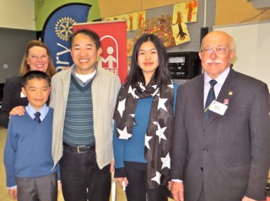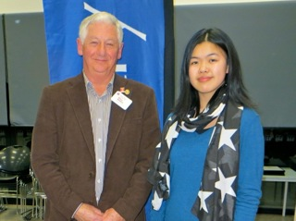

Our NYSF participant Jasmine Gan with her father and brother

Primary Schools Speech Contest held at Parkmore Primary

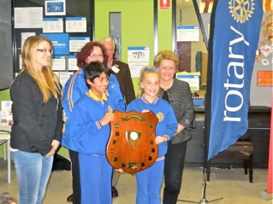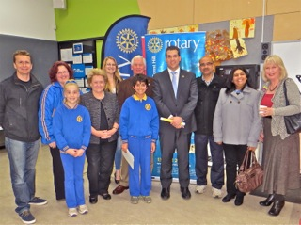

Primary Schools Speech Contest winners from Burwood Heights with Hon Michael Sukkar, childrens’ parents and Toastmaster chair for the night Susan Morrison.

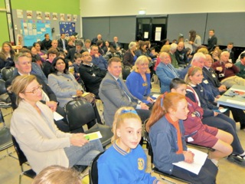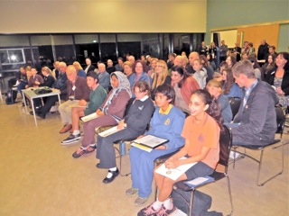

Attentive audience and speakers

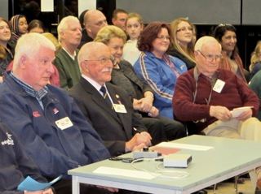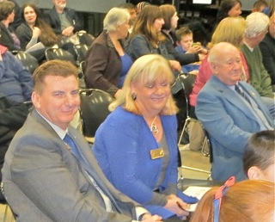

Timekeepers, official photographer and audience at Parkmore Primary