Number 9  Club address:  Email address:  Website:  Meeting location:  Meeting time:  Facebook: | 4 September2017  PO Box 116, Nunawading 3131  foresthillrotary1975@gmail.com  www.foresthillrotary.com  Bucatini Restaurant, 454 Whitehorse Road, Mitcham, 3132 (Melways 48H9)  Monday 6.15 for 6.30 pm  Rotary Club Forest Hill

CLUB PROGRAM

Date | Event | Chair | Thanks & Meeting Report
4 Sep | LAARF Singers Committees  Leon Moore | Stuart Williams | Mike Finke
11 Sep | DG’s Visit CLUB  DG Malcolm Chiverton BIRTHDAY | Bob Williams | Martine McLeod Craig
18 Sep | Shrine of Remembrance  Shirley Devery | Warwick Stott | Ray Smith
25 Sep | WHITEHORSE- Our future BOARD  Mayor Denise Massoud | Ray Smith | Warwick Stott

CELEBRATIONS
A quiet week
DUTY ROSTER

 | SEPTEMBER | OCTOBER
Recorder | Bob Laslett | Glenys Grant
Greeter | Mike Finke | Martine Macleod Craig
Emergency | Ray Smith | Sue Ballard
Cashier | Barbara Searle | Chris Tuck

ATTENDANCE
APOLOGY – IF A MEMBER IS NOT GOING TO COME TO THE MEETING or you intend
bringing a guest please contact Ray Smith by 10.00 am MONDAY on 0412 807 585 or rcssmith@optusnet.com.au
.SPECIAL DIETARY NEEDS to Ray by 10am at the LATEST
Any CANCELLATION AFTER 10.00 AM should be made direct with the management of
Bucatini Restaurant on 9873 0268

BILL’s BYLINES
Bill and Judy are enjoying Queensland sunshine

He would like to
- Seek extraordinary attendance by our partners and friends for the club birthday/ DG’s visit on 11 September as we have a number of our members away on leave (please advise Ray if you can attend)
- Wish Bon Voyage to Sue Ballard, the Stotts and the Tucks and all the best to Mike for his surgery.
Coming Up:
Film Night - 8th September at Forest Hill/Pinewood depending on films.
Committees Meet - 4th September
Blackburn Market - 9th September
WFM - 10th September
DG’s Visit & Birthday Celebration 11th September
Board Meets - 18th September
Remember - Rotary: Making a Difference - is not just a theme it is what we do.

Meeting report August 28
Meeting opened at 6.30 with Bob reflecting on a brief History of the AFL as a lead-up to the finals and the end of the home and away matches.
The usual toasts followed before handing over to President elect Mike, filling in for President Bill for the night.
Mike spoke of the importance of communication in our membership recruitment before passing the meeting over to the night’s Chairperson Barbara.
Barbara welcomed visiting Rotarian Jodie from Manningham Club along with Barbara Williams and Bum. 9 members in attendance.
Reports International
Pencils etc have been boxed ready for delivery to Boronia club for inclusion with the next shipment to Fiji. Value of the packets exceed $2000
Hope Kotolo fundraising film night is being arranged for Thursday 29th September. Details will follow but in the meantime please note the date in your diaries.

Vocational
Martine attended the recent Box Hill Institute pre- apprenticeship awards night and has made useful contacts with staff prior to selection of our awardees later in the Rotary year.
Sergeant Bob was then introduced and he was successful in extracting $22.00 plus.
Joady Barnes from Manningham presented the club with an update of progress on the building of the South Sudan school project.
Joady’s presentation was very informative and covered the work done to-date with particular reference being made that the school will open to include female students and female toilets to encourage full time attendance. His power point presentation showed that the exterior building construction is now complete and that fit out is now underway with early completion expected.
Cost of the project, $90,000.
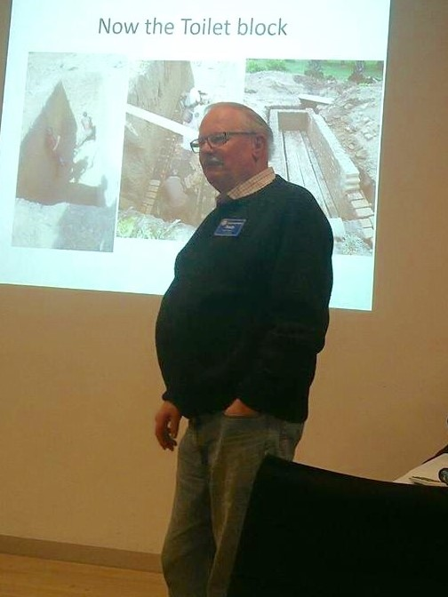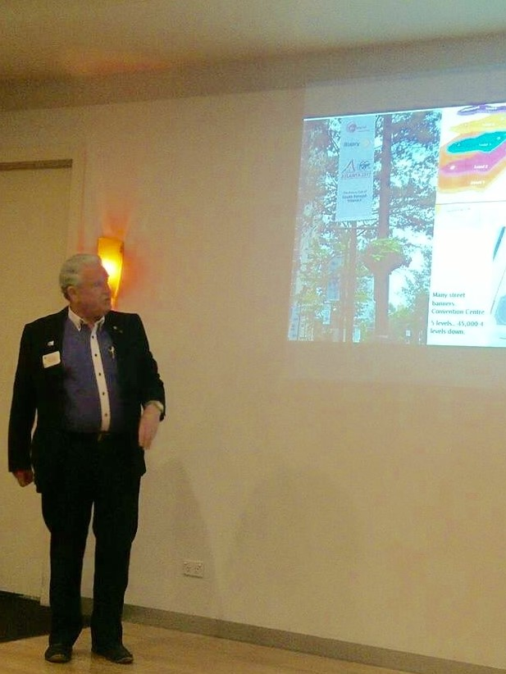

Our Guest speaker Past President Stuart Williams then took the floor as he entertained all with an excellent power point presentation relating to his recent attendance at the Rotary World Conference at Atlanta USA. The conference was held in the former 1996 Olympic Games precinct. The venue had the capacity to accommodate the 45000 attendees over the 4 level building in which only 1 level was above ground with inadequate exits in an emergency.
Pre- conference activities of youth exchange and Rotaract were held and well represented. Also a concert in the Park of bluegrass music of which Kacie Page was one of the lead performers and was enjoyed.
Highlights of the conference were the quality of the keynote speakers, the fellowship around the venues and the diversity of the attendees.
The Polio day pledges amounted to $1.2 billion and Foundation celebrated its Centenary. About 6000 potential attendees failed to secure entry visa to the USA
Stuart was thanked for his presentation and Mike closed the meeting at 8.15pm.
John

Stand-in Sergeant’s Reflection
The AFL home and away season has just concluded so some facts about our great game.
AFL has been around since the 1850s and is now one of the most popular sports in Australia. Would you believe that early AFL uniforms consisted of canvas lace-up, guernseys, long trousers, socks and high leather boots? Imagine playing in those clothes on a hot or rainy day?
In the beginning, there was no time limit on a game and it would end once a team had scored two goals or if it became too dark or, funnily enough, if the ball burst.
The first games were played in the parklands next to what is now known as the MCG. The field was originally rectangular and about three or four times larger than the oval shaped fields used today.
AFL was influenced by many well-known sports such as early forms of soccer and rugby, but did you know that it may have also been influenced by a traditional Aborigine game called Marngrook? Marngrook involved kicking a ball made from animal skin and stuffed with feathers or charcoal.
Although AFL was developed in Australia, it is now played by more than 100,000 people in over 80 countries. You can find AFL competitions in Nauru, Denmark, Sweden, USA, Canada and South Africa to name just a few.
Around fourteen percent of AFL players come from culturally diverse backgrounds and about nine percent are Indigenous Australians. Considering that only two percent of the total Australian population are Indigenous, this is an impressive statistic.
Onto the Finals.
Bob Williams

Podcasts
Mike’s latest podcast on the idea of an elevator pitch.
https://m.soundcloud.com/mike-finke-167583478/five-minute-forest-hill-episode-21
Whitehorse Farmers Market
Sunday 10th September
RCFH Roster
7.30 to 9am Stuart Williams
9.00 to 11.00am Bill Marsh
11.00 to 12.30pm Barb Searle
Last shift attendees to help with putting away the portable signage and bins etc.

Breakfast Roster
Ben spoilt Barbara and John as he had made up the pancake mixture. They still toiled in very cold conditions.
Barb and Bob Williams step up to the plate(s) this week
Good Manners in Rotary
You can get a copy by hitting the link here: "Good Manners in Rotary". Alternately, you could go to the Kindle Store and search for 'Rotary Manners', for instance.
There is a small cost (through Kindle), but 100% of the proceeds go to The Rotary Foundation. The booklet is a service to clubs and Rotarians. It is considered that all leaders should have a copy including district leadership and club leadership, then after reading the guidelines, to take action.
The original content has been wholly revised, updated and enhanced for this digital edition.
CLUB POLO SHIRT DELIVERY
The new Club polo shirts have arrived.
Bob W will bring them to the Rotary meeting on Monday 4 September for distribution.
Many thanks for your support
Barbara Williams

ROTARY MONTHLY THEMES
September Basic Education and Literacy
October Economic and Community Development

ARTICLES
Newsletter articles to rlaslett76@gmail.com.au by 5 pm Wednesday please.

