### 

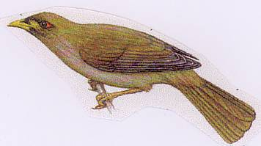

|  |  |  |
| --- | --- | --- |
|  | 2012-2013  Weekly Bulletin of the  Rotary Club of Forest Hill |  |
| Edition 33:15 April 2013  The Rotary Club of Forest Hill meets at 6.15 pm for 6.30 pm on Mondays at Bucatini Restaurant, 454 Whitehorse Road, Mitcham, 3132.  Meal cost $27.00  PO Box 116, Nunawading 3131  Email [rlaslett@optusnet.com.au](mailto:rlaslett@optusnet.com.au) Website foresthillrotary.com | | |

|  |  |  |  |  |  |  |  |  |  |  |  |  |  |  |  |  |  |  |  |  |  |  |  |  |  |  |  |
| --- | --- | --- | --- | --- | --- | --- | --- | --- | --- | --- | --- | --- | --- | --- | --- | --- | --- | --- | --- | --- | --- | --- | --- | --- | --- | --- | --- |
| |  | | --- | | **CLUB PROGRAM**  **THIS WEEK’S CELEBRATIONS 1**  **DUTY ROSTER 1**  **ATTENDANCE 1**  **BOB’S BELLBIRD BLOG**  **LAST WEEK’S MEETING** Error! Bookmark not defined.  **PEACE 2** |   **ROTARY CLUBS play a vital role in kids education 2**  **CONFERENCE**  **FOREST HILL’S MEMBERSHIP CHALLENGE**  **3**  **INTERESTING PROPOSITION**  **PROGRAM**Error! Bookmark not defined.  **IMPORTANT UPCOM ING CLUB AND DiSTRICT EVENTS** | |  |  |  |  |  | | --- | --- | --- | --- | --- | | CLUB PROGRAM | | | | | | **Date** | **Event** | **Chair** | **Thanker and Meeting Report** | **Member Talk on an aspect of peace** | | **15 April** | **Valentine Night** | **Ron Brooks** | **John Donaghey** |  | | **22 April** | **ANZAC Celebrations** | **Doug Berwick** | **Stuart Williams** |  | | **29 April** | **Bucatini Social Night** |  |  |  | |
| THIS WEEK'S CELEBRATION Own up on the night |
| DUTY ROSTER  |  |  |  | | --- | --- | --- | |  | **April** |  | | Cashier | Glenys Grant |  | | Recorder | John McPhee |  | | Greeter | Chris Tuck |  | | Emergency | John Donaghey |  |  ATTENDANCE  |  | | --- | | Apologies - **Please contact Ray Smith by** **10.00 am MONDAY** on9878 4891 or[rcssmith@optusnet.com.au](mailto:rcssmith@optusnet.com.au%20)  Any cancellation after 10.00 am should be made direct with the management of Bucatini Restaurant on 9873 0268 | |
|  |  |

# 

# BOB’S BELLBIRD BLOG

Last week we had Steve McDonald treating us to the details of the wonderful Timor Leste Children’s Home project to which we intend to contribute financial assistance.

Some other good news

* District Conference – 20-23 March 2014 –Bendigo
* Stan raised $29.75 for our Foundation
* ConocoPhilips is the new sponsor of the Science Experience. The Science Experience has been granted charity status.

Don’t forget this week we have the markets on Saturday and Sunday.

This week we have the fabulous Valentines Extravaganza. So make sure you come along ready to have some fun. We look forward to hearing from PE Chris re:his post PETS experience.

Please continue to send all Flyer articles to Ron as well as me.

**INTERNATIONAL NOTES**

The Easter edition of Nadrasca News has arrived. They have just launched their new Website. Check it out at [www.nadrasca.com.au](http://www.nadrasca.com.au).

2. The Good Guys, Nunawading, is having a VIP night for Nadrasca Thursday April 18th, 5 - 9 pm. If anyone would like to take advantage of the offer of 10% discount by presenting the Nadrasca flyer please see Glenys

3. Any last minute takers for the Giant Monopoly night? Only $20.00 each and great fun!

4. To track progress of the disaster aid box go to website [www.disasteraidaustralia.org.au](http://www.disasteraidaustralia.org.au) and follow box number AUS 2332

Glenys Grant

# LAST WEEK’S MEETING

Not many of us are aware of the poverty and hopelessness of our neighbours, just 400 kilometres to the North of Australia. For its poverty, East Timor has been rated 158 out of 179 Nations. Gaining independence in 2002, it is estimated that two thirds of the population is under the age of 25. Most people live on less than US$1 per day. It has one of the highest infant mortality rates in the world. Around 65% of children, especially girls, are subject to some form of abuse. Homelessness is a huge problem for children.

Steve McDonald, our guest speaker told of these grim statistics in his address, and then went on to tell us of one project that Rotary is directly involved with. Known as the Timor Leste Project, and with significant backing from Box Hill Tafe, a 17 bed children’s family home is being constructed. Much of the labour is being undertaken by a group of Building Trades apprentices. Total cost of the project is $180,000. This is a project deserving of all the encouragement and help that Rotarians can give.

Steve is currently the District Vocational Services Chairman. His address was short and to the point, gaining our attention and interest, as evidenced by the numerous questions that followed.

Graham Sharman

# PEACE



Some of you will remember in 1994 there was an extraordinary effort to establish a memorial to World Peace to which we contributed. Ours was one of 531 packages of pebbles, stones and rocks sent to Maui in Hawaii to build an apropriate memorial to World Peace. Ha anyone been to Mauii to see the fulfilment of this dream?

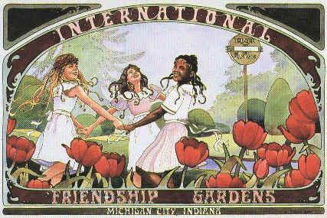

peace gardens in Michigan city, indiana

**Rotary clubs play a vital role in kids education**

Our club wishes to support the Whitehorse Rotaract **GIANT MONOPOLY** evening on Sat April 20th . Venue Box Hill Town Hall. Cost $20 at the door. BYO Food and Drink.

Contact: Stuart Williams by 8th April. It should be fun, let’s get a table organised.

The project is to support the Vuna Children’s Education through the ABCD programme.

# FOREST HILL’S MEMBERSHIP CHALLENGE

# Current 15

# Aim 20

**THE JOHNSTON COLLECTION**

There are 14 attendees on Monday 22 April at 10am. Cost is $21.

# INTERESTING PROPOSITIONS

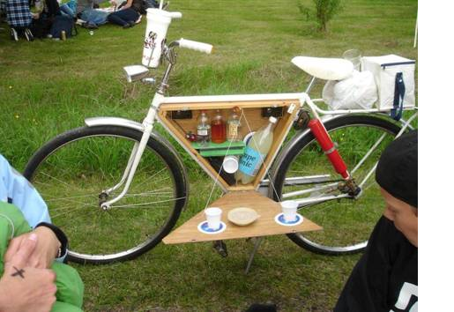

Who needs a car and caravan, lets go camping!

# PROGRAM

An update of our program to the end of the year.

15th April is our (slightly late) Valentines night with Ron organising so it will be a treat. Please let Ron know numbers as soon as possible.

22nd April. We are celebrating Anzac Day and Stan is again going to regale us with a tale (or tales) from his war experiences for 5 to 10 minutes and **so we invite any members with war experiences (or those of their forebears), to also join in and talk about them.**

29th April is our regular social night in the restaurant with our partners.

6th May is a “Hat” night to raise some funds and have some fun. We have Warwick Duncan coming along to tell us of his experiences walking the Kokoda track as a liver transplant patient.

13th May we have Gillian Hibbins who is a Paul Harris Fellow and past secretary of the RC of Melbourne. She was commissioned by the AFL to write the opening chapters for the *Australian Game of Football since 1858* and will talk to us on that topic.

20th May we have an offer I am following up on for a speaker on organ donations which would fit in well with our speaker on the 6th May.

Our Box Hill Institute Awards night will be the 27th May and an important night for the club. It was of interest hearing from Steve Macdonald last Monday that the Institute is sending trained and student volunteers to assist in building the Timor Leste children’s home.

3rd June is set for our club forum with a club speaker.

10th June is the Queens holiday.

We have the 17th June for our joint committee meetings, joint Board meeting plus possibly an extended talk from one of our members or?

24th June is Changeover.

So, plenty of options for our partners to come along and join in the fun.

Bob Williams

|  |
| --- |
| PERIDOT The next Peridot excursion is on Fri 17th May and the play is “Nunsense”. Contact Chris Tuck for tickets. |

# APRIL CINEMA NIGHT

Seven of us, Lasletts, Brooks, Tucks and Heather Bremner, went to see “Hyde Park on Hudson” at the Forest Hill Chase last Fri evening at 7pm. This followed a meal at the Melba Café in which we were joined by Bill Marsh who had just got back from Singapore. The film was a 3 star historical drama about Franklin D Roosevelt and cousin Daisy’s relationship together with FDR’s relationship with his domineering mother and live apart wife plus various other dalliances. It centred on a weekend in 1939 when FDR played host to the King and Queen of England during which time they were hoping to persuade the USA to join in the war against Hitler. Very interesting and absorbing but perhaps not perfectly representing true historical facts.

Ron Brooks, Membership and Fellowship

# IMPORTANT UPCOMING CLUB AND DISTRICT EVENTS

|  |  |  |
| --- | --- | --- |
| **4/2013** |  | **ROTARY MAGAZINE** |
|  |  |  |
| 15/4/2013 |  | Club meeting |
| 22/4/13 |  | Johnston Collection visit & Club Meeting. Board Meeting |
| 29/4/13 |  | Bucatini meal & social night for partners and friends |

Please have FOREST HILL FLYER articles to the Editor at rlaslett@optusnet.com.au by **5 pm Wednesday** (in Microsoft Word format please)