|  |  |
| --- | --- |
| Number 01  Club address:  Email address:  Website:  Meeting location:  Meeting time:  Facebook: | 2 July 2018  PO Box 116, Nunawading 3131  foresthillrotary1975@gmail.com  www.foresthillrotary.com  Bucatini Restaurant, 454 Whitehorse Road, Mitcham, 3132 (Melways 48H9)  Monday 6.15 for 6.30 pm  Rotary Club Forest Hill |

|  |  |  |  |
| --- | --- | --- | --- |
| **CLUB PROGRAM** | | | |
| **Date** | **Event** | **Chair** | **Thanks & Meeting Report** |
| 2 July | Open House Melbourne  *Sue Ballard* | Glenys Grant | Chris Tuck |  |
| 9 July | Person behind the Badge  *Barbara Williams* | Stuart Williams | Bob Williams |  |
| **16 July** | ***CHANGEOVER NIGHT*** | Bob Williams | Stuart Williams |
| 23 July | Report on the RI Convention in Toronto *Stuart Williams* | Ray Smith | Bob Laslett |

**CELEBRATIONS**

**Happy birthday Ray Smith 7th July (90 …………. but who’s counting!!**

You’ll burn the house down if you have so many candles

Kira & Mike Finke **Wedding anniversary**

**DUTY ROSTER**

|  |  |  |
| --- | --- | --- |
|  | **JULY** | **AUGUST** |
| **Recorder** | Chris Tuck | Bill Marsh |
| **Greeter** | John McPhee | Ron Brooks |
| **Emergency** | John Donaghey | Bob Laslett |
| **Cashier** | Glenys Grant | Stuart Williams |

**ATTENDANCE**

|  |
| --- |
| **APOLOGY – IF A MEMBER IS NOT GOING TO COME TO THE MEETING or you intend** |
| **bringing a guest please contact Ray Smith by 10.00 am MONDAY** on 0412 807 585 or rcssmith@optusnet.com.au |
| SPECIAL DIETARY NEEDS to Ray by 10am at the LATEST. |
| Any CANCELLATION AFTER 10.00 AM *should* be made direct with the management of |
| Bucatini Restaurant on 9873 0268 |

**BILL’s BYLINES**

Doesn’t time fly when you are having fun? It is now 12 months since the first of Bill’s By-lines and this will be the last.

As always our club has achieved much in the year and touched many lives thus truly Making a Difference.

I would like to say ‘Thank You’ to all of the members of our club – you are an amazing group and you achieve an amazing amount. It has been a privilege to serve as President and I know that under the leadership of Mike Finke you will go on to even better outcomes.

At this time I also need to recognise the support of the Gysi-Davis Family and the Harper Family who have been long-time supporters of the club and continue to fund so many of our projects.

On Saturday a group of members and friends joined the Blackburn Lake Sanctuary volunteers in a Tree Planting morning. The volunteers do a great job and it was a pleasure to be able to help them. Over 500 trees, shrubs and ground covers were planted by the volunteer workforce – a super effort that truly enhances our community.

Our next Film Night will be on Friday, July 6th. I will circulate the available films in the week prior. We will have dinner before heading off to the films.

The July markets are fast approaching and this month they are spread over two weekends – make sure you have the dates in your calendar. WFM is on Sunday 8th and Blackburn on Saturday 14th.

Only 5 more ‘big sleeps’ to go!!

**Dates for your calendar**

Fri 6th July - Film Night

Sun 8th July - Whitehorse Farmers’ Market

Sat 14th July - Blackburn Craft Market

**Mon 16th July Official Changeover Dinner**

Fri 17th Aug Nunawading Rotary Club Christmas in July………… **in August**!

Wed 22nd August - Primary Schools’ Speech Competition

**Did You Know?**

The opening line of Jerome K Jerome’s “*Three Men In a Boat” is: ‘*There were four of us’

**Remember - Rotary: Making a Difference - is not just a theme it is what we do.**

PS For anyone who is interested the quirky little ‘facts’ that have been at the bottom of the By-line can be found in a book called ‘1227 QI Facts to Blow Your Socks Off’ compiled by John Lloyd, John Mitchinson and James Harkin.

**Club Meeting Report 25th June Robotics- World Challenge in Houston**

Our meeting began with a moment of reflection on the speed of change in our society over the last 50 years and a moment of wonderment as to where it might lead in the next 50 years.

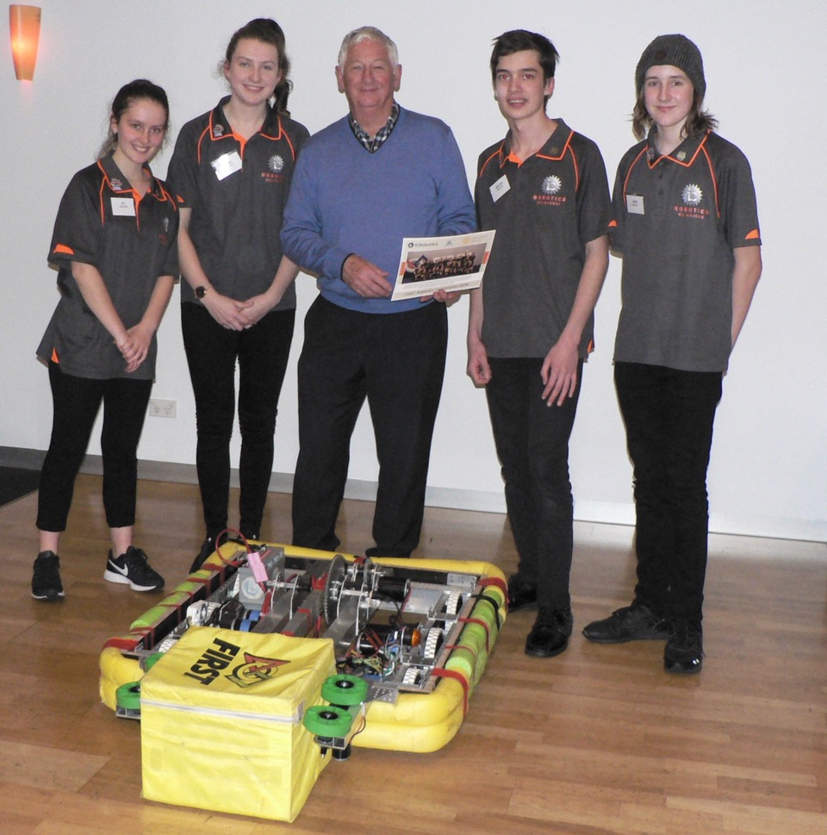President Bill reflected that his first excursion from school was to walk across the street with a bunch of 14 year olds and watch Coca Cola being manufactured. Our guests tonight are of a similar age and they have just returned from taking their robot to the world championships in Houston, Texas. These young people have not only enhanced their own skills and learning but they are taking them out to their communities to ‘*bring learning to life*’ for others – truly Making a Difference.

Those Rotarians who attended our Conference in Bendigo would have had a taste of what IC Robotics have achieved. Our club has been lucky in having a direct link to the group through past member John Bindon and so we have now enjoyed two visits from the team and their robot. They are a truly amazing group of young people who have a passion for STEM and have followed their passion with determination and skill. They have just returned from competing in the world robotics championship in Houston, Texas. Some 500 teams from across the world descended on Houston to demonstrate their skills. IC Robotics finished 19th in their group of 80 teams. A super effort for a young team up against the best in the World. The group told us about their visit, demonstrated their latest robot at work, thanked us for our support & donation and presented a certificate to the club. Among their skills these youngsters self-funded a team of 35 plus robot to fly to Texas for a week. We may not need to talk to them about robots (because we would never understand) but we could sure use their entrepreneurial and fundraising skills in Rotary.

A quiet night as sub-committees wind down meant there were no reports apart from Warwick mentioning the Membership group would be planning another membership night and Sue brought us up-to-date with progress towards the PSSC. Oh, and Ron filled us in on the speaker program for the next couple of weeks. Maybe it wasn’t so quiet!

The raffle was won by Barb Searle (who is quietly building up a collection of prizes to rival John Donaghey) and second prize went to (you guessed it!) John Donaghey. The third prize, a box of chocolates, was donated to the IC Robotics team to share amongst the five who were at the meeting.

President Bill thanked everyone for attending and closed the meeting after mentioning that next week we would have Sue Ballard talking about the Open House Melbourne program. The chair will be Glenys Grant and Chris Tuck will give the vote of thanks and prepare the meeting report.

The Raffle raised $55.95 and the collection bowl $18.20

*Bill Marsh*

**DUTIES OF CHAIRMAN and VOTE OF THANKS/MEETING WRITEUP**

Without wishing to offend anyone (have I ever? would I ever?) during the last little time I have noticed that these duties have been carried out in different ways by different members, or not carried out as the case may be. Some years ago, the Board noticed a lack of consistency with our meetings and some that went way over time so came up with some procedures. They were put in the Newsletter at the time ………… but is is some time ago and worth reiterating. So without it being an exhaustive list I note the following

**Chair**

1. Prior to the night contact the speaker and find out how the speaker wants to be introduced. You can get the contact details from the person organising the programme.
2. Note who is giving the vote of thanks from the Flyer. Check that person is present and that they have the pen for the Vote of Thanks. If that person is absent it is your responsibility to ensure someone else knows they have the job and the pen.
3. Make yourself known to the Speaker and tell them where they are sitting (check with the President, or whoever is standing in for the President)
4. Ask the guest speaker if they would like a drink. Get it from the bar and **get a receipt**. Give it to the Treasurer who will immediately refund you.
5. You need to tell the speaker how long they have. **You control the timing**, that is why you get a running sheet. Tell the speaker when they have 2 mins or 5 mins to go ….. whatever **YOU** arranged with the speaker. Arrange whatever signal you like with the speaker but pre arrange it.
6. When time is up, STAND UP and walk to the front. The speaker will get the message.
7. It is up to the chairman, not the speaker to ask for questions and field those questions from the floor as you know the audience. And when to stop taking questions.
8. It is not up to you to say thankyou to the speaker, we have a person nominated.
9. Stay at the front while the vote of thanks is given then call on the President, or whoever has taken the President’s place, to close the meeting.

**Vote of Thanks/ Meeting writeup**

1. Come prepared to take notes. Take notes on the entire meeting not just what the guest speaker said.
2. Make sure you check on what wood has been used to make the pen before you get up to speak.
3. Keep the vote of thanks short. You are not there to give a precis of what the speaker said. You are there to thank the speaker on behalf of the audience.
4. Write up a report of the entire meeting and ensure that your report gets to the newsletter editor before 5pm on Wednesday. Spell check the report.

*Ron Brooks*

|  |  |  |
| --- | --- | --- |
| **FORE****ST HILL COLLEGE BREAKFAST**  Robbie teamed up with Barbara W to cook lots of toasties last Tues 26th June. The small group of people who get involved in this project work are up early every Tuesday and deserve more credit than they get.  **ANNUAL REPORT**  Committee chairs are kindly asked to have their reports to me by the end of June.    **ROTARY MONTHLY THEMES**  July Rotary Awareness  **ARTICLES**  Next week please forward your prize-winning articles to [ronbrooks1942@gmail.com](mailto:ronbrooks1942@gmail.com.) by 5pm Wednesday. A big thank you once again to Ron- unfortunately he never gets to go away like me! |  |  |
|  |  |  |

**OUR WEBSITE**

Please remember to ALWAYS put our web address below your name on any email you send to anyone regarding Rotary business whether they are members of the general public or are Rotarians. They won’t learn more about our wonderful active club unless we lead them to the information.

www.foresthillrotary.com