Number 04  Club address:  Email address:  Website:  Meeting location:  Meeting time:  Facebook: | 23 July 2018  PO Box 116, Nunawading 3131  foresthillrotary1975@gmail.com  www.foresthillrotary.com  Bucatini Restaurant, 454 Whitehorse Road, Mitcham, 3132 (Melways 48H9)  Monday 6.15 for 6.30 pm  Rotary Club Forest Hill

CLUB PROGRAM

Date | Event | Chair | Thanks & Meeting Report
23 July | Report on the RI Convention in Toronto Stuart Williams BOARD | Ray Smith | Bob Laslett
30 July | Trachoma  Alex Ioannidis | Chris Tuck | Ron Brooks
6 Aug | “The Three Brothers”  Stephen Manatelli | Barbara Searle | Sue Ballard
13 Aug | Kate Shirley  “My Health Record” | Bill Marsh | Ray Smith
CELEBRATIONS
Happy Birthday to Christine Stott (28 July).

DUTY ROSTER
 | JULY | AUGUST
Recorder | Chris Tuck | Bill Marsh
Greeter | John McPhee | Ron Brooks
Emergency | John Donaghey | Bob Laslett
Cashier | Glenys Grant | Stuart Williams

ATTENDANCE
APOLOGY – IF A MEMBER IS NOT GOING TO COME TO THE MEETING or you intend
bringing a guest please contact Ray Smith by 10.00 am MONDAY on 0412 807 585 or rcssmith@optusnet.com.au
SPECIAL DIETARY NEEDS to Ray by 10am at the LATEST.
Any CANCELLATION AFTER 10.00 AM should be made direct with the management of
Bucatini Restaurant on 9873 0268

Mike’s Musings

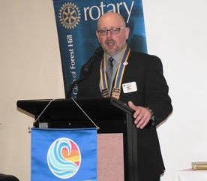
In this, the first of my columns since the changeover evening, I’d like to share some of the challenges I can already see I’m facing. There are a lot of emails. There are a lot of people in other clubs whom I do not know and, as is the norm with Rotary clubs of long standing, there is a lot of information that people ‘just know’. With that in mind, I’d ask that you give me a bit of time to get up to speed. But not too long.
On a related note, I’d like to ask club members to consider embracing (or at least trialling) some of the updated communication tools we now have access to. One of those is the Google Group email. It does not have all our corporate members, but it should be otherwise complete. I’ll be using it for any communication intended for club-wide consumption. I’d ask that you try it out. On a related note, for those with access to a Google Calendar, I’ll be putting events and activities there. Dates, times, places, rosters, duties and all similar pertinent information should be available in the one spot if I can get my act together. Panicked phone calls and emails to confirm last-minute details may at some point be unnecessary.
Organisation of fellowship events is now in my hands. I will organise the tickets for the monthly film nights (though, as Ron’s pointed out, I’ve yet to attend one), but change and new opportunities are also positive. I ask each one of you to think about not just what you might like to do, but what you think new members might be looking for. Lawn bowls? A one-day art class? Spelunking?
There is much to do this year, including the entirely new project of the Primary Schools Photography Competition. It’s a tremendous honour and privilege, but if I start to fall behind in my duties, please pull me up on it.
Coming Up
Saturday and Sunday, 28 & 29 July: Open House Melbourne
Saturday, 11 August Blackburn Market
Sunday, 12 August Whitehorse Farmers’ Market
Friday, 17 August: Rotary Club of Nunawading’s Christmas in August Dinner
Wednesday, 22 August: RCFH’s Primary School Speech Contest
Friday, 24 August Peridot Theatre’s performance of The Shoe Horn Sonata

Club Meeting Report 16 July
This was our Rotary Changeover meeting. Sgt Bob Williams opened the meeting with a brief reflection from Winston Churchill. “A pessimist sees the difficulties in every opportunity. An optimist sees the opportunity in every difficulty. We welcomed: Dist. Gov. Russell Gurney and Shelly, 2018-19 Assist. Gov. Joan Young, 2017-8 Assist. Gov. Graeme Aspinall, ROMAC representative- Graeme Chester, our partners, Honorary members- Marg Taylor, Kevin and Lynne Grigsbey, Heather Neilson and Glenys Coates. Mike introduced his guests, Martine, Morgan and Spencer.
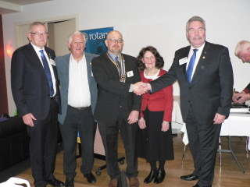

PDG Bob Laslett proposed a toast to Rotary International. DG Russell Gurney responded to the toast and gave us a few words of the RI vision for the up-coming year.
We had two great musical interludes by Spencer Finke playing the cello.
President Bill recognized the outgoing board and briefly commented on his year. He presented two Paul Harris Awards- Mike Finke and Glenys Grant. Both well deserved.
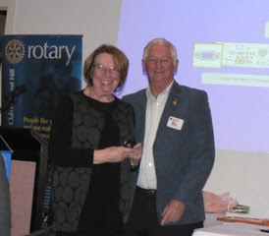
Glenys Coates presented a $1,000 cheque to Graeme Chester –ROMAC- to assist in their work. This donation was made possible by PP Roger Coates nominating this in his will.
The annual report was handed out and then Ron Brooks interviewed incoming president Mike and Kira.
Ron explored how they met. Met on the internet, Kira flew from London to New York and later Mike proposed near Niagara Falls. It was quite an unconventional courting and romance experience. Kira did well, getting 16 of 20 questions correct, concerning Mike’s likes.
President Bill did a formal induction of Mike. Our new president was presented with the Club Collar and the podium banner for 18/19 was unveiled.
Glenys Grant presented a bouquet of flowers to Judy Marsh.
President Mike Finke thanked Bill for his club leadership and Ray Smith presented Bill with photos and a USB of the photos of his year.
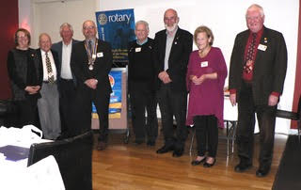
Mike introduced his Board and presented them with Director’s badges. Mike said it was an honour and a privilege to be president. Mike talked about his personal and work KPI’s and the boxes he hopes to tick in 18/ 19. He stressed we need to make money, induct new members and promote our club and Rotary. He hoped this would make Forest Hill a stronger and better club.
Our raffle had 8 prizes and it raised $117.
President Mike closed the meeting and thanked all present. Next week will be the first meeting of the new club board. Stuart Williams, with assistance from Bob Williams, will talk about and show images of the Toronto RI convention.
SW.
Blackburn Market
Takings from the Blackburn market
Stalls $335
Sausages $226.70
FOREST HILL COLLEGE BREAKFAST
This week and last it is the usual very reliable team of Robbie and Barbara W.

ROTARY MONTHLY THEMES
July Rotary Awareness
August Membership and Extension

ARTICLES
Please forward your prize-winning articles once more to rlaslett@optusnet.com.au by 5pm Wednesday.

Thoughtful Poem
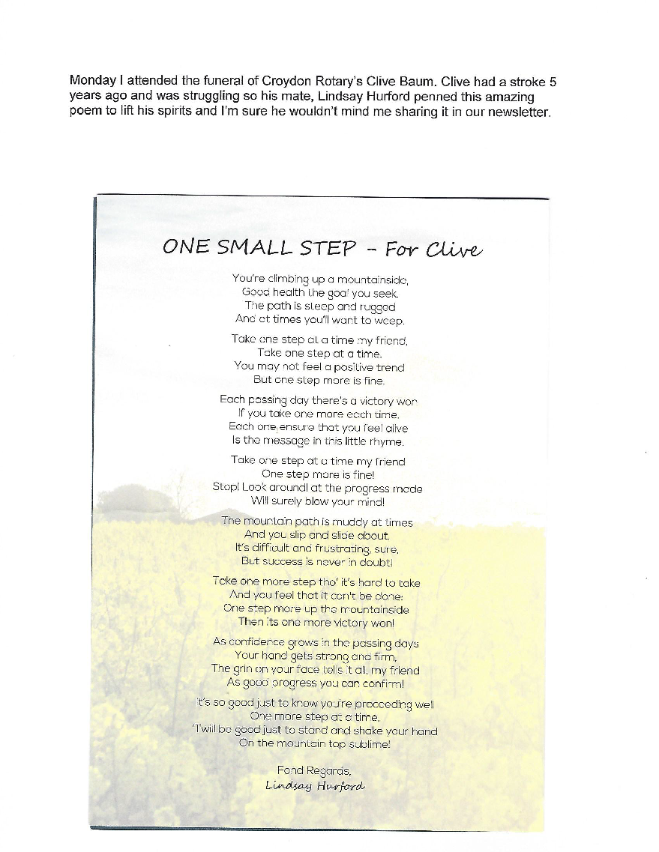
Bob W

