|  |  |  |
| --- | --- | --- |
|  | Weekly Newsletter  foresthillrotary@hotmail.com |  |
| Number 10: 8th Sept 2014  Club address: PO Box 116, Nunawading 3131  **Website:** [**www.foresthillrotary.com**](http://www.foresthillrotary.com)  Meeting location: Bucatini Restaurant, 454 Whitehorse Road, Mitcham, 3132  Meeting time: Monday 6.15 for 6.30 pm  **Facebook: ForestHill Rotary** | | |

|  |  |  |  |  |  |  |  |  |  |  |  |  |  |  |  |  |  |  |  |  |  |  |  |  |  |  |  |  |  |  |  |
| --- | --- | --- | --- | --- | --- | --- | --- | --- | --- | --- | --- | --- | --- | --- | --- | --- | --- | --- | --- | --- | --- | --- | --- | --- | --- | --- | --- | --- | --- | --- | --- |
| |  |  |  |  |  | | --- | --- | --- | --- | --- | | **CLUB PROGRAM** | | | | | | **Date**  **8th Sept** | **Event**  **Welfare at Forest Hill College - Marianne McEwan** | **Chair**  **Ron Brooks** | **Thanks/meeting report**  **John McPhee** |  | | **15th Sept**  **22nd Sept**  **29th Sept** | **DG Tony Monley Visit and Club Birthday**  **Murray Baird**  **ACNC**  **Footie fever night** | **Pres Bill Marsh**  **Jenny Coburn**  **Bob & Stu W** | **PE Bob Williams**  **Ray Smith**  **Stu & Bob Williams** |  |  THIS WEEK'S CELEBRATIONS Sept 13th Warwick Stott Club anniversary (39years) DUTY ROSTER  |  |  |  | | --- | --- | --- | |  | **Sept** | **October** | | Cashier | John McPhee | Jenny Coburn | | Recorder | Stuart Williams | Warwick Stott | | Greeter | Doug Berwick | Glenys Grant | | Emergency | Bob Williams | Ray Smith |  ATTENDANCE  |  | | --- | | **APOLOGY** – **IF A MEMBER IS NOT GOING TO COME TO THE MEETING or you intend bringing a guest**  **Please contact Ray Smith by** **10.00 am MONDAY** on9878 4891 or[rcssmith@optusnet.com.au](mailto:rcssmith@optusnet.com.au%20)  Any cancellation after 10.00 am should be made direct with the management of Bucatini Restaurant on 9873 0268 | |

Chris Tuck will be absent from 23rd Aug to 25th Sept

Doug Berwick will be absent from 21st Aug to 12th Sept

**BILL’S** **BLURB**

The trip by four members and one honorary member to Roger & Claire Davis' property was a most enjoyable day. I particularly enjoyed it as it gave me a chance to talk to the Davis boys in a relaxed atmosphere and I now know a great deal more about them and their relationship with our club, of which they have been long time supporters.

Lachlan Williams, from Fletchers Real Estate, has informed us that his firm will sponsor our first edition of Community Connections at Forest Hill and he hopes they will continue to sponsor future editions. Michael Sukkar's office will print our first edition in colour and future editions in B & W. They will also fold them for us - that will be a blessing for arthritic fingers!! Both offers are very generous and greatly appreciated. They will help us get our newsletter out to 9,500 homes in our area.

On Monday night we held the first of our weekly in-house raffles to raise some funds for the General Account and to help pay for our on-going membership drive. Each week we will raffle a bottle of wine or a box of chocolates. This week's winner was Glenys and she chose a lovely bottle of Shiraz that was generously donated by John Donaghey. John has also purchased a further dozen bottles for future prizes through his son, Tim, and Dan Murphys. Thanks John and Tim. This first raffle was wholeheartedly supported by members and we raised $69.

Our guest speaker for the night was Maree Chadwick who gave us a little of the background for Tai Chi, in particular Tai Chi for Arthritis. A very gentle, modified form that improves strength, balance and movement. It was a great session and Maree was ably supported by Ray Smith in her demonstrations.

Members all received a copy of "humanity in Motion" a beautifully presented book outlining all of the programs offered by RI worldwide. The books are $5 each and we have 5 spare copies if anyone would like to learn a little more about the work of Rotary.

On December 8th the World RI President will be addressing a Foundation Conference at the Knox Club. We have slotted the date into our program and are proposing that we attend the Conference instead of our normal meeting. Should be a good night for partners and friends to attend. A great opportunity to hear one of the Rotary leaders who, for the most part, do not normally enter our Rotary lives.

On Wednesday 19th November Box Hill Central are organising a Cluster event 'Rotarians Against Child Slavery'. Cost will be about $15 and the venue is to be decided. We hope that as many members and partners as possible will attend as the topic will be very interesting, perhaps disturbing, and it will also be a chance for us to support another Cluster club. Please put it into your diary. More details and commitments in the next couple of weeks.

Great news with "Larry". The Blackburn Lake Sanctuary Committee are going to share the cost of a reprint of 150 copies of "Larry the Lorikeet at Blackburn Lake Sanctuary" with our club. This is a magnificent children's book that we are selling for $20. Great as a birthday or Christmas present. If you would like one, or more, copies please contact Glenys with your details so we can put a copy aside for you. The first run sold out in an hour so you will need to be quick.

We have our Film Night coming up on Friday and then on the 14 - 15 September we have Market Madness! Our Blackburn Market on Saturday, the Whitehorse Farmers' Market on Sunday and also on Sunday the Schwerkolt Cottage sausage sizzle for the Whitehorse Historical Society. A fine, sunny weekend will be greatly appreciated by all.

We were particularly pleased to be able to welcome Ken Follett to our meeting on Monday. Ken is a long time Rotarian and a member of the Rotary Club of Sunshine. Sunshine have just changed to breakfast meetings which make it difficult for Ken to attend so, hopefully, we may see Ken again at future meetings.

**Little Known Fact**: Lava can flow as fast as a sprinting greyhound.

**Enjoy your week in Rotary and keep working to "Light Up Rotary"**

Pres Bill

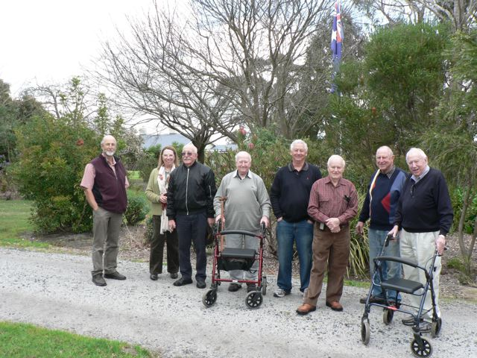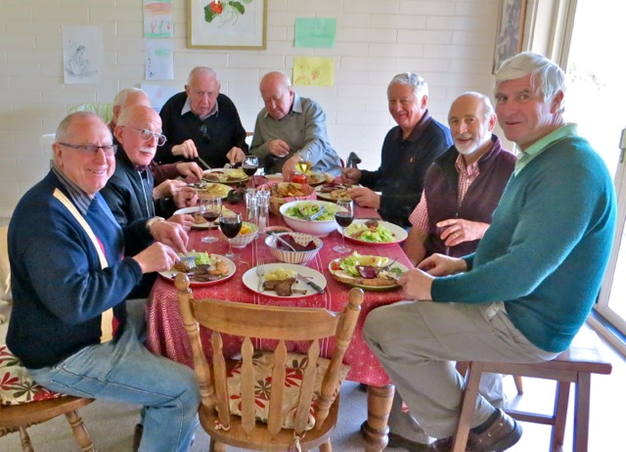

A stroll around the Davis garden Fuel for a strenuous garden walk

**LAST WEEK’S MEETING**

The meeting commenced with the introduction of a visiting Rotarian Ken Follett from Sunshine, and Meryl Johnson. We are sorry to hear that Graham Sharman is in hospital with septicaemia.

Pres Bill mentioned about the very enjoyable trip to the Davis family property (which may be repeated again next year), the very successful Primary School Speech Contest, that Fletchers would sponsor the delivery of 10000 leaflets in the area to “sell” the club, whilst our local parliamentarian (Michael Sukkar) will sponsor the colour printing of them. He also mentioned that we would be raffling a bottle of wine or a box of chocolates each week for the general account to pay for our membership drive, that Humanity in Motion will be given to all club members (for $5), that Rotary Foundation will be hosting a meeting at the Whitehorse Centre on 8th December with the RI President in attendance, that Larry will be delivered to all local schools (and Glenys needs assistance from members to do it), that Blackburn Lake Sanctuary will buy and pay for 75 Larry books, so we will reorder another 150, that all service committees have had their budget cut by 20% (sounds a bit like governments recently), and that Forest Hill College will be a corporate member of the club.

Other members mentioned that the member who gives the vote of thanks must also do the report for the flyer (Sec Ron), that Warwick desperately needs the membership forms from members, that we are sending students to RYPEN and the Science Experience (Glenys), that the Counselling and Wellbeing Leader at Forest Hill College is our guest speaker next week (Jenny).

Later a very interesting, informative and lively meeting with a speaker who kept everyone watching her movements of Tai Chi, and those of her young(??) assistant.

Chairman Ray Smith introduced the speaker to the meeting with the symbol of Tai Chi in timber, appearing to be two curved tear drops locked together in a circle. He himself found that Tai Chi was life changing, challenging and frustrating. He mentioned that our speaker Maree Chadwick had been in Occupational Therapy until she discovered Tai Chi. She had not been a sporting person but her father had been so and he urged her to exercise. Her form of Tai Chi is called Tai Chi for arthritis, and was developed by Dr Paul Ham, a Sydneysider and he modernized it for Australian conditions. It was originally from China where it had been a very ancient art, where it was used in 3 forms, viz., for exercise, for meditation and for exercise for their fighting men. Modern Tai Chi is a relic of the original, where the original style was Yang, whilst the most modern is Sung which she teaches. Dr Ham devised TaiChi for arthritis, which he has taken world-wide, and now there are probably 5 million people who participate. There is also a simple form for diabetics.. The movements are slow, and you learn how to move slowly and safely, to help prevent falls. It is good for concentration and memory. There is also a form called Chi Gong. It won’t take away arthritis but joints become more flexible. After the talk both Maree and Ray gave a beautiful, seriously concentrating demonstration, which was a sheer delight to watch.

The meeting ended with the drawing of the first weekly raffle of wine or chocolates, which was won by Glenys (who chose the shiraz) – half your luck, and please enjoy it

Notes by Warwick Stott

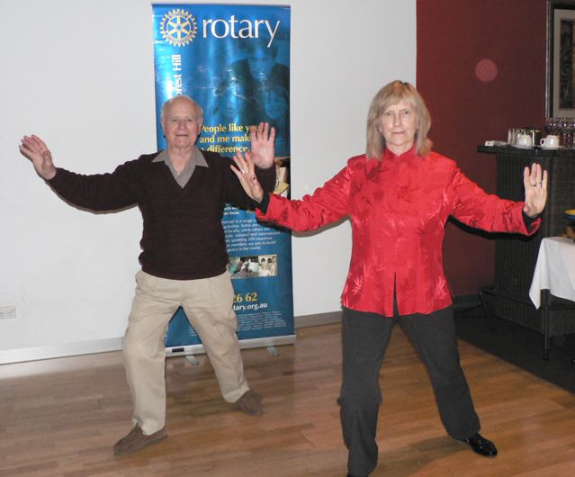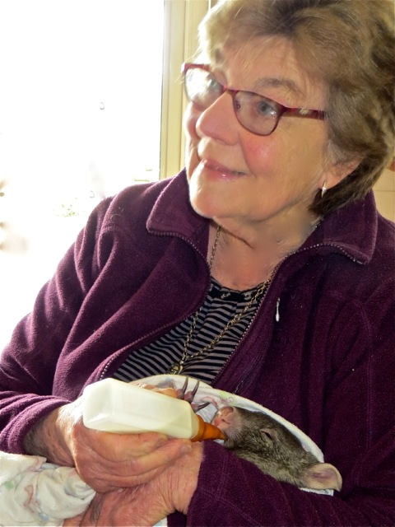

Instructor and pupil. Which is which? Clare Davis caring for a baby wombat

# DON HULLAND

Don is not too well. His arthritis is a real problem. He is at present in Kellock Lodge in respite and hoping to be able to stay there full time. The address is 15 Bon St, Alexandria 3714 and his telephone is 0409 530 435. Why don’t you give him a call or write to him.

**DINNER AUCTION FOR SOUTH SUDAN SCHOOL**

RC of Manningham is running a dinner auction at 7 for 7-30pm on Saturday 11th October at Monte Carlo receptions, 5 Mitchell Street, Doncaster East. Cost is $70 per person for a buffet dinner with drinks at bar prices. All proceeds to go towards the cost of building a school in Rumbek, South Sudan. For further details see article later in the Bulletin. If you wish to join us at our table on the night please let Bob know by the 10th September. Thank you

Barbara and Bob Williams

**“LARRY the LORIKEET” BOOK**

Take action NOW. If you want to buy a copy … or two, ….. or three, then give your order into Pres Bill ([**bjmarsh@bigpond.net.au**](mailto:bjmarsh@bigpond.net.au)) as we are planning a second print run if the demand is large enough.

# WEBSITE

This needs updating as there is nothing about any projects done in the last few years. It makes it look like we have done nothing. Having old stuff is worse than having no stuff. What about Hope Katolo, Hand Brake Turn, Larry, Youth Achievement Awards, Apprentice Awards, I need photos and some short written stories. As from the end of the week, I will be deleting all stuff over three years old.

Do not forget to check out our website, [www.foresthillrotary.com](http://www.foresthillrotary.com) and send Ron Brooks any information and suggestions.

**WEBINAR ABOUT MEMBERSHIP AND CLUB MEETINGS 27th and 28th August**

**What an excellent** **RI initiative for the August Membership month in Rotary.** I hope many of you logged on to one of the two webinars. The beauty was you could have been anywhere in the world and taken part. Evidently there were people logged in from Malaysia, Indonesia, Africa, Europe, etc. Four speakers gave specific examples of how we can be **Flexible and Innovative**. PDG Jessie Harman (Wendouree) , Des Lawson (Port of Brisbane), Kaye Kitmarsh (Rotary Club of NextGen, a Qsld based eClub with members in Germany, USA, and NSW) and PDG Noel Trevaskis (organiser) shared how some Clubs have gone about their approach to membership, club meetings, and diversity. They stressed that clubs are autonomous so within quite wide boundaries can do many things.

Clubs now meet on Saturdays. Port of Brisbane decided to alternate between breakfast and dinner each week as some people were available mornings and some evenings. After 6 months they found that many liked the club so much they were able to alter their arrangements and come every week. Stawell have just one large committee of the whole club. Maryborough had difficulty attracting women as they nly had one, so targeted 15 women and asked them all to join together-6 did. Some clubs have gone to another service organisations and offered to do a project for them as a combined project and having one of them on the Rotary committee. They see how rotary works, the project knows exactly what the other group need and some of these people have joined Rotary as they see it as useful to their organisation. One district made $60,000 available to clubs for supporting getting new members.

Corporate membership was talked about. There are 100 clubs on a pilot in the world and neither RI nor the district have any problems with the concept. One club allows anyone from an organisation to attend Rotary if two people from that organisation join. Another has set a limit of 5 corporate members. Another has said one of three specified people can attend any meeting if the company pays for 1 membership (with one specified person officially being the Rotarian). Some clubs have similar arrangements for an “Associate” or a “Friend” and perhaps they pay half annual fees or no fees and are not made Rotarians. All the above category people are covered by rotary isurance if they are working on an official Rotary project. The next council on Legislation has a motion to change meetings from “weekly” to “regular” for the 50% attendance requirement. A list of publications available were discussed (they can be sourced via the website). There was so much more.

Notes by Ron Brooks

# HOPE KATOLO SCHOOL

More photos from the school we support. You saw the water tanks we paid for last time. Below is the almost complete chicken shed.

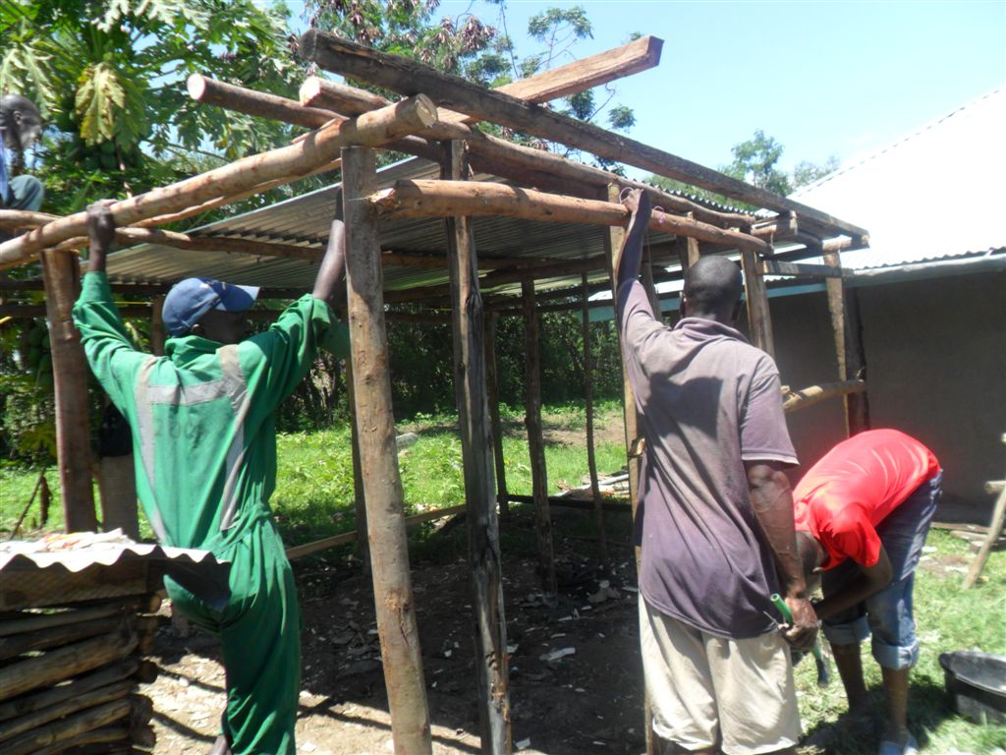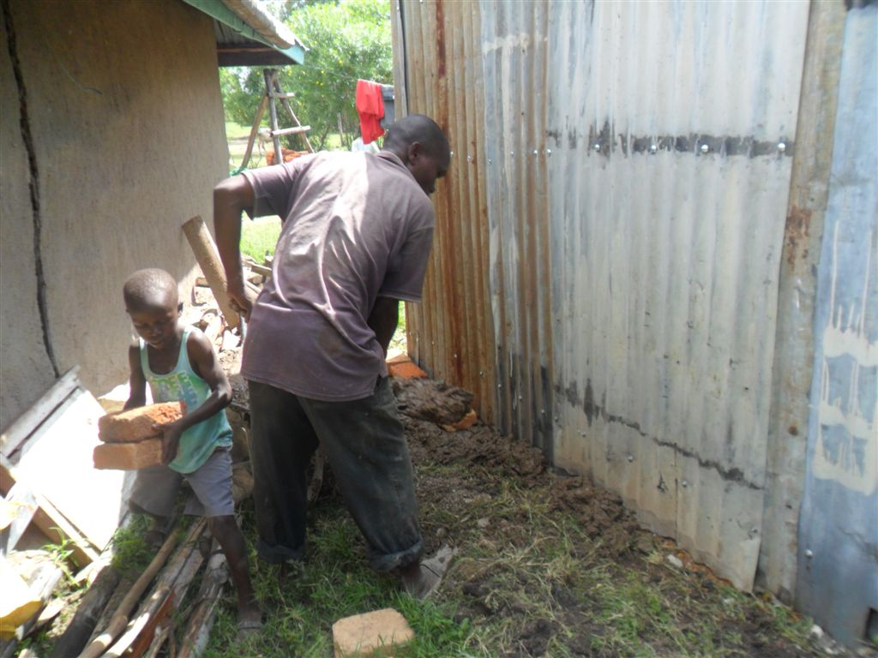

# REASONS FOR JOINING ROTARY

Jenny Coburn gave me a list of reasons, I am putting in a different one every week - **think about them when you talk to prospective members**

**Continuing Education:** Each weekly meeting provides an opportunity to listen to different expert speakers on a variety of timely topics

**WEEKLY RAFFLE.**

We are now running a weekly raffle, winner’s choice of a bottle of white wine, red wine, or a box of chocolates. Tickets $2 each or 3 for $5. Proceeds will go to our General account to help keep costs down. It raised $69 last week. Fantastic

**South Sudan Dinner Auction -Saturday 11th October 2014**

The Melbourne Rumbek Primary School Committee, of whom I’m a member, and the RC of Manningham are running a dinner auction at Monte Carlo Receptions, 5 Mitchell Street Doncaster East at 7 pm for 7-30pm on Saturday 11th October 2014. Full buffet dinner at a cost of $70 per person plus drinks at bar prices.

You may remember that Samuel Manhom spoke at our club a couple of years ago now of his experiences as a refugee from South Sudan escaping from the Civil War there and of his desire to build a school in his home town of Rumbek in South Sudan. My link is that when I was at Good Shepherd I employed Samuel as the accounts person as his first “desk” job in Australia and he impressed me as a wonderful young man with a vision and when he spoke of forming a committee to explore the possibility of building a school there I readily “joined up.”

The project is under the umbrella of R.A.W.C.S. and so has tax deductibility etc. There is still some unrest in South Sudan but mainly in the capital of Juba which is several hours away from Rumbek. Whatever the result of our fund raising for the project we wouldn’t commence building until total peace is possible. If this proves to not be possible then all money raised will go towards an existing school near the town to build extra classrooms and employ extra teachers etc. Sam‘s strong desire is that the school will have equal numbers of girls and boys as there is at present little education opportunities for girls in South Sudan. There is a Rotary Club in Juba and they are willing to assist where possible. Our committee has equal representation from the local South Sudanese community here and so have good links to schools and contractors there.

Samuel has been to Rumbek and has acquired land to build the school from the local chief and has organised costing from local contractors there. He also met with Government and Education Ministry officials and has their support for the project as they recognise the great need but of course there are no local funds for such a project. The local Education Ministry has promised to provide trained teachers. The local South Sudanese community here are so thankful for our input and have made South Sudanese singers and dancers available for the entertainment on the night. The idea (still being formed) is to have tables of 10 with perhaps 2 of the table being local South Sudanese.

We meet monthly at North Melbourne Football Club and they have promised us some auction prizes for our auction plus there will be a silent auction as well as raffles. To find out more about the project go to <http://southsudanschool.org/> It would be great to have at least one table from Forest Hill, or as many as we can.

Please let me know by the 10th September if you can come and I will book you in with Barbara and me.

Notes by Bob Williams

**STAMPS**

Please cut out all the stamps you get on your snail mail leaving an approximate 1cm margin and give to Jenny Coburn. They are worth nothing to you but Rotary sells them. Over $89,000 since starting in 1991/92 and $7,091 in 2013/14.

**WHITEHORSE FARMERS’ MARKET**

**Egg and Bacon Stall and Information Table**

Sunday 12th October

Our club is manning both the egg and bacon stall and the information table and we need 17, repeat ***17*** assistants on the day. Please see Warwick Stott (Mob 0412444393, email [wstott@netspace.net.au](mailto:wstott@netspace.net.au)) to offer your help for a 2 hour shift of cooking, conversing and enjoying a beaut Rotary project. We need you, being either Rotarians, partners, friends of Rotary, offspring, and possibly friends of individual Rotarians, because it is a huge number for our small club

**BALLARAT CONFERENCE 2015**

A booking has been made for 6 double rooms at Ballarat Lodge  for District Conference.( Fri 13 - Sunday 15 March 2015.  Rooms booked for Fri night and Saturday night at the venue of the Saturday night function.

Families  Grant/ Williams, Bob/ Williams, Stuart/ Brooks/Laslett/Marsh.     Jenny and Roger will stay in own accommodation.

Cost  $149 per night.  FULL Buffet breakfast if required $20.  I believe no money needs to be paid until we arrive. (I believe the Saturday Night function will be held at this venue)

Stuart Williams

On to Conference organiser

Club officers & Committees 2014-15

**President** Bill Marsh

**Vice President** John Donaghey

**Secretary** Ron Brooks

**Treasurer** Warwick Stott

**President Elect** Bob Williams

**Sergeant** Stuart Williams

**Foundation & International** Chris Tuck

Members: John Donaghey, Stan Harper,

**Youth Service** Glenys Grant

Members: Ray Smith, Bob Williams, Graham Sharman

**Community & Vocation** Bob Laslett

Members: Stuart Williams, Gary Baltissen, Ron Brooks

**Membership & Publicity** Doug Berwick

Members: John McPhee, Warwick Stott, Jenny Coburn

**Fellowship** John McPhee

**Primary Schools Speech Night** John McPhee

**Programme** Ray Smith & Gary Baltissen

**Bulletin Editor** Ron Brooks

**Web page & Facebook** Ron Brooks

**On to Conference** Stuart Williams

**Historian** Stan Harper

**Almoner** Graham Sharman

**Public Officer** Bill Marsh

Note that Bob Williams has volunteered to swop over from Foundation/International to Youth Services to support Glenys and Ray as Graham will be spending very little time in Melbourne.

Newsletter articles to the editor at [ronbrooks1@optusnet.com.au](mailto:ronbrooks1@optusnet.com.au) by **5 pm Wed**. If you do not wish to receive this publcation please contact the editor.

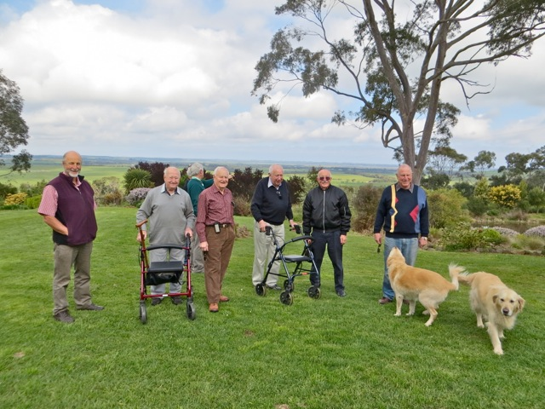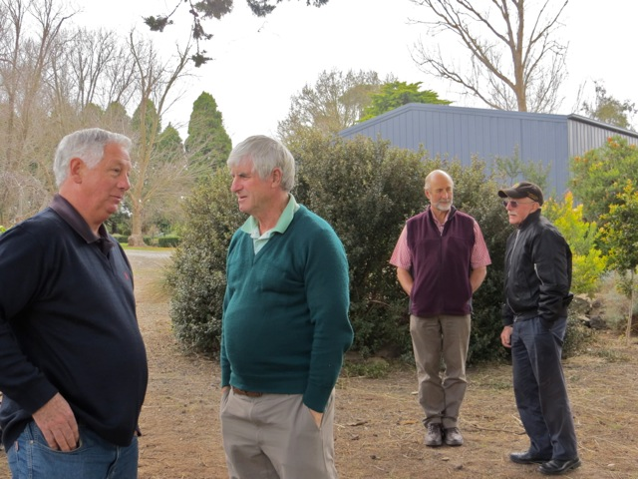

View from the Davis garden Serious talk