FOREST HILL HAPPENINGS
No. 11 President: Bill Marsh 14 September 2022

BILL’S BY-LINE

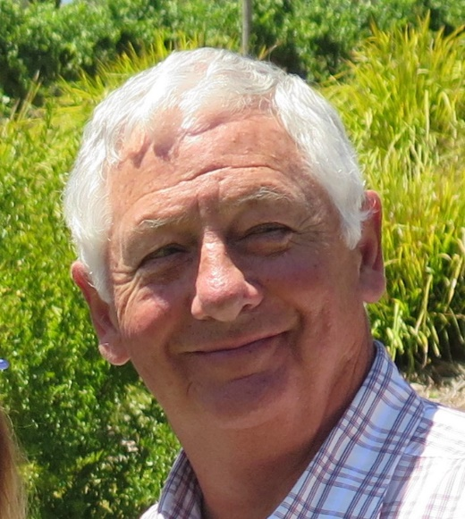
On Monday evening our club celebrated its 47th Birthday. We were very pleased to also welcome DG Ken Miller for his ‘official’ annual visit. Ken was ably assisted by AG Catherine Elfick. It was a pleasure to welcome Judith Eadon from the RC Nunawading join us for the evening. RC Forest Hill was formed in 1975 when a number of RC Nunawading members opted to start up a new club and we have enjoyed a close relationship ever since.
The night was made even more special because Warwick Stott, still an active member, and a Charter Member of the club was on hand to blow out the candles and cut the cake. A number of Honorary Members and partners were also able to join us for the occasion.
After the meal and birthday festivities DG Ken rounded out the evening with an excellent presentation in which he highlighted the achievements of the club and spoke about the areas where the club could look to improve. Obviously, the key area is membership (along with most clubs) and Ken stressed how the District team could assist, and, in fact, was eager to assist, in anything the club wanted to pursue. It was an enjoyable note to end the evening and we thank DG Ken for his time, patience and great company. Bob Laslett presented Ken with a bottle of wine as a Thank You.
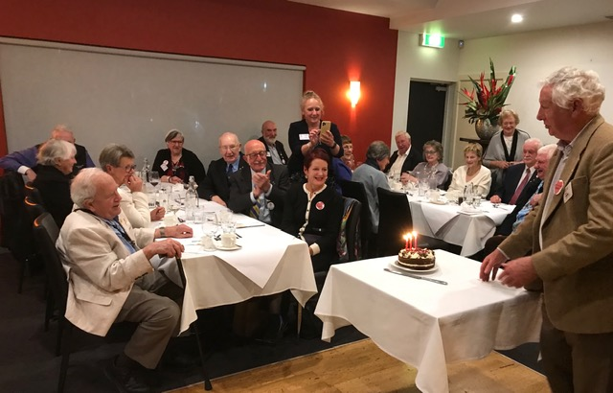
We have just had a very busy, but very successful, weekend. Our Blackburn Market on Saturday, WFM on Sunday and the Whitehorse Historical Society Open Day at Schwerkolt Cottage were all great days that were blessed with good weather. Thank you to all who worked so hard to make them successful events.
Peridot Theatre is now on Friday 30th September. Please let me know ASAP if you are going to join us. This will enable me to confirm our booking or add additional seats if required.
We had our first Film Night for a long time. Nine of us ventured over to Forest Hill where we spread ourselves around three different films. Six of us had a very nice meal at the new Lebanese restaurant – on the left just as you come into the top floor from the carpark. Social distancing was not a problem – the restaurant is large and was not crowded and there were only three others in the theatre. Our next Film Night is planned for the 7th October. I hope even more members and partners can join us for an enjoyable evening.
Presidents are now taking more details back to their clubs regarding the APH Holdings proposed market. We will meet again on the 29th to decide if we are to proceed.
Have a great week and ‘Make a Difference’.
September is
Basic Education and Literacy
Month

Bill

MEETING REPORT- 12 September- 47th Club Birthday and DG visit
President Bill opened the meeting with a welcome to country and acknowledged RI and our wonderful country.
It was delightful to be able to welcome- District Governor Ken Miller, Assistant Governor Catherine Elfick, partners- Judy Marsh, Judy Laslett, Robbie Brooks, Chris Stott and Marg McPhee. We also welcomed honorary members Glenys Coates and Heather Neilson. We were also delighted to have the hard-working District secretary- Judith Eadon from the RC of Nunawading joining us.
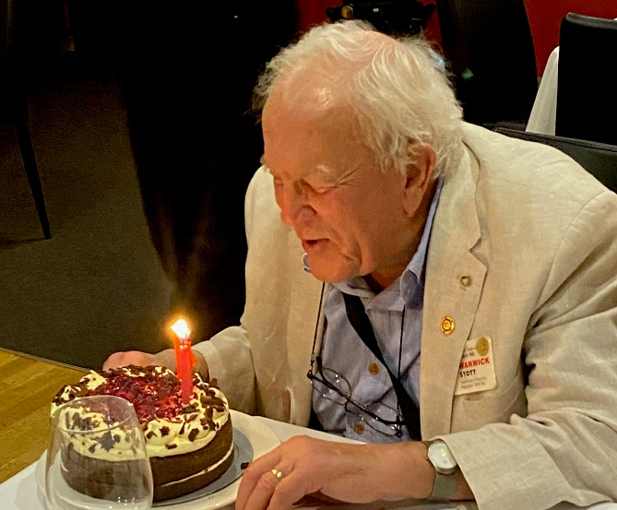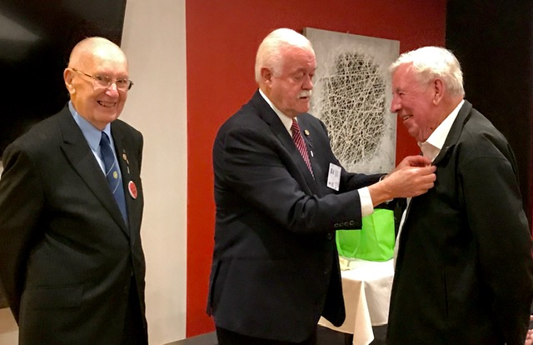
We enjoyed a slightly different meal- entrée of cold cuts, a main course and a tasty black forest birthday cake. Then Warwick Stott (a Charter member of our club) took delight in blowing out the candles.
Bill’s announcements and comments included- APH possible market, our Blackburn Craft market and sausage sizzle, WFM bucket rattling, Schwerkolt Cottage and Whitehorse Historical Society Open Day…there we had Glenys Grant, Barb Searle, Bob Williams, Bill Marsh and Stuart Williams. We managed to cook over 800 sausages—all working under pressure because at times we had 40 people in the queue. Bill mentioned the successful film night and the excellent Lebanese restaurant at Forest Hill. Peridot Theatre has been changed to 30 Sept. Contact Bill for tickets.
It was a proud moment when PP John Bindon and DG Ken Miller presented a PHF- with 2 sapphires – to John McPhee. John’s work managing our Blackburn art and craft market was highlighted.
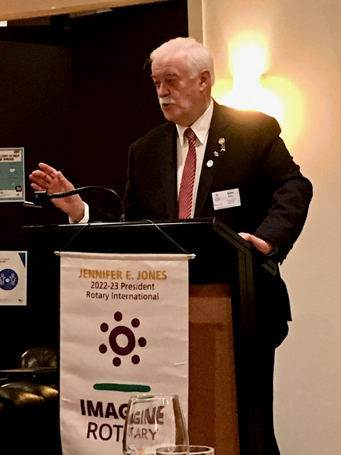
Bill then introduced DG Ken to address the club. The DG thanked the club for its comprehensive contribution to Rotary in our district and to the world through RI. We have for many years been excellent contributors to Polio Plus, the Rotary Foundation, Interplast, ROMAC and Centurion project, stamps and coins. Ken also congratulated the club on its many young peoples’ programs.
The information part of Ken’s speech outlined his 4 Focus Areas for our Rotary. The public image committee have a card with – 10 reasons to join Rotary. He also mentioned the future regionalization vote and the district conference in Canberra- 3,4, 5 March. Saturday night dinner- in the Great Hall of Parliament House- has a theme- Through the Ages.
The DG’s project this year is- The Rotary Foundation.
In late May we have an amazing opportunity to attend an RI Convention, being held for a second time in Melbourne.
PDG Bob Laslett thanked Ken.
The raffle raised $85 – winners –Barb Searle, Judy Marsh, Ron Brooks.
Next week’s meeting- 19 September, at Bucatini- Guest Speaker Ron Brooks.
Stuart Williams

NEXT MEETING
19 September Chateaux of the Loire Valley Ron Brooks
Club roster for 19 September 2022.
Chairperson: Barbara Searle
Greeter: Stuart Williams
Notes for “Happenings” Bob Laslett
Thanks John McPhee
Cashier & Recorder: Bob Williams

COMING UP
26 September Footy fever Bob/Stuart Williams
28 September A ticket to paradise
3 October Women of Whitehorse Jennifer Brosnan
7 October Film night
10 October Bees Michael Johnson
CELEBRATIONS
Keep celebrating our club’s 47th birthday and charter member Warwick.

RC of Forest Hill Football Tipping 2022
25 Participants at $30 = $750
Of that - $7.00 X 25 = $175 to be paid to Hope Katolo (plus the $5 from round 23 where 5 participants tipped 9 winners— (the Administrator decided that one dollar each would be added to the HK money.) therefore $180.
To distribute to participants- $575.
80% for end yr prize = $460
20% for weekly prizes = $115 ie $5.00 per week if pick 9 winners.
Top tipsters % of prize money
38% --- FIRST $174.80
26% --- SECOND $ 119.60
Bob Laslett and Bob Williams tied on 146 winners. $147.50 each
17% for THIRD Lachlan Williams $ 78
12% for Fourth Barbara Williams $ 55
7% for Fifth Candice Fergus $ 32
100% $ 460
Bob Williams and Barbara Williams are not relations of mine. Lach is my son.
Weekly tipsters who picked 9 winners
Rd 9 Rebecca Tzerefos =$45
Rd 11 Todd Briscoe =$10
Rd 19 Sandra Sexton = $40
Rd 22 Judith Eadon, Stuart Williams ($7.50 each) = $15
Total $ 110
In Round 23 – 5 tipsters picked 9 winners- $1 each—Bob Williams, Lachlan Williams, Judith Eadon, Sandra Sexton, Sybil Yardin. Hope Katolo appreciate the one dollar each of you donated.
Thanks for participating. Please get more tipsters involved in 2023 Stuart W
Hope Assisting local Tradies (HALT)
Join Mark Foley from HALT with work places, tradies, bowlers, Rotarians and community, for a free brekkie Egg / Bacon / Snag / Coffee & Wellbeing toolkit
We are passionate about raising awareness associated with mental health, reducing stigmas, building bridges between support services and strengthening social connection.
Tuesday 27 September 2022 7:00 AM - 9:00 AM South Oakleigh Bowling Club 1216 North Road Oakleigh South RSVP Jackie 0408 105 598 or jackie.gleeson7@gmail.com, by Friday 23 September.
Rotary Club Oakleigh Clayton Huntingdale.

Sproutings
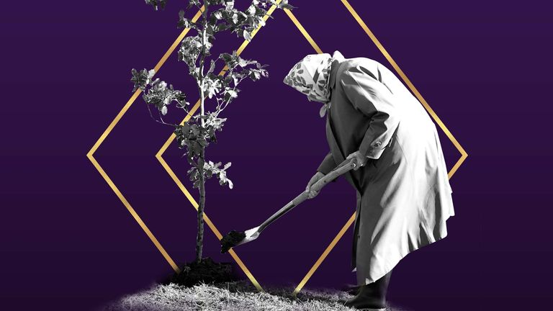

Elizabeth11

April 21, 1926- September 8, 2022

The Queen's Green Canopy (QGC) was a tree planting initiative created to mark Her Majesty's Platinum Jubilee in 2022

Queen and climate:

When it came to the environment, her actions spoke louder than words

Sky News: Victoria Seabrook @SeabrookClimate, Climate reporter , 8 September 2022 19:51, UK

While some of her family members were more active as environmentalists, the Queen loved the natural world - and led by example.

For a leader in her position, the Queen trod relatively lightly on the planet, according to royal historian Kate Williams.
"As a person, she was very frugal, and it's very much about her upbringing as a war baby," she said.
Her Majesty's simple diet of local produce and meat had low food miles.

She reused wrapping paper, kept furniture for decades, re-wore outfits, farmed honey at Buckingham Palace and took holidays in Scotland at her Balmoral estate.

While some of her family members were more openly and prominently associated with environmentalism - Prince Philip was president of the World Wildlife Fund; Prince Charles championed organic farming; Prince William founded the environmental Earthshot prize - the Queen held dozens of patronages and links with environmental organisations, from African Parks to Botanic Gardens.
Trees sprang up all around the country in her Platinum Jubilee year, after she requested everyone mark the occasion by planting trees as a part of her Queen's Green Canopy project.

E&ENews: A king for the climate takes the throne in England
By Sara Schonhardt | 09/09/2022 06:40 AM EDT
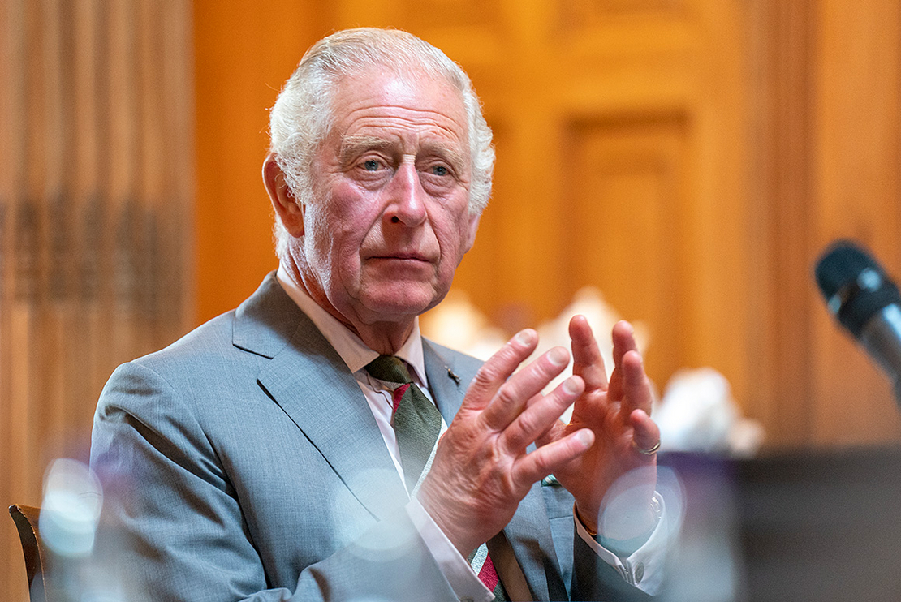

King Charles III is seen Wednesday during a roundtable on allergies and the environment in Scotland.
Jane Barlow - WPA Pool/Getty Images

The world now has a climate king.

When Prince Charles became King Charles III on Thursday after the death of his mother, Queen Elizabeth II, his decades long crusades to elevate environmental protection ascended to the throne with him.
Charles gave his first speech on the topic in 1970, revealing an interest that has evolved over the past half-century. He has used his public persona to advocate for forest, soil, ocean and biodiversity conservation and has pushed businesses to invest in programs to preserve and value nature.
“King Charles has demonstrated a very long-lasting and extremely deep knowledge of the impact of human activities on the environment,” said Bob Ward, policy and communications director at the Grantham Research Institute on Climate Change in London. “In many ways, he has been ahead of politicians in his appreciation and concern for the issue.”
Read more at https://www.eenews.net/articles/a-king-for-the-climate-takes-the-throne-in-england/

As Queen Elizabeth II dies, climate advocate King Charles takes the throne

King Charles III has campaigned on environmental issues for more than 50 years and was an early advocate for climate action
By Joe Lo htps://www.climatechangenews.comPublished on 09/09/2022, 2:47pm

Veteran climate advocate Prince Charles has become King Charles III
Charles has always been quite passionate and outspoken on environmental issues and has lobbied politicians for his favoured environmental policies. These have largely focused on nature conservation rather than clean technology or redistribution of resources.

British environmentalist Tony Juniper is a former adviser to Charles. He told Climate Home News: “I think he’s done pretty much more than anyone really to raise awareness and draw attention to what’s needed and, most importantly, to bring people together to think through the solutions… the depth of his knowledge and the breadth of his interests is really quite remarkable.”

Asked what motivates the king, Juniper said: “He is very focused on people… this is all about the wellbeing and the welfare of humankind, you know, the fact of him finding common cause with indigenous people in the rainforest, visiting flood victims in England, helping communities whose livelihood is threatened by the collapse of fish stocks.”

The Guardian revealed in 2015 that Charles had lobbied UK government ministers on a range of issues including environmental concerns. In 2005, he wrote to the then UK prime minister Tony Blair about the “enormous problem of climate change”, urging him to promote energy efficiency and adopt a stringent emissions trading system.

Early environmentalism
Charles has also campaigned publicly on environmental issues. In 1970, he listened to his father Phillip tell the conference on world pollution in Strasbourg that they “need to act now on pollution before it’s too late”.

Ten days later, Charles himself warned, about overpopulation, plastic waste, oil pollution at sea and growing pollution from “gases pumped out by endless cars and aeroplanes”.
When climate change entered the agenda, Charles was an early and consistent advocate for action. He regularly gives keynote speeches at climate talks.

Climate consultant Nick Brooks told Climate Home that Charles could exert influence as head of state, despite the ceremonial nature of the monarchy.
https://www.climatechangenews.com/2022/09/09/as-queen-elizabeth-ii-dies-climate-advocate-king-charles-iii-takes-throne/

‘There is hope’: Prince William in rallying cry for the environment
“Together, if we harness the very best of humankind and restore our planet we will protect it for our children, for our grandchildren and for future generations to come,”

Glenys

.

RCFH BLACKBURN STATION CRAFT MARKET – TRADERS OF THE MONTH
Powerhouse Cheese Barbara Power started making her own cheeses over 10 years ago. With a degree in Microbiology, she had a good scientific foundation to base her production. Two years ago, she started up her own commercial business Powerhouse Cheese and persuaded her sister, Donna Hall, who also has a Science degree, to leave her native New Zealand and join her in this venture. These two Artisan Cheesemakers use cow’s milk in small 100 litre batches of milk from St David’s Dairy in Fitzroy. They sell their cheeses at markets every Saturday and Sunday around the Melbourne area or you can order online for pick up on Monday afternoon. The rest of the week you will find them busy in their cheesery making their standard Blackburn Blue, Whitehorse White and Ash Bree cheeses or producing new varieties like their Bellbird Blue or a surface ripened Rosella Red which may become another standard offering in the future. Certainly, these two talented very local artisan cheesemakers running Powerhouse Cheese have a future.
www.powerhousecheese.com.au
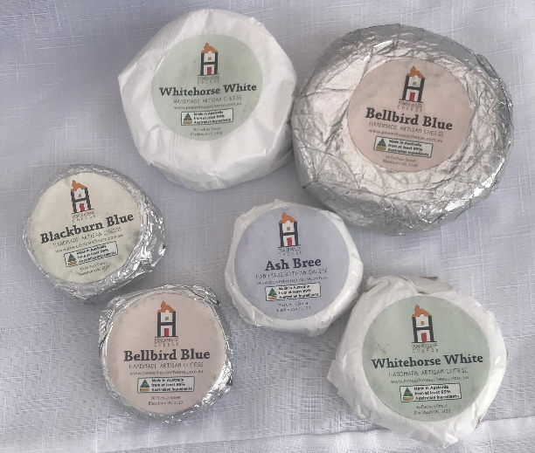
Dawn’s Flowers
Dawn Hooton has been a regular at the Blackburn Craft Market from the very beginning. If you want her plants, you have to come to our market as she sells nowhere else. Dawn lives in Forest Hill and propagates every plant herself from her own seeds or cuttings. Her love of flowers and gardening started as a young girl when her father bought her a packet of fuchsia seeds………. it has been her hobby ever since. It’s amazing looking at the large healthy specimens of evergreen perennials such as the fuchsias, ferns, and pelargoniums she sells with long flowering periods all at very reasonable prices.
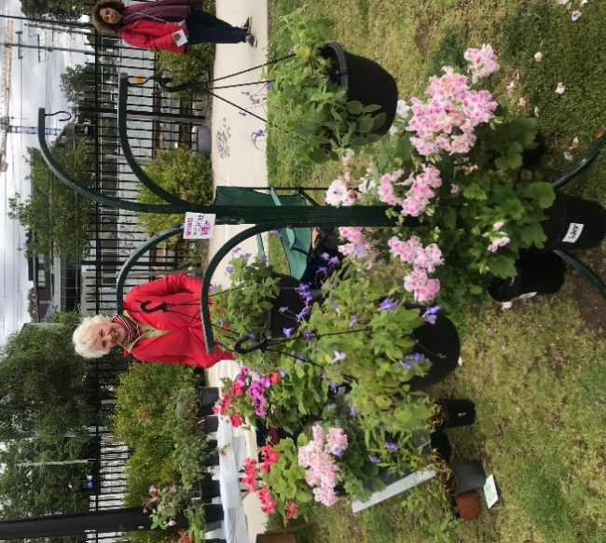 | 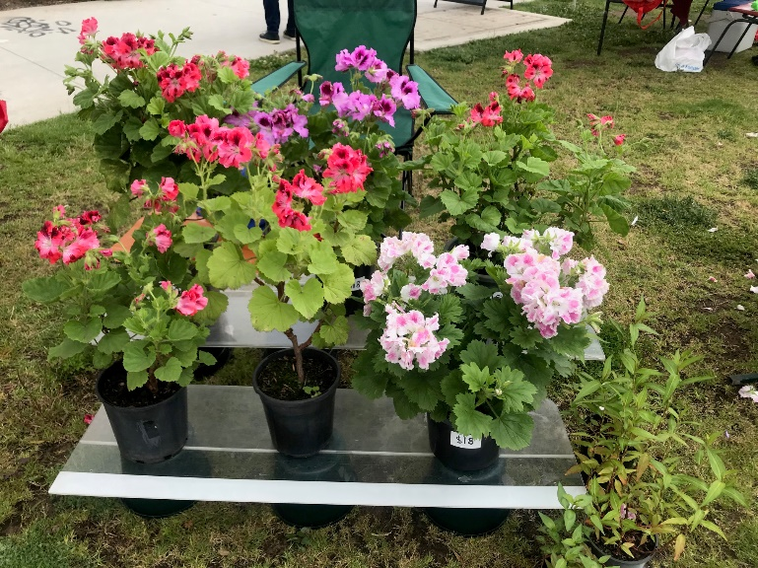

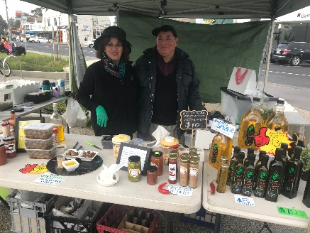 | 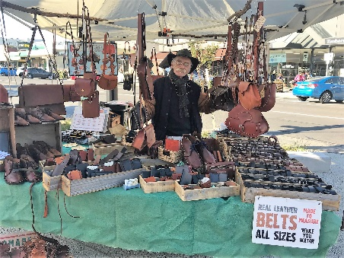 | 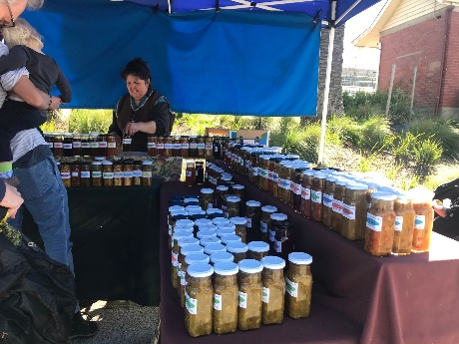
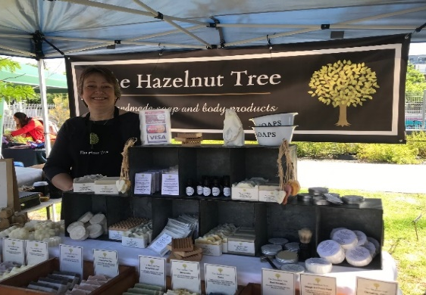 | 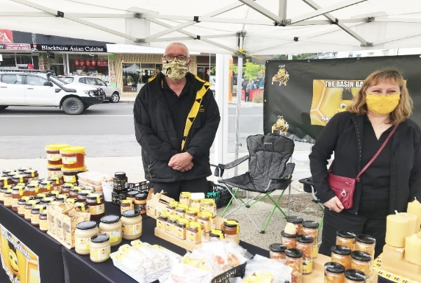 | 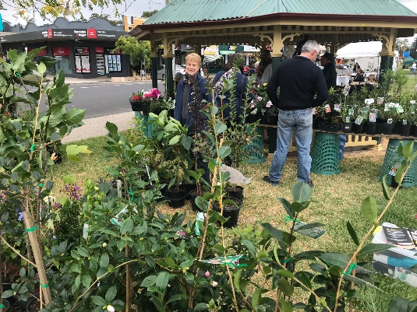
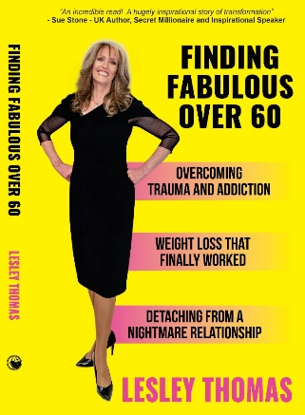 | 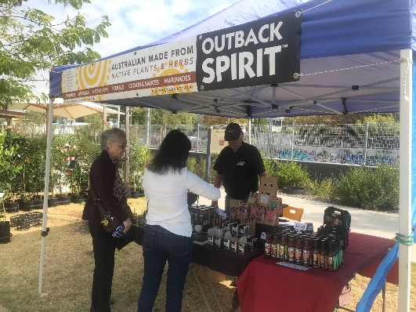 | 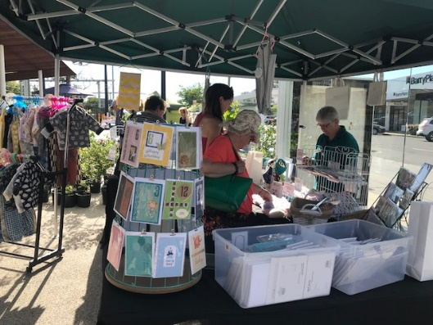
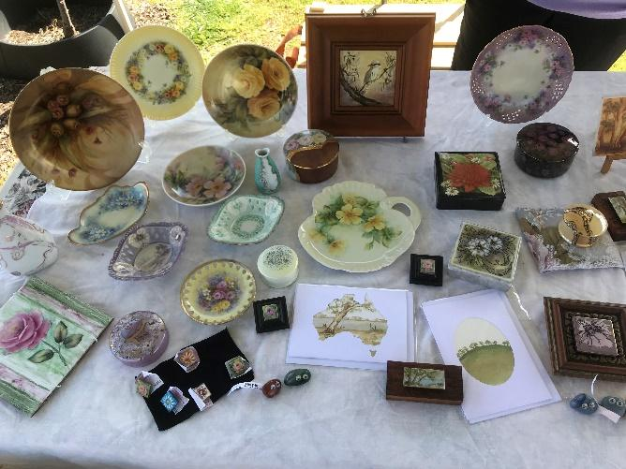 | 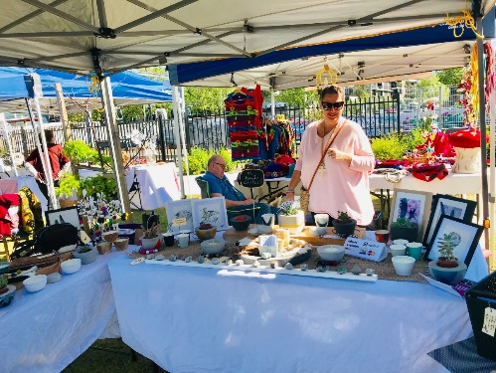 | 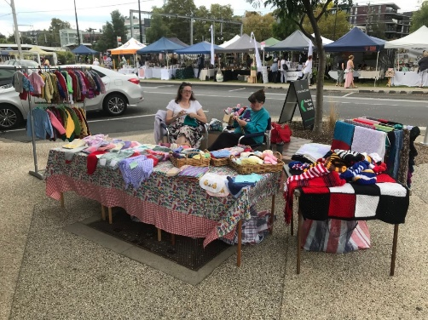
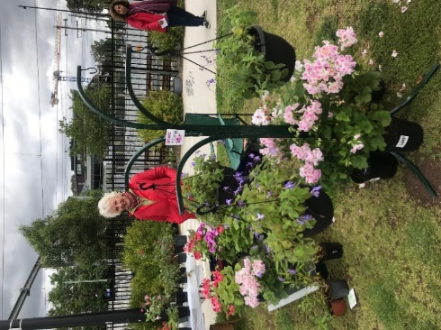 | 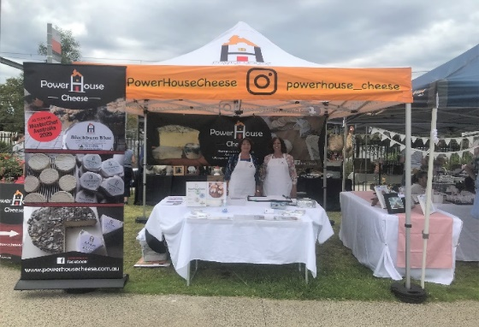 | 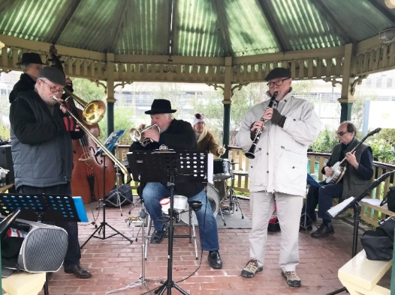
Come to the Market next month- October 8

