|  |  |  |
| --- | --- | --- |
|  | Weekly Newsletter  foresthillrotary@hotmail.com |  |
| Number 22: 1st Dec 2014  Club address: PO Box 116, Nunawading 3131  **Email address: foresthillrotary@hotmail.com**  **Website:** [**www.foresthillrotary.com**](http://www.foresthillrotary.com)  Meeting location: Bucatini Restaurant, 454 Whitehorse Road, Mitcham, 3132  Meeting time: Monday 6.15 for 6.30 pm  **Facebook: ForestHill Rotary** | | |

|  |  |  |  |  |  |  |  |  |  |  |  |  |  |  |  |  |  |  |  |  |  |  |  |  |  |  |  |  |  |  |  |
| --- | --- | --- | --- | --- | --- | --- | --- | --- | --- | --- | --- | --- | --- | --- | --- | --- | --- | --- | --- | --- | --- | --- | --- | --- | --- | --- | --- | --- | --- | --- | --- |
| |  |  |  |  |  | | --- | --- | --- | --- | --- | | **CLUB PROGRAM** | | | | | | **Date**  **1st Dec** | **Event**  ***Interplast* Bob Williams** | **Chair**  **Doug Berwick** | **Thanks/meeting report**  **John Donaghey** |  | | **8th Dec**  **15th Dec** | **Foundation Dinner at the Whitehorse Club**  ***Christmas Meeting***  **Ash Humphrey** | **RIPE K.R. 'Ravi' Ravindran**  **Graham Sharman** | **Pres Bill Marsh**  **John Donaghey** |  |  THIS WEEK'S CELEBRATIONS   Bob Williams welcome back from Tasmania  Stuart Williams welcome back from Thailand and Singapore DUTY ROSTER  |  |  |  | | --- | --- | --- | |  | **December** | **January** | | Cashier | Jenny Coburn | Stuart Williams | | Recorder | Warwick Stott | Bob Williams | | Greeter | Glenys Grant | Doug Berwick | | Emergency | John McPhee | Bob Laslett |  ATTENDANCE  |  | | --- | | **APOLOGY** – **IF A MEMBER IS NOT GOING TO COME TO THE MEETING or you intend bringing a guest please contact Ray Smith by** **10.00 am MONDAY** on9878 4891 or[rcssmith@optusnet.com.au](mailto:rcssmith@optusnet.com.au%20)  Any CANCELLATION AFTER 10.00 AM should be made direct with the management of Bucatini Restaurant on 9873 0268 | |

Ron Brooks will be overseas from 26th Nov and his first meeting will be Mon 2nd Feb

Look at the photo in the City of Whitehorse calendar for May 2015

**BILL’S** **BLURB**

Welcome to this week's words of wisdom from your part-time President!

My heartfelt thanks to Chris Tuck who has stood in for me at the last two meetings. Thanks Chris for a great job. Thanks also to all of the members who have worked so hard to keep the ship running smoothly.

Last night saw us celebrate the fantastic array of talent on show in our primary schools. Our Youth Achievement Awards brought together 12 of the best talents in the Whitehorse area together with their families. The gathering was addressed by two of Australia's top swimmers - Travis and Libby. These two great young people epitomised what the awards are about. Setting your goals, working hard and utilising your talents to the maximum. This is an ethic that our twelve recipients have already ingrained into their way of life. A night like this demonstrates the potential for good that abounds in our community. Well done to Glenys Grant and her team for organising such a successful night.

Already the bookings have been made and the cases are packed (well almost!!) for our District Conference at Ballarat in 2015. If you haven't booked in please see Stuart Williams and do so as it will be a great event. It is now time to start thinking about the 'dress up' theme. Remember 'Gold Finger' from earlier this year? Who could forget it - a sight to behold. 'Under the Southern Cross' and Ballarat give us plenty of scope so let your creative thoughts flow so that we can again enjoy the gala dinner and the fun that goes with it.

Doug Berwick attended the 'Slavery Forum' and reported on what an interesting and informative night it proved to be. Congratulations to RC Box Hill Central for their work in organising this event.

Don't forget Peridot Theatre on Friday night. Always and enjoyable experience to be shared with Rotary friends.

Don't forget that our AGM will be held in conjunction with our normal meeting on the 1st December.

**Coming Up:**

28 Nov Peridot Theatre

8 Dec Foundation Dinner and Address by RI President Elect

13/14 Dec Blackburn Market & WFM

15 Dec Final meeting for 2014

**Little Known Facts (One for last week and one for this week):**

If all the Lego bricks ever manufactured were clipped on top of each other, they would make a tower ten times as high as the distance to the moon (and my grandchildren would account for the first half!).

10% of US electricity is made from dismantled Soviet atomic bombs.

**Enjoy your week in Rotary and keep working to "Light Up Rotary"**

*Pres Bill & the editor*

**LAST WEEK’S MEETING**

Each year since 1978 the Rotary Club of Forest Hill has presented awards to one student in Year six at each Primary School located in the south east corner of the City of Whitehorse. This year twelve awards were given out. The Youth Achievement award is given to a student who is unique in that they have not so much achieved academically or on the sporting field, but more likely have been a contributor to non academic activities within the school and presented as a role model to other students. This award is unofficially called the ‘unsung hero’ award. Since inauguration 302 awards have been given.

The 36th year awards were made at the Rotary Club of Forest Hill meeting on MondayNovember 24 at Buccatini’s restaurant. Past President Chris Tuck chaired the evening, while President Bill Marsh read out the citations for each awardee. Ray Smith took many photos and these will be on the Club website. The Speakers were Travis Mahoney and Libby Forbes - Olympic, AIS swimmers and medal holders who gave excellent presentations on the lives of international competition swimmers and the commitment needed to become a champion. Their message of try, try, try again was a wonderful incentive to the young achievers present.

Libby and Travis congratulated each awardee and gave out framed certificates and a voucher of $50.00 to each awardee. Ten members, six partners and two prospective members supported the evening by looking after our guests – the 12 awardees, their parents and grandparents. An excellent dinner was served, with meals of their choice given to the children. Information bags, which included the citations, handouts on all our Youth Service and other programs and tasty surprises were given to the families. This was great evening as usual, with many thanks to all those who contributed.

Award winners were:

Lily Collins - Blackburn Lake Primary School; Grace Wagner - Burwood Heights PS; Shannon McDonald – Livingstone PS; Rebecca D’Souza – Mt Pleasant Rd PS; Reilly Horner – Orchard Grove PS; Joshua Lowe– Parkmore PS; Emily Ragg– Rangeview PS; Stephanie Kotsiros– St Timothy’s; Kristin Ashton-Fox– Vermont PS; Christopher Creasey Robinson -Vermont Sth Special School; Amy Hill – Weeden Heights PS; Cooper Hattwell – Whitehorse PS

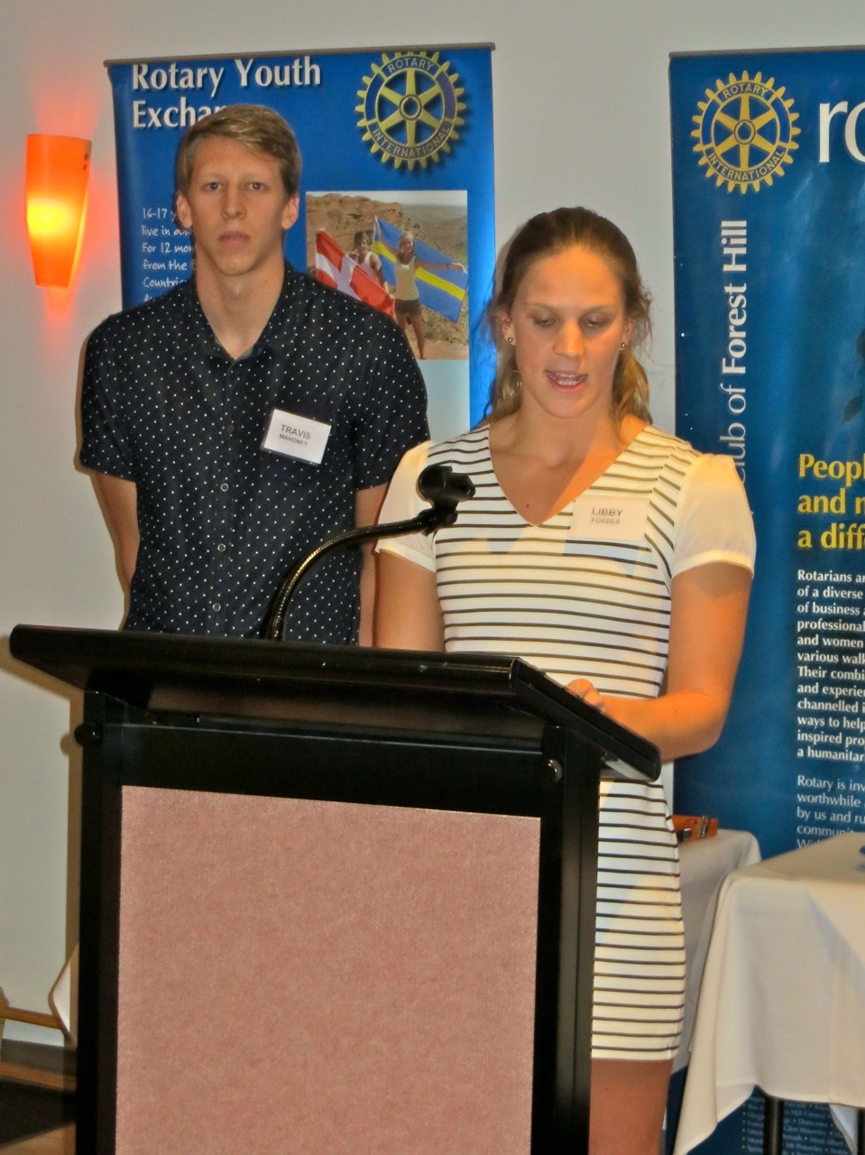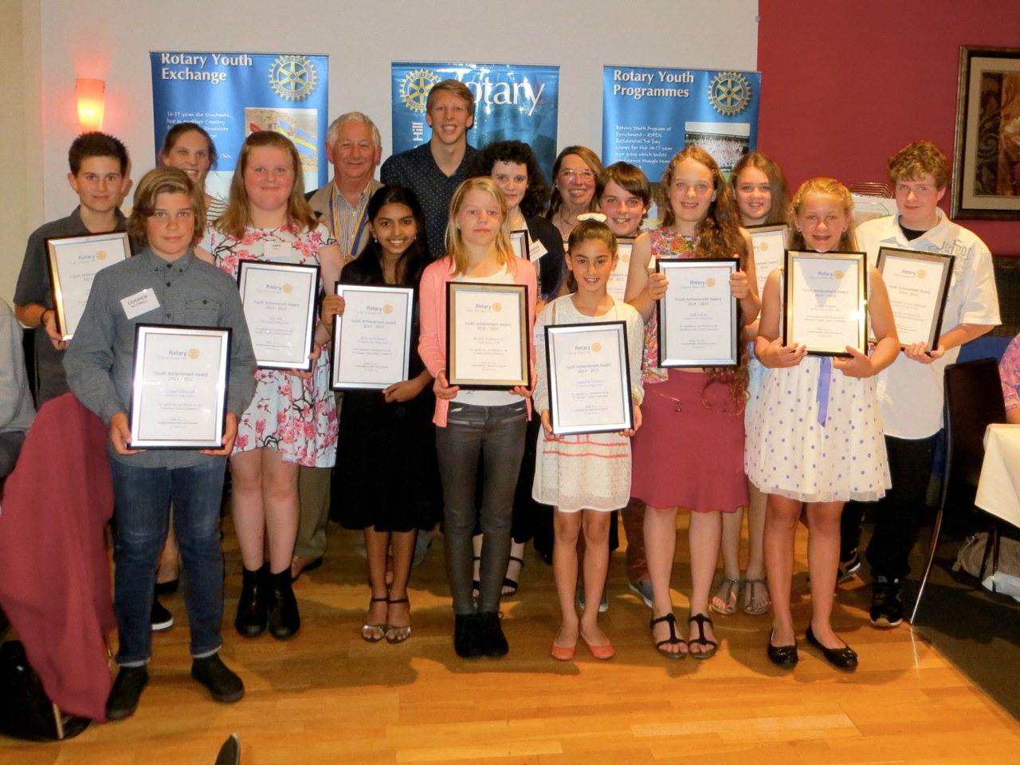

Notes Glenys

**GIVE YOUR FOREIGN COINS (and NOTES) TO OUR ROTARY COLLECTION**

Big **THANKYOU** to everyone. UNICEF will get a real boost. Look at the collection. I have washed and cleaned 7 more coffee jars ready to be FILLED.

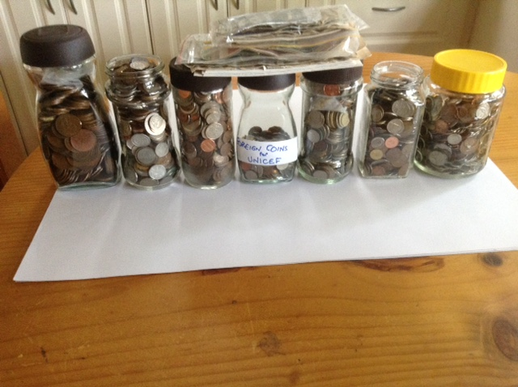

The foreign coin collection is GROWING !!!!!

*Notes by Ron Brooks*

# PAST EXCHANGE STUDENT CORNER

I got this email from Carmina de Tress (ne Rossano), Mexico

Hello!!!!! Ron & robbie, how are you, well I'm  just back from mexico city, I was visiting my aunty and my uncle for the last week of holidays, but now i have to go back to my normal life getting used to the school again, my children start school next week and Carmina the oldest is going to secondary school so we have to be up at 6:00 am now, and she doesn't like to get up early so this is gonna be a problem but that's life.

After my mum died I went to live with my aunty's family and start university in mexico city, I was studying hotel management, I did like it, but what I really liked was graphic design or architecture but it was too complicated at that time, and I wasn't too enthusiastic so I start hotel management and I did like after all, and it helped with what I already knew. I had some food and beverage classes and thanks to Robbie I knew some things, so that was good (no chili on the pavlova) but I remembered some steps so I was grateful. I was sad, my brother went to USA to study high school, so I was really alone, but with my aunty's family I was much better, they love me and made me fell welcome. With my mum stuff, the furniture and my house accessories in my grandma’s storage room, I rented my house and lived in another city with them.

After some time I went to work to a hotel in Mississippi, for 3 months in a exchange university program but it was more work than study. I really learned what real hard work was and it is exhausting. Then I went to Norway for another two months with one of my mums friends who was living on the fiords. She works for international high schools. So I went over there and just had fun. I went to see anders, a exchange student from norway when I was in Australia, and then went back to mexico, and university and in my grandparents home I meet my husband. He was very presumptuous and I didn't like him, but you now how this kind of thing happens and at last he got me. Then we got married and have 3 beautiful kids that I'm in love with and I start to live again after my first daughter. And suddenly my life had a reason again, so I am myself again!!!! It took time and too many tears but now I'm full of smiles, laughs and hugs. I have my mini company, candy bars and sweets and I also organize full theme kids parties, its a small company i just started last year but i love it; i'm a church teacher, i got closer to the church and now i teach catechism, that's a real new beginning. I have 3 kids to take care and a husband, so i'm busy, so busy, full of live and remembering all the good things in my live. I sometimes miss my mum but my family has take care of me very well and my husband and kids keep me very busy and loved, so i´m blessed. I´m just exited to be in contact with you again. I have also got in touch with kathy and john, and of course with stuart but, i can´t find bruce and connie and david and carol, i don´t know what happen, so if you have a little time for me, please let me know what happened with the rest of the club and families.

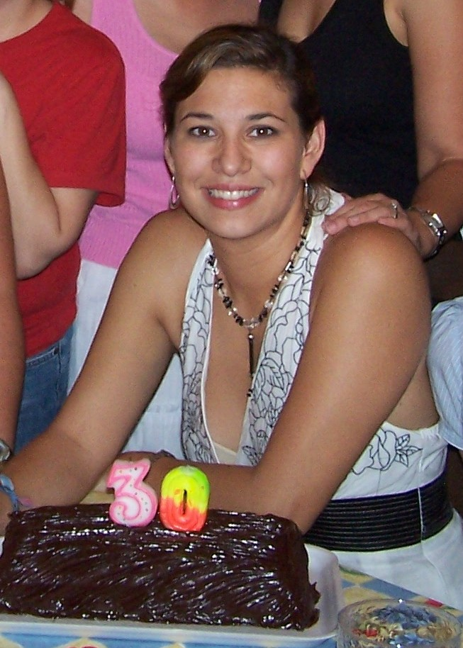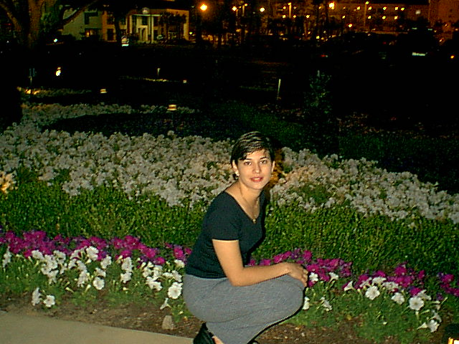

At 30th birthday In Mississippi

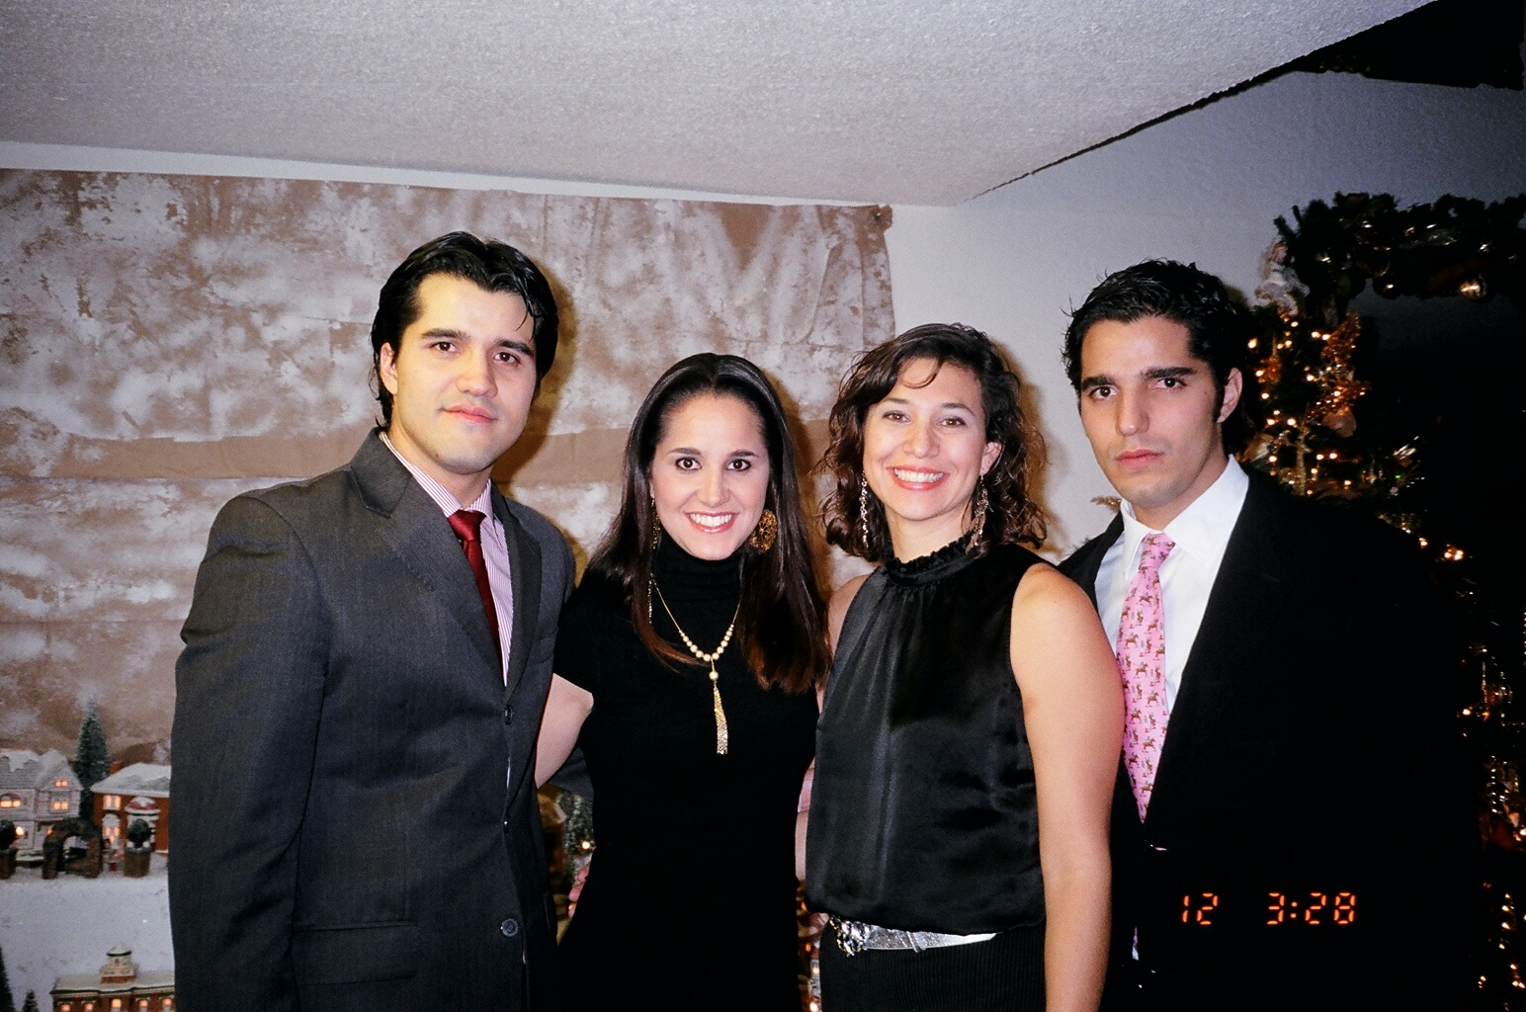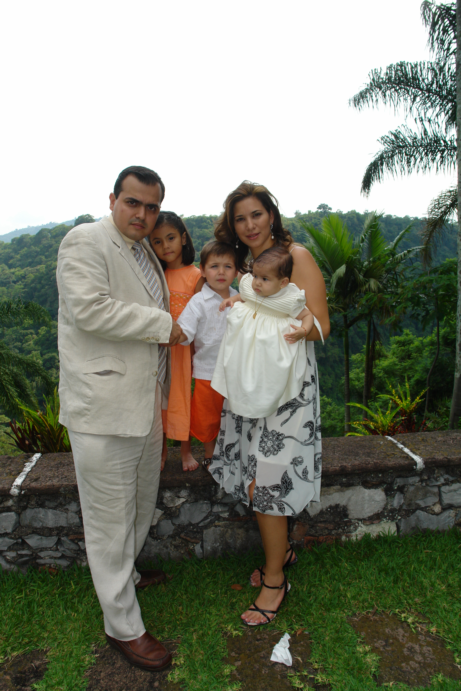

With family at Christmas At Isobel’s baptism

**Rotarian Action Group Against Child Slavery (RACSRAG)**

Last Wednesday I had the pleasure of representing the Club at a presentation held in the old Box Hill Town Hall. The event was arranged by the Rotary Club of Box Hill Central and the guest speaker was Dr Gillian Yudelman from Western Australia.

Dr Yudelman told us an estimated 35.8 million people are forced to live in slavery around the world today. A recent survey of over 160 countries (including Australia) found that slavery still existed in one form or another. She also spoke of the work being done by mining magnate Andrew “Twiggy” Forrest and the Walk Free Foundation, indicating that he was interested in working with Rotary to address slavery issues.

Dr Yudelman then told us about her experiences working with a Nepalese charity group called Maiti (pronounced ‘mighty’) Nepal. Like a lot of other great Rotary projects it started with a chance encounter between Dr Yudelman and its founder, Ms Anuradha Koirala. From there it led to Dr Yudelman supporting the work of Maiti Nepal and getting Rotary involved. Maiti Nepal is registered under RAWCS.

Maiti Nepal (the word means “Mother’s home” in Nepali) was founded in 1993 as a non-profit, child rights and women rights social organisation to find sustainable solutions to issues related to trafficking. Unfortunately for Nepalese women their natural beauty has been desired for immoral purposes in India for over a century and they are often trafficked into brothels in India and some other countries. Maiti Nepal is engaged in the protection, rescue and rehabilitation of survivors of trafficking. They also conduct education programs in some of the poorest parts of the country to help villagers avoid being exploited by traffickers. Dr Yudelman went on to describe the difficult but inspiring work being undertaken by this charity.

Overall it was a very informative, at times confronting, presentation about the world we live in and highlighted how some of the luxuries that first-world societies enjoy today are provide by modern slaves.

At the end of the presentation one of the audience members asked a question along the lines of “You have described ways to treat the symptoms but how do we address the cause".  While Dr Yudelman tried to answer the question the reality was that no one yet has the answer to such a complex issue. The good news is that will not stop Rotary from trying to find it.

The following is a list of other RAWCS projects helping to provide care, support and development opportunities for people at risk.

*Report by Doug Berwick*

**CHRISTMAS HAMPERS**

It is that time of year when we distribute hampers to needy local people. Can you please bring to our meetings over the next few weeks suitable Christmas food items and toys? **Contact Bob L. for details.**

# DON HULLAND,

Honorary member Don is at present residing in Kellock Lodge and hoping to be able to stay there full time. The address is 15 Bon St, Alexandria 3714 and his telephone is 0409 530 435. Why don’t you give him a call or write to him

**LARRY THE LORIKEET HAS FLOWN…**

Thank you to all Club members who interrupted their busy schedule to distribute Larry books to the Whitehorse Libraries, Primary schools and preschools. Feedback has been excellent. Of the second printing about 30 copies remain and these may fly as Christmas presents. If you want a copy, please contact Glenys on [glen.grant008@gmail.com](mailto:glen.grant008@gmail.com) , or Bill on [bjmarsh@bigpond.net.au](mailto:bjmarsh@bigpond.net.au).

# WEBSITE

Do not forget to check out our website, [www.foresthillrotary.com](http://www.foresthillrotary.com) and send Ron Brooks any information and suggestions. It has recently been updated. If you have photos, please send them to me with a suitable file name so I can post them on the web. If you do a project then write a short story that can be posted on the web. Other people do look at our website. It is another avenue for promoting our club.

**WEBINARS**

You can find Rotary webinars on the webinar page at:  
[https://www.rotary.org/myrotary/en/learning-reference/webinars/upcoming](http://echo4.bluehornet.com/ct/46091121:27778557647:m:1:1539467922:DD51372589336BD9C4D899283508EA00:r) These webinars are a great way to learn more from the comfort of your own armchair

**FELLOWSHIP FUNCTIONS**

**Friday 19th December 2014**

Regular film night. to be advised.

**Sometime January 2015**

Kathy and John Donaghey have offered their place at Ocean Grove for a fellowship lunch during the latter part of January. With seaside traffic being so hectic at that time of the year, it has been suggested that this fellowship activity be on a weekday rather than at the weekend. What is the preferred day Thursday or another day?

*John McPhee*

**OUT AND ABOUT IN MELBOURNE**

Your roving reporter was at another one woman show at the Melbourne Theatre Company, Southbank Theatre, The Sumner last Wednesday to see irrepressible **Joanna Murray-Smith** in a World Premier of **“Pennsylvania Avenue**”. This is 1½ hrs of non stop fabulous entertainment that ended with a standing ovation. The show opened with her singing like Marilyn Munroe (with the famous “Happy birthday Mr President”) and she then went on to sing like Maria Callas, Eartha Kitt, Ella Fitzgerald, Barbra Streisand, Peggy Lee, Aretha Franklin (I think I have missed a couple out). Close your eyes and you’d swear you were at Carnegie Hall listening to the actual singers (How does she do it?). She plays a retiring White house worker who after 32 years is reminiscing about all the stars that had a deep connection to the White House as a performer, a friend, or something more intimate. Her ear for accents either when she is speaking or singing is very special. It is on till 20th Dec and we highly recommend it. Every bit as good as her first show “Songs for Nobodies” in 2009.

Another show well worth seeing (we were there last Tuesday) is **Donizetti’s opera Don Pasquale at the Arts Centre**. Conal Coad sings the bass Don Pasquale and is a very comical performance while Rachelle Durkin as Norina & “Sofronia” really makes you laugh with her witty portrayal and strong soprano voice. It has been costumed as a 1950’s “Roman Holiday” film look alike. The stage set is absolutely brilliant with three buildings rotating so they can portray a street scene, a garden courtyard setting and indoors in Don Pasquale’s house with equal plausibility.

*Notes by Ron Brooks*

**REASONS FOR JOINING ROTARY**

Jenny Coburn gave me 41 reasons. Have you got others you can tell us about? I am putting in a different one every week - **think about them when you talk to prospective members**

**You can build your CV:** The value of Community Engagement as an individual will be of great value on your CV when applying for roles / boards, etc..

**STAMPS**

Please keep cutting out all the stamps you get on your snail mail leaving about a 1cm margin and give them to Jenny Coburn or to me. Robbie gave a huge box to Carol Farmer last week.

**HOPE KATOLO SCHOOL, KENYA- SELLING OLIVE OIL**

We are selling the delicious Hope Katolo Nursery School labelled Cockatoo Grove olive oil again for the months leading up to Christmas. 500mL bottles are only $12 and make a lovely gift for Christmas.

Please contact Melanie on 0412 187 353 if you would like to order some.

**BALLARAT DISTRICT CONFERENCE FRI 13th –SUN 15th MARCH 2015**

Families  Grant/ Williams, Bob/ Williams, Stuart/ Brooks/Laslett/Marsh are going to stay at a hotel together.     Jenny and Roger will stay in own accommodation. Cost  $149 per night. Buffet breakfast $20. It’s not too late to join us

*Stuart Williams On to Conference organiser*

Club officers & Committees 2014-15

**President** Bill Marsh

**Vice President** John Donaghey

**Secretary** Ron Brooks

**Treasurer** Warwick Stott

**President Elect** Bob Williams

**Sergeant** Stuart Williams

**Foundation & International** Chris Tuck

Members: John Donaghey, Stan Harper,

**Youth Service** Glenys Grant

Members: Ray Smith, Bob Williams, Graham Sharman

**Community & Vocation** Bob Laslett

Members: Stuart Williams, Gary Baltissen, Ron Brooks

**Membership & Publicity** Doug Berwick

Members: John McPhee, Warwick Stott, Jenny Coburn

**Fellowship** John McPhee

**Primary Schools Speech Night** John McPhee

**Programme** Ray Smith & Gary Baltissen

**Bulletin Editor** Ron Brooks

**Web page & Facebook** Ron Brooks

**On to Conference** Stuart Williams

**Historian** Stan Harper

**Almoner** Graham Sharman

**Public Officer** Bill Marsh

Newsletter articles to the editor at [bjmarsh@bigpond.net.au](mailto:bjmarsh@bigpond.net.au) by **5 pm Wed**. If you do not wish to receive this publcation please contact the editor.