Number 42  Club address:  Email address:  Website:  Meeting location:  Meeting time:  Facebook: | 18 June 2018  PO Box 116, Nunawading 3131  foresthillrotary1975@gmail.com  www.foresthillrotary.com  Bucatini Restaurant, 454 Whitehorse Road, Mitcham, 3132 (Melways 48H9)  Monday 6.15 for 6.30 pm  Rotary Club Forest Hill
THERE WILL BE NO FLYER NEXT WEEK SO KEEP THIS TILL 18th JUNE MEETING
CLUB PROGRAM

Date | Event | Chair | Thanks & Meeting Report
11 June | No Meeting | Bill Marsh | Mike Finke
18 June | ROMAC  Graeme Chester | Sue Ballard | Glenys Grant
25 June | Holiday Talk  Ron Brooks | Mike Finke | Bill Marsh
2 July | Open House Melbourne  Sue Ballard | Glenys Grant | Chris Tuck
CELEBRATIONS
Happy birthdays to Glenys Grant and Robbie Brooks both on 20th June.
DUTY ROSTER

 | JULY | AUGUST
Recorder | Chris Tuck | Bill Marsh
Greeter | John McPhee | Ron Brooks
Emergency | John Donaghey | Bob Laslett
Cashier | Glenys Grant | Stuart Williams

ATTENDANCE
APOLOGY – IF A MEMBER IS NOT GOING TO COME TO THE MEETING or you intend
bringing a guest please contact Ray Smith by 10.00 am MONDAY on 0412 807 585 or rcssmith@optusnet.com.au
SPECIAL DIETARY NEEDS to Ray by 10am at the LATEST.
Any CANCELLATION AFTER 10.00 AM should be made direct with the management of
Bucatini Restaurant on 9873 0268

BILL’s BYLINES
What a super night was had by all on Monday as we celebrated our Youth Citizenship Awards.
Five wonderful young people (Year 8) received the awards in front of their family, teachers and friends. The joy and pride could be felt as each one received their award. I could say ‘her award’ as all five awardees were girls for the first time since we began the awards.
It was great to welcome DGE Russell Gurney (recently installed as DG), AG Graeme Aspinall, staff from four of the five schools (a last minute hitch prevent Joanna Alexander from Blackburn High School from attending), parents, awardees and siblings along with Rotarians and partners. All joined in enthusiastically and had a wonderful evening.
Today John McPhee and I enjoyed attending a morning tea at Government House to celebrate Taralye’s 50 great years of work for children born profoundly deaf in the community. Our club has been associated with Taralye for a number of years and our invitation to attend was in recognition of the club’s contribution.
On Thursday we are off to Peridot Theatre. All of the arrangements are in place, the cakes and slices cooked and the drinks are in the fridge. All we need now is a super production, and when has it not been a super production, and 130 Rotarians and friends of Rotary will have a fantastic night. Our chosen beneficiary from money raised is the Hope Katolo Nursery School in Kenya. Our club has supported them for a number of years and they will benefit with around $1,500 being raised on the night. Our thanks go out to all of the other Rotary Clubs, Berengarra School and the Hope Katolo supporters for their support in ensuring the night is a success.
Three of our members and one partner are off to the International RI Conference. We wish them safe travel and an enjoyable and informative trip. I am sure we will get a full report on the ‘goings on’ when they return.
This weekend is Market Weekend. Blackburn on Saturday and WFM on Sunday. Thanks to all who have volunteered their help on the two days. Could we be lucky enough to get weather like today?
Nine members, partners and friends of Rotary enjoyed dinner and the films on Friday night. My thanks to all who regularly support this activity. A great opportunity to see some recent films, enjoy dining out and catch up with friends.
There will be no Rotary Meeting this coming Monday – 11th June.
Only 24 more ‘big sleeps’ to go.
Dates for your calendar
18th June - Combined Board Meeting
23rd June - Tree Planting at Blackburn Lake
16th July - Official Changeover Dinner
Did You Know?
Every month in the Netherlands 133 billion insects are killed colliding with cars.
(I reckon I get that many on the average trip across to Adelaide!!) from Pres
Did You also Know?
The Woolly Mammoth genome has now been completely mapped so they have the ability to deextinct it.
From Ron
Remember - Rotary: Making a Difference - is not just a theme it is what we do.

Meeting report 4 June Youth Citizenship Awards
The event was held on the evening of June 4, 2018 at Bucatini Restaurant, Mitcham.
Sergeant Stuart Williams opened with an eloquent moment of reflection on Rotary and Youth.
He proposed toasts to:
- • Rotary International
- • Australia
- Chairperson for the evening President Bill Marsh then welcomed our guests ie Rotary 9810 District Governor Elect Russell Gurney and Assistant Governor Graeme Aspinall; Guest speaker Jemma Frisina, her mother Josie and RYPEN leaders Christine Tolotchkov and Iain Uren; our Year 8 student awardees, their parents, siblings and supporting school staff members; Rotary partners and Rotary friends.

Each Rotarian host then introduced the awardees, families and guests on their table as dinner was served. Following the delicious meal District Governor Russell Gurney spoke about the large number of youth programs Rotary sponsors and runs, the opportunities offered by Rotaract, Interact and EarlyAct for young people to get involved in doing work to improve the lives of others, and the need in Rotary for more people to join to continue the excellent projects.

He also mentioned the recent win of the Model United Nations Assembly team from Box Hill High, who were sponsored by our Club, and that they will be attending the National MUNA competitions in Canberra.

Chairman Bill then introduced our Speaker, Jemma Frisina, who gave an excellent talk about the Rotary Youth Program of Enrichment - RYPEN – and how it had greatly benefited her abilities and maturity.

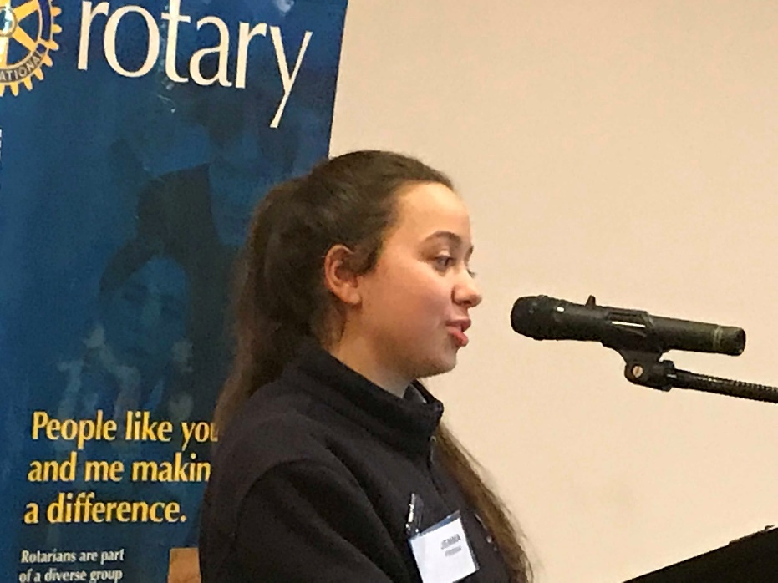
Hello everyone, my name is Jemma, I am in year 10 and last year and I was chosen and sponsored by the Glen Waverly Rotary club along with one other student to participate in the 2017 RYPEN camp, for students aged 14-17.
RYPEN is a leadership program and camp run by Rotary where students are sponsored to take part by their local Rotary Club. Prior to my invitation to attend the camp I hadn’t heard of the program and never would I have guessed the impact it would soon make on me. The program went from Friday 15th-17th of September and truly lived up to its name because it was one of the most enriching and most fun experiences of my life. I met so many new students from a range of ages, backgrounds and personalities and we all had one common goal. That was to grow and learn to discover who we are, how we are going to succeed, thrive and lead in our different ways. Over the weekend we were led by a variety of leaders to help us along the way and I’m so excited to be chosen to be apart of this team for RYPEN 2018.
Over the 3 days we did many purposeful, meaningful and enriching activities that taught me so much about what leadership means and who I want to be. We did activities on teamwork and communication, values, power of choice and heaps of fun activities that enhanced leadership skills such as trust, initiative and determination. It taught me that you need to stay focused and clear of distractions if you want to achieve a goal. It highlighted that trusting people and cooperating with one another is integral to getting a job done efficiently and that we have the power of choice about everything we do and how we react to events can result in a positive or negative impact upon ourselves and the situation and others.
The entire weekend was completely supportive and I loved that the topics were different to the generic things we learnt at school year after year. The lessons we learnt and the things we spoke about really opened up our eyes and was the best gift to bring back home with us.
All leaders know that it takes getting out of your comfort zone and pushing yourself to achieve great things, and this camp, going into it knowing only 2 other people really forces you to do that and I’m so glad that it does. It really is up to you to put effort in and to apply yourself to achieve new things. It is a skill and habit that will get you far.
How have I changed? How I have benefited from this and what did I learn? I felt like the camp increased my confidence in networking and meeting lots of new people. It definitely heightened my self-awareness and self-esteem, and enabled me to explore my values and discover what makes me the person I am. It also outlined the importance of having good relationships in your life, whether it be at school, at work or at home. I learnt countless things on this camp and the RYPEN experience will always be very close to my heart. It was an ideal environment where everyone was equal, socialising and bonding 24/7 and I felt like I really thrived.
My favourite parts of the camp were meeting so many new people, the dance party, the environment, the activities, the many new friends I made and the invaluable life lessons I learnt through this camp. I feel incredibly privileged to have been able to take part in this wonderful program. This year after being chosen to be a student group leader I can’t wait to help more participants like me to reach their full potential through RYPEN! I can’t speak of it highly enough!
What would I say to someone such yourselves who have the opportunity to go? I would say to not hold back! Immerse yourself completely into every activity, introduce yourself to as many people as you can, don’t limit yourself, try everything and find the purpose and meanings behind the activities and see how you can bring them into your life and leadership.
It truly is a great program and not only have I benefitted immensely from it but through my experience I could bring this into my leadership work at school and generally in life!

Thank you to the people who allow the RYPEN program to run and for having me here tonight. I hope you all take part in as many programs like RYPEN as you can.

Jemma Frisina

As a record of our appreciation President Elect Mike Finke gave vote of thanks to Jemma and gift of a beautifully crafted Ray Smith wood turned pen.

Chairman Bill then explained the Youth Citizenship Awards, which is an award for unsung heroes in the school community. It is unique to our Club and aimed specifically at Year 8 students to help fill a perceived small gap in the wonderful and very comprehensive District Youth program.

Certificate giving then proceeded, with each school’s staff member reading out a citation on the Awardee
explaining why the school had chosen them. This was a wonderful moment and brought tears to the eyes of some listeners. The Awardee was then presented with a framed certificate from DGE Russell Gurney, a laminated citation from AG Graeme Aspinall, and a $100.00 gift voucher.
Award winners were:
- Blackburn High School’s Lizzie Cooper, supported by Ron Brooks
- Box Hill High School’s Maria Mafi supported by school representative Justin Bond
- Forest Hill College’s Kayla Chatley supported by school representative Greg Heaton
- Kingswood College’s Grace Robertson supported by school representative Sula Tyndall
- Vermont Secondary College’s Kate Tong supported by school representative Peter Henderson
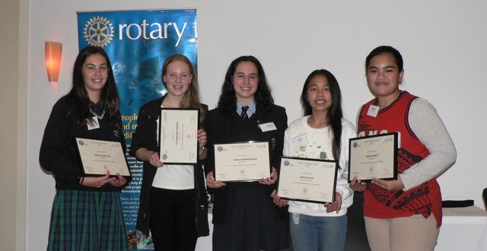
The raffle raised $108. Josie Frisina won the white wine, Bob Laslett came back just for one week to win the chocolates before heading off again and John McPhee had to make do with the third prize of a bottle of red.
Chairperson Bill Marsh then closed the evening with thanks to all.

Report By Youth Director, Glenys Grant
Comment: I wish to thank all those who contributed to an excellent evening. ie
Speaker Gemma Frisina for her excellent summary of RYPEN and its rewards.
Ray Smith, for photographs of all proceedings and table seating arrangements, etc, etc
Bill Marsh, for supplying framed certifications, laminated citations and Chairing the evening
Stuart Williams for the introduction, Reflections
Youth Team; also Warwick Stott and Chris Tuck for all their assistance
DGE Russell Gurney & AG Graeme Aspinall for presenting the awards etc.
All Rotarians and partners who hosted our guests and letting them see the ‘Rotary warmth’
Participating schools and staff
Bucatini for the meal and their pleasant and efficient

Email just in from our guest speaker:
Hi Glenys,

Thank you for the opportunity to speak last night and for having my mum and I! Rotary is such a great club and organisation and the interactions and opportunities given to the youth through Rotary are so special and influential.

Thanks :)
Jemma Frisina

Email in from one of the students
Hi Rotary club,
On behalf of me and my family we would like to say thankyou for a amazing night.I am so glad that i had the chance to come and join you tonight and thankyou for your amazing work you do to help others. I wish to be like all of you one day giving, generous and caring.
Maria mafi.

Sergeant’s Reflection 4 June
An African proverb states: “It takes a village to raise a child.” We live in a community, not a village, but do we have a feeling for our community? The school and neighbourhood we live in is made up of people from many cultures.
Schools often try to create experiences that enable people to be their best. We surely build a better society if we are able to embrace people with respect and dignity wherever there is a perceived difference. A delightful Papua New Guinea expression that is used when talking about respect is: “with eyes equal”.
A fine citizen is a respectful citizen. I am sure we will hear some wonderful citizenship stories tonight.
Dr Donna Hicks, of Harvard University, said- “ The glue that holds all of our relationships together is the mutual recognition of the desire to be seen, heard, listened to and treated fairly; to be recognised, understood and to feel safe in the world.”
Our Rotary Citizenship Awards might not be able to change the world, but we can create a more respectful way of being in it together.

Peridot Theatre Fund Raising Event Thursday 7th June. FANTASTIC SUCCESS !!!

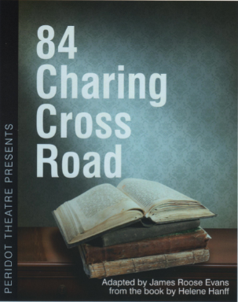
What a great success !! If you are flexible enough, give yourselves a vigorous pat on the back. Last Thursday 7th June the club held it’s major fundraising events of the year. We were given the preview night of 82 Charing Cross Road by Peridot as opportunity to raise money. They were good enough to give us this fund raiser last year and because we donated back some of those funds to other Rotary Clubs, they repeated their generosity again this year. Last year we had 80 attendees and word must have got around as this year we had 140 which is more than Peridot get to their normal productions, basically a full house. We had major representations from Rotary clubs of Nunawading, Boronia, MASH, Mitcham, and I saw loads of other Rotarians from Box Hill Central, Waverley, our other cluster clubs plus Berengarra school who were the major beneficiaries last year, plus the dynamos behind Hope Katolo school who will be the major beneficiaries this year…. and the list just goes on.

Peridot ran a free chance to get two tickets to their next production which was won by PP Nicole Osner from RC of MASH. We also were given a hamper of chocolates to raffle by
Michael Sukkar, our local MP for Deakin which raised substantial money.

The way everyone of our club plus our Rotary friends provided sandwiches, cakes, slices, biscuits, fruit, dips, nibbles was just incredible. Like last year, even with the vastly increased numbers, we did not run out of sherry, food, wine, biscuits, or soft drink. Judging by the level of conversation before the play, at the interval, and after the play was over everyone had a great time. I know talking to the Peridot people that they all enjoyed our company and the evening. Everyone at Peridot is so easy to work with Adam and Damien in Front of House just doing so much, Wilf is a great guy to coordinate with and so it makes the evening so easy to organise. Especially with PE Mike organising the trybooking website and Robbie not leaving until all the vacuuming was finished. No glass breakages so we got our deposit back.

Yes, you are right, I leave the best to the last. The play and the actors were so good. Absolutely up to the standard we have come to expect over the years. The audience interaction clearly showed through. Peridot said at the end that they love playing to a full house.

Who knows if we will get this Fund Raiser again next year. We have been extremely lucky to be given this opportunity two years in a row when so many other organisations want it. All we can do is what we did last night………. Make a resounding success of the event and have loads of fun doing it.
Ron Brooks

FOREST HILL COLLEGE BREAKFAST
This week it is Robbie and Barbara.

ANNUAL REPORT

Committee chairs are kindly asked to have their reports to me by the end of June.

ROTARY MONTHLY THEMES
June Fellowships
July Rotary Awareness

ARTICLES
Next week please forward your prize-winning articles to ronbrooks1942@gmail.com by 5pm Wednesday. A big thank you once again to Ron- unfortunately he never gets to go away like me!

