|  |  |
| --- | --- |
| Number 44  Club address:  Email address:  Website:  Meeting location:  Meeting time:  Facebook: | 25 June 2018  PO Box 116, Nunawading 3131  foresthillrotary1975@gmail.com  www.foresthillrotary.com  Bucatini Restaurant, 454 Whitehorse Road, Mitcham, 3132 (Melways 48H9)  Monday 6.15 for 6.30 pm  Rotary Club Forest Hill |

|  |  |  |  |
| --- | --- | --- | --- |
| **CLUB PROGRAM** | | | |
| **Date** | **Event** | **Chair** | **Thanks & Meeting Report** |
| 25 June | Houston Experiences  *The Robotics Team* | Mike Finke | Bill Marsh |  |
| 2 July | Open House Melbourne  *Sue Ballard* | Glenys Grant | Chris Tuck |  |
| 9 July | Person behind the Badge  *Barbara Williams* | Stuart Williams | Bob Williams |
| **16 July** | ***CHANGEOVER NIGHT*** | Bob Williams | Stuart Williams |

**CELEBRATIONS**

Happy birthday to Joan Harper (25th June)

Club anniversaries Chris Tuck (29th June) and **John Bindon** (30th June).

**DUTY ROSTER**

|  |  |  |
| --- | --- | --- |
|  | **JULY** | **AUGUST** |
| **Recorder** | Chris Tuck | Bill Marsh |
| **Greeter** | John McPhee | Ron Brooks |
| **Emergency** | John Donaghey | Bob Laslett |
| **Cashier** | Glenys Grant | Stuart Williams |
|  |  |  |

**ATTENDANCE**

|  |
| --- |
| **APOLOGY – IF A MEMBER IS NOT GOING TO COME TO THE MEETING or you intend** |
| **bringing a guest please contact Ray Smith by 10.00 am MONDAY** on 0412 807 585 or rcssmith@optusnet.com.au |
| SPECIAL DIETARY NEEDS to Ray by 10am at the LATEST. |
| Any CANCELLATION AFTER 10.00 AM *should* be made direct with the management of |
| Bucatini Restaurant on 9873 0268 |

**BILL’s BYLINES**

I must start this By-line with a big ‘Thank You’ to all of our friends in the surrounding Rotary Clubs. We asked for your support and you gave it ‘in spades’. We had 140 guests at our Peridot Theatre Night to raise money to support our Hope Katolo Project in Kenya. Initially we thought we might raise $800-1,000 all going well, this was revised up to $1,500 when tickets began selling and now we are able to transfer $2,309 into the Hope Katolo Fundraising Account. What a super result! And the absolute best part? Everyone had a great night. The cast enjoyed having a bumper crowd for their preview and the enthusiasm during interval and after the show was contagious. Our raffle prize, the very nice hamper of chocolates donated by Michael Sukkar, was won by Wayne Willoughby. Wayne is a member at Nunawading so it was fitting that one of their members won given they were our biggest supporters. Winning raffles must be a Nunawading ’thing’ as Bob Hoskins won the last hamper we raffled.

On Saturday as many members as possible will be meeting at 9.30am at the Visitors’ Centre at Blackburn Lake before taking part in a Tree Planting morning. Ian Riseley would be proud of us!! Thank you to Glenys for arranging this for the club. Don’t forget your gloves and trowel or shovel.

RC Nunawading will be holding a very special Christmas in July **– it’s going to be in August**!! On Friday 17th August to be precise at the Whitehorse Club. Please let me know ASAP how many tickets you will need for this event so that I can give Harvey a reasonable estimate of our numbers. Last year’s event was excellent and Harvey promises me that this one will be bigger and better. Again all proceeds will go to Interplast.

Our next Film Night will be on Friday, July 6th. I will circulate the available films in the week prior. We will have dinner before heading off to the films.

On Monday we held a Combined Board Meeting, 2017-18 & 2018-19, and it was great to be able to welcome Sue Ballard onto the Board. Sue will take over the role of Chair of Community & Vocational.

It was lovely during the week to be notified of a $500 sponsorship from the Blackburn branch of the Bendigo Bank. This is to help set up a photography competition under the guidance of President Elect Mike Finke.

Our next super “Youth’ activity is underway with our Primary Schools’ Speech Competition on 22nd August rapidly taking shape. This is always a fantastic night as we watch in awe as these young 10-12 year olds strut their stuff with confidence and skill that never ceases to amaze.

Only 11 more ‘big sleeps’ to go!!

**Dates for your calendar**

Sat 23rd June Tree Planting at Blackburn Lake Visitors Centre 9:30am

8th July Whitehorse Farmers’ Market

14th July Blackburn Craft Market

**Mon 16th July Official Changeover Dinner**

Fri 17th Aug Nunawading Rotary Club Christmas in July………… **in August**!

**Did You Know?**

Summer nights in the Faroe Islands are so well illuminated that between May and July the lighthouses are turned off

**Remember - Rotary: Making a Difference - is not just a theme it is what we do.**

**Club Meeting Report 18th June ROMAC**

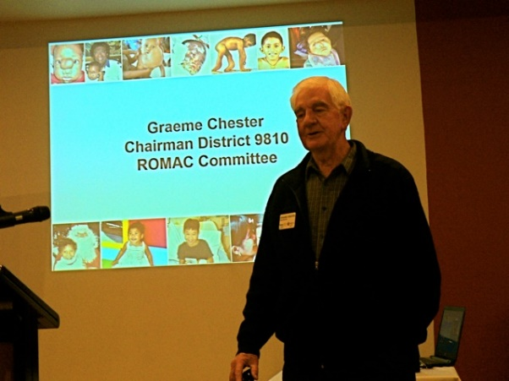The meeting was opened 6.30pm with Toasts by President Bill Marsh. He introduced Sue Ballard, Chairperson, who welcomed the 10 members and our Speaker, Graeme Chester, from ROMAC.

Program reports followed:

* President Bill Marsh reported the Peridot theatre night had been an excellent fundraiser, with $2300 raised for Hope Katolo School, Kenya. It was well attended, with approximately 140 tickets sold. Members from six District Clubs and others enjoyed the night and the excellent Supper. Bill thanked all who participated.

He also reminded members of the 9.30am start to the tree planting at Blackburn Lake on June 23, and of a Nunawading dinner event to celebrate Xmas in July.

* Membership - Warwick Stott mentioned a possible new member attending soon, and that a membership night is being planned for later in the year.
* Program - Ron Brooks commented on program highlights, including the return of the Robotics group from USA and their progress. He asked for more stamps and coins to be collected.
* Community – John McPhee spoke of the 50th anniversary celebration of Taralye at Government House; Apprenticeship Award presentations at Box Hill Institute; and the need for help at the August Blackburn market.
* Youth – Glenys Grant thanked everyone involved in the successful Youth Citizenship Awards night and mentioned that the planning for the up-coming Primary School Speech night on August 22 was well underway. She thanked two of our very special ‘unsung’ heroes in the Club, Ray Smith and Mike Finke, for their recent efforts.

Following our meal, Chairperson Sue Ballard introduced our Speaker and ROMAC Chair Graeme Chester. He explained Rotary Oceanic Medical Aid for Children, ROMAC, is a combined Australian and New Zealand Rotary Multi District initiative.

Since 1988 ROMAC has been providing children from developing countries of the Southwest Pacific with specialist surgical life saving treatment and care in Australian and New Zealand Hospitals.

This not-for-profit humanitarian organization is being operated entirely by volunteers to provide treatment to these children that is not accessible to them in their home country. ROMAC relies on donations of funds and on surgeons and medical staff donating their time. Average cost per patient is approximately $25,000, so for 40 patients annually, 1.3million dollars is required.

Potential patients with life threatening medical issues considered beyond the scope of the home country hospitals are identified, assessed, and flown over here for treatment. They have surgery then, when receiving outpatient care, live with their family member in a Rotarian’s home until well enough to return home. Graeme then showed many excellent and impressive pre and post surgery examples of recent ROMAC patients.

Since 1988 ROMAC has saved 470 children. More than 70 are currently on the waiting list.

He finished to great applause and was then thanked by all members.

The Raffle raised $46.00 and the collection bowl $15.20

President Bill then closed the General meeting.

A meeting of the in-coming and the out-going Boards followed.

*Glenys.Grant*

**RYDA My Life My Choices**

[www.rse.org.au/ryda](http://www.rse.org.au/ryda)

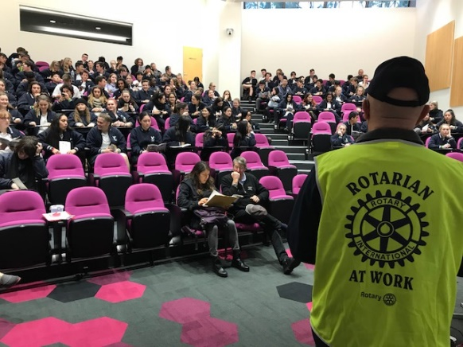 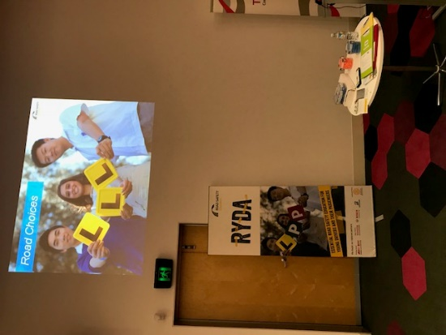 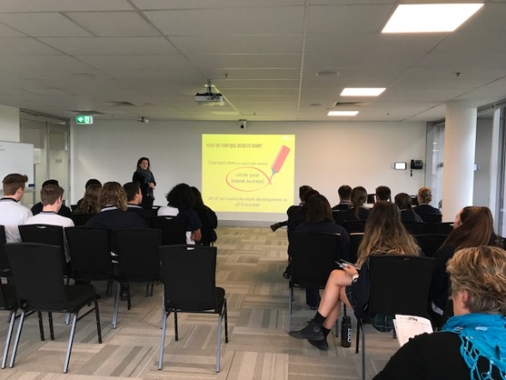

On Tuesday 12th June, Barbara W, Martine, and Ron went out to the Box Hill TAFE at Lilydale to help RYLA personnel look after 120 Vermont Secondary year 12 students. We started at 8:30am being briefed / reminded on what to do. The day programme is divided into 6 presentations on

1. Road Choices
2. The “I” in drive
3. Genevieve’s Story
4. Crash Investigators
5. Speed and Stopping (out in the carpark with a moving….. and stopping vehicle
6. Hazards & Distractions

All the presentations were interactive with the students with a class size of 20.

Each presentation stressed the personal choices that are there when they are interacting with motorised transport whether as driver or passenger. The decision can be life changing. You don’t get the opportunity to press the restart button and make a different choice. As volunteers looking after a group of 20 (mine was the red group) you get to sit in on all the presentations. They were all excellent as they were last time. The students were privately praised by a number of the presenters as being well behaved and responsive. So it makes you feel it was worthwhile giving up your time.

If the opportunity arises again I recommend you volunteer. An excellent day. Finished at 2:30pm

*Ron Brooks*

**Peridot Theatre** **Fund Raiser**

**The unaudited accounts show we raised $3,363.26 after expenses for charity. What a magnificent effort from all the Rotary clubs that supported this event and from the Friends of Rotary.**

**Emails received**

*Last Thursday evening - 9th June 2018  - a friend & I attended the Charity Night fundraising performance of the Peridot Theatre’s production of ’82 Charing Cross Road’, thanks to my involvement with the Rotary Club of Mont Albert & Surrey Hills (MASH). Monies raised allocated to the Hope Katolo Nursery School, Kenya.*

*My thanks go to the Rotary Club of Forest Hills & the Peridot Theatre Group - it was a night of excellent entertainment & good old-fashioned hospitality!*

*The choice of play was ‘tops’ (great script line) & was so well acted. The lead actors were outstanding & the support roles were perfectly cast.*

*Most entertaining indeed.*

***cid:image003.png@01D401B9.8F9DAD80The RC Forest Hills’ catering was excellent with great food & drink selections.***

*As Sandy Stone (Barry Humphries’ creator) would have said:*

*‘By and  large though, all things considered, and taking everything into account, it was a pretty nice night’s entertainment’! (‘The Life and Death of Sandy Stone – Days of the Week’)*

*Please pass on my thanks & congratulations to all concerned at the Forest Hills Rotary Club.  I’ll now look forward to the* ***next*** *Peridot Theatre/RC Forest Hills Charity performance!*

*Sincerely,*

***Annie Wysham (Friend of MASH)***

**Email received from Peridot Theatre**

*Dear Ron and Annie*

*Thank you very much for your favourable feedback. It’s great to know that you not only enjoyed the performance but you also raised $2,000 for charity. It’s always good to hear that the audience had an enjoyable night out and Peridot is always grateful for a live audience at our final dress rehearsal. That fact that community groups raise funds is a dual benefit. I shall pass on your feedback to the Peridot Board of Management.*

*Regards, Wilf Seelig*

*Peridot*

**Sergeant’s Reflection 18th June meeting**

President Bill reflected briefly on how far and wide the influence of Rotary spreads and the unexpected ways it touches people throughout the world and how we, in turn, are touched by those we help.

In our case a young woman with a dream to be able to feed, clothe and educate the children in her remote village led to her starting the Hope Katolo Nursery School. Then two young Australian volunteers saw what she was trying to do and vowed to do something to help. Through their contacts with one of our members our club began to fund projects to help develop the school. This led to us holding a fundraising function which attracted Rotarians from eight different clubs which has meant 140 Rotarians and friends of Rotary have contributed to the school which will mean the families and children at the school will continue to prosper. And so the dream goes on…

|  |  |  |
| --- | --- | --- |
| **FOREST HILL COLLEGE BREAKFAST**  Robbie teamed up with John McPhee to cook lots of toasties last Tues 19th June.  **ANNUAL REPORT**  Committee chairs are kindly asked to have their reports to me by the end of June.    **ROTARY MONTHLY THEMES**  June Fellowships  July Rotary Awareness  **ARTICLES**  Next week please forward your prize-winning articles to [ronbrooks1942@gmail.com](mailto:ronbrooks1942@gmail.com.) by 5pm Wednesday. A big thank you once again to Ron- unfortunately he never gets to go away like me! |  |  |
|  |  |  |

**OUR WEBSITE**

Please remember to ALWAYS put our web address below your name on any email you send to anyone regarding Rotary business whether they are members of the general public or are Rotarians. They won’t learn more about our wonderful active club unless we lead them to the information.

www.foresthillrotary.com