### 

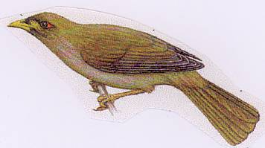

|  |  |  |
| --- | --- | --- |
|  | 2014-2015  Weekly Bulletin  Rotary Club of Forest Hill |  |
| Number 5: 4th Aug 2014  Club address: PO Box 116, Nunawading 3131  **Website:** [**www.foresthillrotary.com**](http://www.foresthillrotary.com)  Meeting location: Bucatini Restaurant, 454 Whitehorse Road, Mitcham, 3132  Meeting time: Monday 6.15 for 6.30 pm | | |

|  |  |  |  |  |  |  |  |  |  |  |  |  |  |  |  |  |  |  |  |  |  |  |  |  |  |  |  |  |  |  |  |  |  |  |  |  |
| --- | --- | --- | --- | --- | --- | --- | --- | --- | --- | --- | --- | --- | --- | --- | --- | --- | --- | --- | --- | --- | --- | --- | --- | --- | --- | --- | --- | --- | --- | --- | --- | --- | --- | --- | --- | --- |
| |  |  |  |  |  | | --- | --- | --- | --- | --- | | **CLUB PROGRAM** | | | | | | **Date** | **Event** | **Chair** | **Thanker & Meeting Report** |  | | **4th Aug** | **“Pompey Elliott” - Ross McMullin** | **R.C.Box Hill**  **Central** |  |  | | **11th Aug**  **18th Aug**  **25th Aug** | **Eastern Suburbs Real Estate - Lachlan Williams**  **Bestchance child family care – Chris Thompson, Geraldine Ryan**  **Primary Schools speech contest** | **Stuart Williams**  **Glenys Grant** | **Gary Baltissen**  **Graham Sharman** |  |  THIS WEEK'S CELEBRATIONS Aug 10th Jenny Tuck Birthday  Aug 10th Chris Tuck Wedding anniversary DUTY ROSTER  |  |  |  | | --- | --- | --- | |  | **July** | **August** | | Cashier | Jenny Coburn | Ron Brooks | | Recorder | Glenys Grant | Chris Tuck | | Greeter | Bob Williams | Stuart Williams | | Emergency |  | Ray Smith |  ATTENDANCE  |  | | --- | | **APOLOGY** – **IF A MEMBER IS NOT GOING TO COME TO THE MEETING or you intend bringing a guest**  **Please contact Ray Smith by** **10.00 am MONDAY** on9878 4891 or[rcssmith@optusnet.com.au](mailto:rcssmith@optusnet.com.au%20)  Any cancellation after 10.00 am should be made direct with the management of Bucatini Restaurant on 9873 0268 | |

John McPhee will be absent from 14th July to 13th Aug

Chris Tuck will be absent from 23rd Aug to 25th Sept

**BILL’S** **BLURB**

On Friday Glenys, Ray and I travelled to Forest Hill College where we attended their school assembly and presented the Art Awards for "Larry the Lorikeet" to Zena Zeng and Courtney Gough. The assembly was run by the student leaders with the 600 students seated on the floor of the gymnasium. A most impressive performance and the applause given to Zena when she received her award indicated a caring and supportive group of friends. The next phase of this outstanding project will be the Book Launch on Monday 18th, August at the Whitehorse Library, Nunawading. This project was "a dream" by Glenys and her hard work and attention to detail has ensured a fantastic outcome. Well done to Glenys and her committee.

Friday evening I attended the District Membership Seminar as, unfortunately, none of our Membership committee were available. This was an enjoyable meeting - it was well organised, short and to the point. The District committee has obviously done a deal of work and planning. If clubs can implement the ideas and make user of the materials available I am sure some positive results will follow. The really good aspect, from our point of view, was the ideas introduced followed very closely the ideas Judy Ford presented to our club a couple of weeks earlier. Our committee is already well on the way to putting these into action and I think, with the possible addition of some of the audio-visual materials available, we will be able to put forward an attractive presentation to prospective members. Obviously the plans being formulated by the committee will require significantly greater funding than we have put into membership over the last few years. The Board will need to discuss how we are going to finance the activity.

This Friday I will be attending the Cluster Presidents' Meeting where a number of issues affecting clubs will be discussed. Among them a Cluster Rotary Day, a Cluster International Project and Cluster involvement in the Whitehorse Spring Festival.

Next week we will be joining with Box Hill Central Rotary Club at the Box Hill Golf Club for a presentation by local author Ross McMullin on Pompei Elliott - an unsung hero from WW1.

Enjoy your week and keep working to **Light Up Rotary**.

**Little known fact:** Beekeeping is illegal under the New York City Health Code, because bees are 'naturally inclined to do harm'. (Lucky for one of our members the City of Whitehorse is a little more enlightened.)

Pres Bill

# LAST WEEK’S MEETING

It was great to have Alan Tierney (ex RC Chirnside Park) visit us and to hear about

the adventures of Larry the Lorikeet. President Bill regaled us with his Rotary

week reveling in his ability to wear two hats as both Chairman and President.

Secretary Ron followed suit but I’m not sure even he knows how many hats he

is wearing.- film night, Peridot, finances, membership etc.

Most members were present to hear our guest speaker Andrew Popov, the

principal of Parkmore Primary School. He educated us in a pleasant and clear manner on the trials and tribulations of running a school in today’s competitive environment. He gave selected case-studies of pupil backgrounds and explained

several Education Department acronyms. His emphasis on Parkmore’s strengths

explained curriculum changes and safe and sensible approaches to digital echnology. The Columbine massacre has effected changes on the other side of the world as was evidenced by the use of Kimochi dolls for emotional understandings. Andrew taught us about positive psychology and its application in schools. He left us with plenty to ponder as the number of questions indicated.

Sergeant Stuart raised $45.45 for the Rotary Foundation.

Notes by Bob Laslett

**SERGEANTS OPENING ADDRESS LAST WEEK**

Tonight we will hear about Education. Just where do our polititians place education in the broader scheme of things? Like everythi9ng, education has changed and will change along with our world and technology. But do we value it if we burden those interested in university education with a massive HECS debt? Do we value it if we privatise so much of AFE that private companies become super rich while community assets crumble? Do we value it if one sector gets public money and those in need receive a pittance. Do we value it if we reduce research funding and show scant regard towards our best and brightest scientists, sending them offshore. There is little value in returning to the education system we remember but what should we be valuing, stressing, and fostering. Maybe our experience at Rotary tonight will stimulate our minds and have us talking for days.

Sergeant Stuart’s thoughts

(I thought this worth putting in print-editor)

**BLACKBURN STATION MARKET**

With John still away, I will be coordinating the market on the 9th August and I overlooked that we will be “playing away” for our next meeting on the 4th, so a reminder please to let me know if you can assist on the 9th. The usual shifts of 8am to 10am, 10am to midday and midday to 1-30pm need filling. I will send around an email as well so please email me if you can help.

Bob W

# WEBSITE

Do not forget to check out our website, [www.foresthillrotary.com](http://www.foresthillrotary.com) and send Ron Brooks any information and suggestions.

# REASONS FOR JOINING ROTARY

**Youth Development Programs:** Rotary provides an incredibly diverse range of programs specifically developed for youth – in particular leadership training

**FUTURE EVENTS.**

* Club birthday and DG visit Mon 15th Sept.

**PERIDOT THEATRE VISIT**

The next production is “House Guest” a bloodier than average thriller by Francis Durbridge (who wrote all the Paul Temple series for the BBC). 16 club members will be going on Fri 15th Aug.

**STAMPS**

Please cut out all the stamps you get on your snail mail leaving an approximate 1cm margin and give to Ron Brooks. They are worth nothing to you but Rotary sells them

Over $89,000 since starting in 1991/92 and $7,091 in 2013/14.

**Harvey World Travel Offer**

Harvey World Travel, Forest Hill Chase, offers to the Club $30 for any booking up to $10,000 and anything over $10,000 1% plus 10% insurance.

Thanks to Glory Britto for making this offer available to the Club.

**OUT AND ABOUT**

1…The State Library of Victoria at the top of Swanston St has a World First Exhibition called **Les Miserables From Page to Stage** featuring rare items from Musee Rodin, Maisons de Victor Hugo etc including the Victor Hugo hand written book of Les Miserables. It took Robbie and I about 2hrs to get around it all. Lots of clips screening from all of the films made and loads of music and video and dress up clothes from the stage musicals. On from 18th July to 9th Nov, $12 concession price. See victorhugoexhibition.com.au . We loved it.

2. National Gallery of Victoria **Italian Masterpieces** from Museo del Prado on til 31st Aug, $21 member price plus $8 for audio guide (essential really). There are 7 rooms with about 10 paintings/drawings per room. This is the least impressive of exhibitions we’ve seen at the NGV in many years. The audio guide gave a room by room description and listening to every commentary took us 90mins to get around it all.

3. **Dawn of the Planet of the Apes** is a prequel to the Planet of the Apes. Robbie and I saw it at Knox with the Boronia cinema group (4th Fri in month). This turned out to be a more watchable story than we expected. It made you think about how we behave towards animals and it explored a whole range of human emotions….. in people and apes. Worth seeing. The $5 special deal of coffee&choc top-fantastic!!

**FROM THE BACK PADDOCK**

Australia's cattle numbers have dropped from 29million to 26.7 million over the last 18 months due mainly to the drought in Northern Australia. USA cattle numbers are the lowest in 60 years.

*A lady from the city was travelling on a train through the countryside when she noticed some cows.*

*"What a cute bunch of cows!" she remarked.*

*"Not a bunch, herd", the passenger beside her replied.*

*"Heard of what?" she said.*

*"Herd of cows."*

*"Of course I've heard of cows."*

*"No, a cow herd."*

*"What do I care what a cow heard!?”*

**FROM LAST DISTRICT NEWSLETTER**

Well done Glenys for all the publicity you are getting our club on your Book Art Project. Did you see this in No.6 District Newsletter for June 2014 by PDG Merv Ericson.

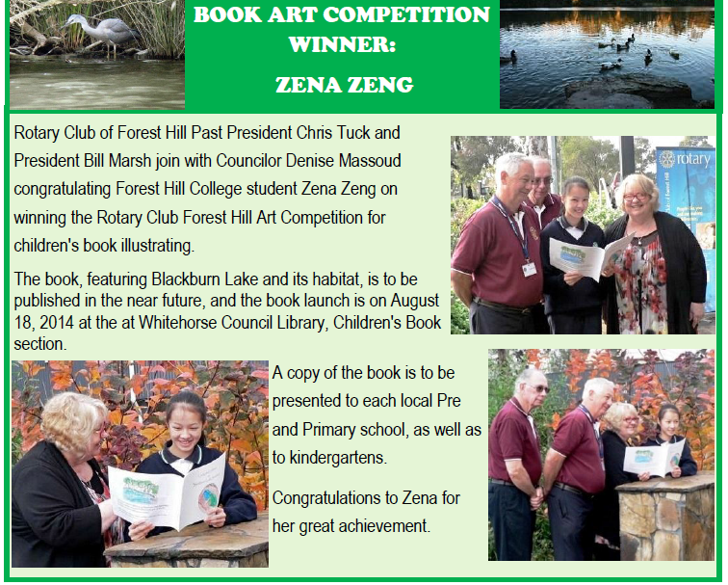

Club officers & Committees 2014-15

**President** Bill Marsh

**Vice President** John Donaghey

**Secretary** Ron Brooks

**Treasurer** Warwick Stott

**President Elect** Bob Williams

**Sergeant** Stuart Williams

**Foundation & International** Chris Tuck

Members: John Donaghey, Bob Williams, Stan Harper

**Youth Service** Glenys Grant

Members: Ray Smith, Graham Sharman

**Community & Vocation** Bob Laslett

Members: Stuart Williams, Gary Baltissen, Ron Brooks

**Membership & Publicity** Doug Berwick

Members: John McPhee, Warwick Stott, Jenny Coburn

**Fellowship** John McPhee

**Primary Schools Speech Night** John McPhee

**Programme** Ray Smith & Gary Baltissen

**Bulletin Editor** Ron Brooks

**Web page** Ron Brooks

**Facebook** Ron Brooks

**On to Conference** Stuart Williams

**Historian** Stan Harper

**Almoner** Graham Sharman

**Public Officer** Bill Marsh

|  |
| --- |
| Bulletin articles to the Editor at [ronbrooks1@optusnet.com.au](mailto:ronbrooks1@optusnet.com.au) by **5 pm Wed**  If you do not wish to receive this pubcation please contact the Editor |
|  |