### 

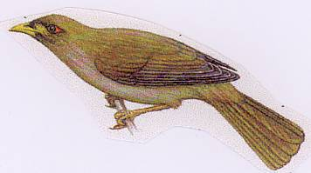

|  |  |  |
| --- | --- | --- |
|  | 2014-2015  Weekly Bulletin  Rotary Club of Forest Hill |  |
| Number 7: 18th Aug 2014  Club address: PO Box 116, Nunawading 3131  **Website:** [**www.foresthillrotary.com**](http://www.foresthillrotary.com)  Meeting location: Bucatini Restaurant, 454 Whitehorse Road, Mitcham, 3132  Meeting time: Monday 6.15 for 6.30 pm  **Facebook: ForestHill Rotary** | | |

|  |  |  |  |  |  |  |  |  |  |  |  |  |  |  |  |  |  |  |  |  |  |  |  |  |  |  |  |  |  |  |  |
| --- | --- | --- | --- | --- | --- | --- | --- | --- | --- | --- | --- | --- | --- | --- | --- | --- | --- | --- | --- | --- | --- | --- | --- | --- | --- | --- | --- | --- | --- | --- | --- |
| |  |  |  |  |  | | --- | --- | --- | --- | --- | | **CLUB PROGRAM** | | | | | | **Date**  **18th Aug** | **Event**  **Bestchance-child family care – Chris Thompson, Geraldine Ryan, Kevin** | **Chair**  **Glenys Grant** | **Thanks/meeting report**  **Jenny Coburn** |  | | **25th Aug**  **1st Sept** | **Feeney (CEO)**  **Primary Schools speech contest**  **Maree Chadwick** | **Ray Smith** | **Warwick Stott** |  |  THIS WEEK'S CELEBRATIONS Aug 15th Doug&Tracey Wedding anniversary DUTY ROSTER  |  |  |  | | --- | --- | --- | |  | **August** | **Sept** | | Cashier | Ron Brooks | John McPhee | | Recorder | Chris Tuck | Stuart Williams | | Greeter | Stuart Williams | Doug Berwick | | Emergency | Ray Smith | Bob Williams |  ATTENDANCE  |  | | --- | | **APOLOGY** – **IF A MEMBER IS NOT GOING TO COME TO THE MEETING or you intend bringing a guest**  **Please contact Ray Smith by** **10.00 am MONDAY** on9878 4891 or[rcssmith@optusnet.com.au](mailto:rcssmith@optusnet.com.au%20)  Any cancellation after 10.00 am should be made direct with the management of Bucatini Restaurant on 9873 0268 | |

Chris Tuck will be absent from 23rd Aug to 25th Sept

Doug Berwick will be absent from 21st Aug to 12th Sept

Welcome back John McPhee from holidays

**BILL’S** **BLURB**

Wow! What a great week and next week promises to be even better!

On the 12th October we will be holding a special Rotary Information stall at the Whitehorse Farmers' Market. The stall will be manned by the 6 clubs in our Cluster and Rotoract and will aim to highlight the great work undertaken by all of the clubs with the funds raised by the market. It will also be an opportunity to provide information on RI and membership information for all of the clubs. All we need is heaps of support from the clubs and a beautiful sunny day.

Clubs are also invited to run an information stall in conjunction with their rostered day on the Egg & Bacon stall.

We are well on the way to getting all of the Cluster clubs involved in a joint project to support Hand Brake Turn. Four clubs are now committed and the remaining two are considering involvement at their coming committee meetings. This will be a terrific venture if it comes to fruition and a first of its kind in my time in Rotary, hopefully the first of many such projects. We are hoping to attract a District grant which will increase the impact we can have on this inspiring program. Our next step will be to combine as a Cluster to support an International project. By working together we can increase the effect made by our contributions.

Our club has committed to continue its support of Polio Plus. By committing our support early we will attract a ! : 1 matching grant from District up to $500. We are so close to eradicating polio and every dollar we can commit brings us a little closer to our goal.

We have five members attending the Foundation Seminar on the 21st August and another group will be off shortly to the Vocational Seminar. It is great to see so many members being involved and bringing new ideas back to the club.

We had both the Blackburn Market and the Whitehorse Farmers' Market over the weekend. Many thanks to all of the members who gave their time to support both ventures. As our major fundraising activities we need to do everything we can to ensure their success.

The first mini issue of our new newsletter 'Community Connections @ Forest Hill' will be ready for distribution at the book launch for "Larry the Lorikeet" on Monday. We are hoping to produce this on a regular basis and increase its distribution to cover all of the areas around Forest Hill.

On Monday we had a very interesting club meeting with a great guest speaker in Lachlan Williams from Fletchers Real Estate and this was then followed by a very productive committee session.

**Little Known Fact**: The gold medals at London 2012 were the largest and heaviest ever awarded at a Summer Olympics, but were only 1.34% gold.

**Enjoy your week in Rotary and keep working to "Light Up Rotary"**

Pres Bill

# LAST WEEK’S MEETING

No official report received.

The following is from a few scribbled notes by the editor.

Our guest speaker was Lachlan Williams, son of Stuart who works at Fletchers, the family real estate people who have been selling property in Melbourne’s east for over 95 years. They now have 14 offices some in recent years are franchisees. When they started, Camberwell was a country escape, Blackburn made the best bricks in Melbourne, Balwyn was home made wines and farming plots and Doncaster was a tourist destination renowned for orchards and hills. Outer rural suburbs are now desired inner suburbs. Lachie gave us a run down of values of houses and units in the suburbs from which we draw our members and told us about the Asian influences, preferable have an 8 in your address and definitely not a 4, 13 is not good and don’t have a place right on a T intersection. The suburbs of Forest Hill, Nunawading, and Blackburn have values of $1,200 to $1,400 m2 and while the market is strong it is best to use auction not private sale. They have had clearance rates of 83-100% in the last 5 weeks. Paint your house in neutral shades, have a stainless steel kitchen, don’t necessarily have a bath installed. Generally Asians prefer carpet and Europeans wood and tiles. House prices may have a rest from going up in the next year but any price fall is likely to be small. Go to [www.ourhousingfuture.com.au](http://www.ourhousingfuture.com.au) to find out what the City of Whitehorse has said you can and cannot do regarding subdividing etc. He then gave each of us a beautiful hard backed 126pp book called “A journey through Melbourne’s east” full of photos and descriptions of the eastern suburbs covering the time Fletchers have been in business. Well done Lachie.

His father fleeced us of $38.10 during the sergeant’s session.

Notes by Ron

**BLACKBURN STATION MARKET- SATURDAY 9TH AUG**

Saturday weather was really good and it resulted in an excellent $673 profit from our sausage sizzle and stall holders contribution. Bob W and Ray reported that we had a good turn up of members to run the day.

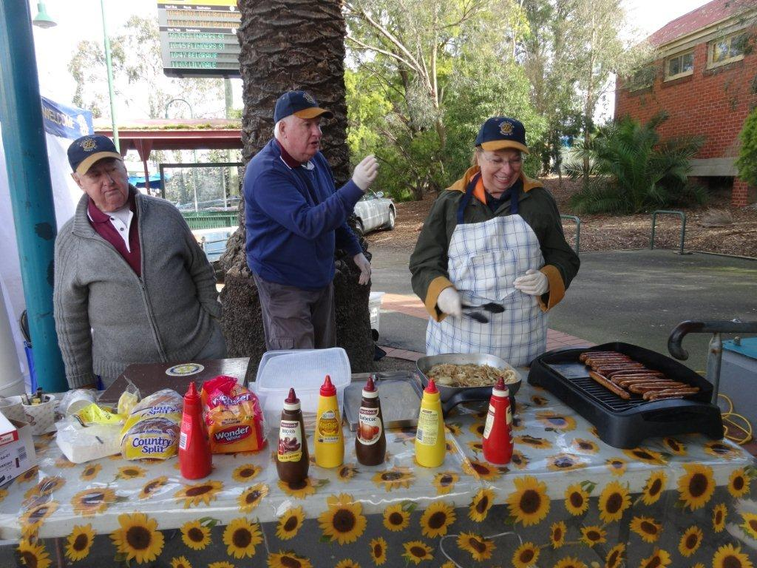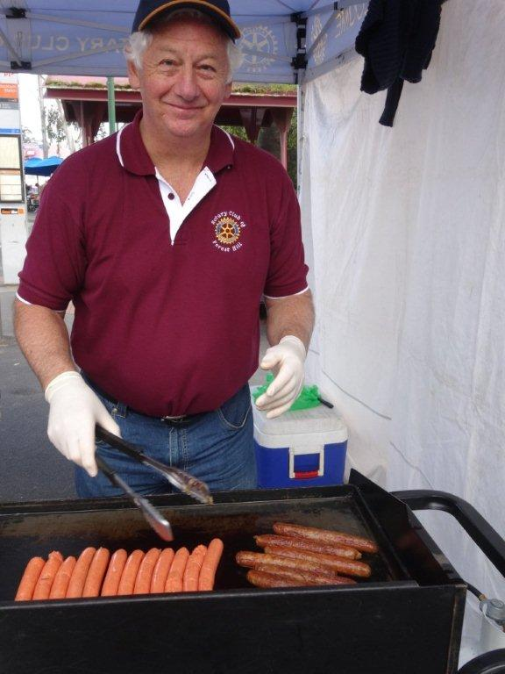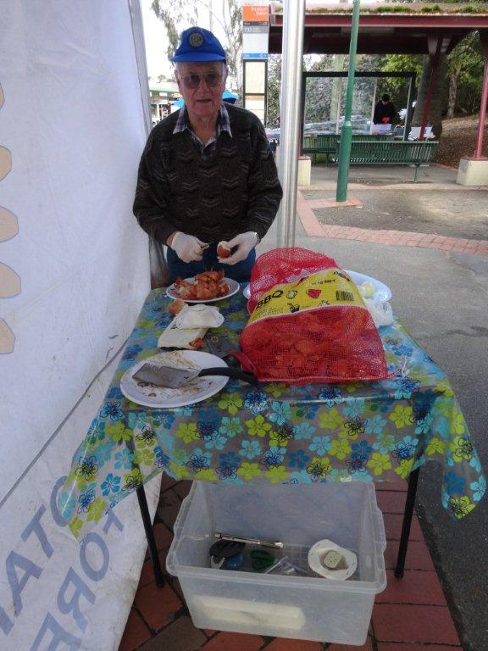

# DON HULLAND

Don is not too well. His arthritis is a real problem. He is at present in Kellock Lodge in respite and hoping to be able to stay there full time. The address is 15 Bon St, Alexandria 3714 and his telephone is 0409 530 435. Keep him in your thoughts. I have placed this notice below the sausage sizzle as he was such a great supporter continuing to help us long after he left the club travelling down from Alexandria to help at the market. We have sent a card from the club to him at Kellock Lodge.

# WHITEHORSE FARMERS MARKET- SUNDAY 10TH AUG

On Sunday 10th August a very successful market was held at the Whitehorse Council parking precinct. A cold blustery day but a good many visitors braved the weather until about 11.45 when a savage blast of sleet hit the area sending many people home. However the usual number of about 66 vendors had a busy day producing a gross profit of $6,698 with Forest Hill share being about $718. Thankyou to PDG Bob L, Pres Bill, and PDG Jenny who each did a shift.

# WEBSITE

Do not forget to check out our website, [www.foresthillrotary.com](http://www.foresthillrotary.com) and send Ron Brooks any information and suggestions.

**WEBINARS ABOUT MEMBERSHIP AND CLUB MEETINGS**

Please register for Flexible and Innovative Clubs on Aug 26, 2014 6:00 PM EST at:

**https://attendee.gotowebinar.com/register/3040662381890031617**

Please register for Flexible and Innovative Clubs on Aug 27, 2014 8:00 AM EST at:

**https://attendee.gotowebinar.com/register/716508106027376897**

These two webinars will discuss how Clubs can and need to be Flexible and Innovative. PDG Jessie Harman and PDG Noel Trevaskis will lead this Webinar and will be sharing how some Clubs have gone about being flexible and innovative in their approach to membership, club meetings, diversity etc.

For those not familiar with webinars, depending on which time you want to listen to the discussion, put the appropriate bolded line in your web browser and hit enter. It will take you to a site where you register by putting down your name and email address and you get emailed instructions, with a link that you click on 5 or 10 mins before the webinar starts and the computer does the rest. Generally you can write in questions before and/or during the discussion. It is very simple.

# OUR HOPE KATOLO SCHOOL PROJECT in KENYA

Warwick received the following email which he circulated to club members

*Hi Forest Rotary Hill members*

*I  am very pleased that you have approved of my work with the tanks, and i want to tell you that they all have water in them as now there are a few episodes of good rain. I am very greatfull and i believe that it would not be easy for them to go dry all at a go,*

*We have now clossed school for the August Holiday and shall be resuming on 1st september to start our final term of the year*

*May all of you and your group be blessed abunduntly*

*Georgina Malanga (Kenya)*

As Warwick said *“it really makes you feel as though we are making a difference to people whom we know a little better because we have met her and seen the organisation grow from small beginnings*”

# REASONS FOR JOINING ROTARY

Jenny Coburn gave me a list of reasons, I am putting in a different one every week - **think about them when you talk to prospective members**

**Learning New Skills:** So many new opportunities arise through Rotary membership. Public Speaking, Chairing Meetings, Project Planning & Evaluation, Training & Facilitating, Leadership, Practical skills in international volunteering and so much more

**FUTURE EVENTS.**

* Club birthday and DG visit Mon 15th Sept.

**PERIDOT THEATRE VISIT**

The club had a visit to see “House Guest” last Friday written by Francis Durbridge (who wrote the Paul Temple series for the BBC). There will be a report next week.

**STAMPS**

Please cut out all the stamps you get on your snail mail leaving an approximate 1cm margin and give to Ron Brooks. They are worth nothing to you but Rotary sells them

Over $89,000 since starting in 1991/92 and $7,091 in 2013/14.

**Harvey World Travel Offer**

Harvey World Travel, Forest Hill Chase, offers to the Club $30 for any booking up to $10,000 and anything over $10,000 1% plus 10% insurance.

Thanks to Glory Britto for making this offer available to the Club.

**BALLARAT CONFERENCE 2015**

A booking has been made for 6 double rooms at Ballarat Lodge  for District Conference.( Fri 13 - Sunday 15 March 2015.  Rooms booked for Fri night and Saturday night.

Families  Grant/ Williams, Bob/ Williams, Stuart/ Brooks/Laslett/Marsh.     Jenny and Roger will stay in own accommodation.

Cost  $149 per night.  FULL Buffet breakfast if required $20.  I believe no money needs to be paid until we arrive. (I believe the Saturday Night function will be held at this venue)

Stuart

**NATIONAL YOUTH SCIENCE FORUM**

Our candidate Jasmine Gan from PLC was successful at the District interview but congratulations must also go to Glenys and her team for the hard work they did in helping her be successful.

This year the District had 73 students register and eventually 51 students were nominated (10 more than last year) by 28 clubs (3 more than last year). There were 37 girls and 14 boys, 22 from government schools and 29 from private schools. We were allocated 18 places (compared to 20 last year as no NZ or Perth available this year). 15 girls and 3 boys were successful, 9 coming from government schools and 9 from private schools. 15 clubs were successful, 3 clubs having 2 successful candidates. 11 schools were successful with 5 having 2 or more successful candidates.

**FROM THE BACK PADDOCK**

Our roving reporter probably had frostbite in his fingers this week! So no contribution or was he out busking trying to earn a crust since Russia have said they are banning all food imports from Australia putting a $200million hole in a $38billion export industry.

Club officers & Committees 2014-15

**President** Bill Marsh

**Vice President** John Donaghey

**Secretary** Ron Brooks

**Treasurer** Warwick Stott

**President Elect** Bob Williams

**Sergeant** Stuart Williams

**Foundation & International** Chris Tuck

Members: John Donaghey, Bob Williams, Stan Harper,

**Youth Service** Glenys Grant

Members: Ray Smith, Graham Sharman

**Community & Vocation** Bob Laslett

Members: Stuart Williams, Gary Baltissen, Ron Brooks

**Membership & Publicity** Doug Berwick

Members: John McPhee, Warwick Stott, Jenny Coburn

**Fellowship** John McPhee

**Primary Schools Speech Night** John McPhee

**Programme** Ray Smith & Gary Baltissen

**Bulletin Editor** Ron Brooks

**Web page & Facebook** Ron Brooks

**On to Conference** Stuart Williams

**Historian** Stan Harper

**Almoner** Graham Sharman

**Public Officer** Bill Marsh

Bulletin articles to the Editor at [ronbrooks1@optusnet.com.au](mailto:ronbrooks1@optusnet.com.au) by **5 pm Wed**. If you do not wish to receive this pubcation please contact the editor.